Date: 01.04.2023

**Program 1 – a) Dataset Exploration – Iris data set**

* Features in the Iris dataset:
  1. sepal length in cm
  2. sepal width in cm
  3. petal length in cm
  4. petal width in cm
* Target classes to predict:
  1. Iris Setosa
  2. Iris Versicolour
  3. Iris Virginica

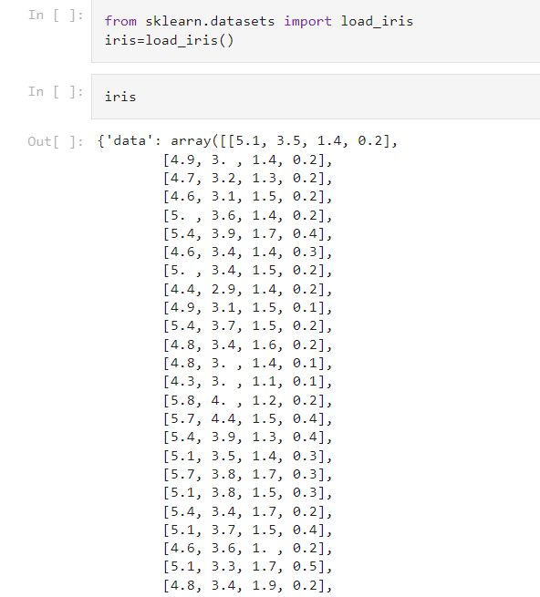

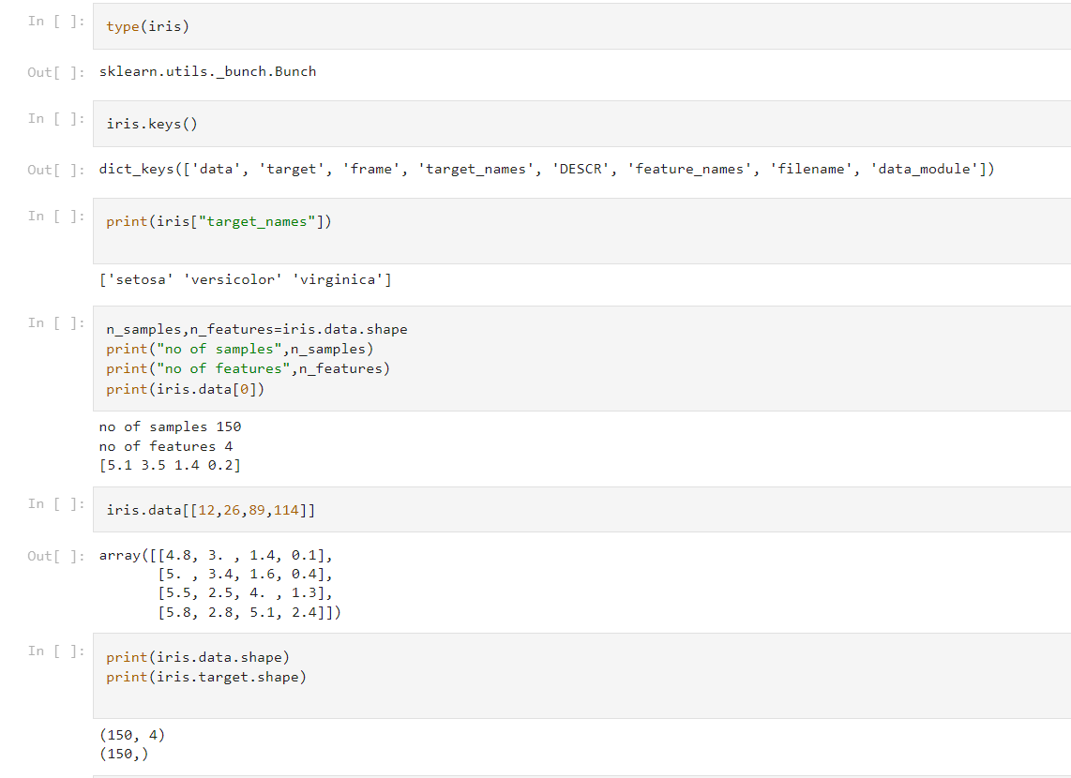

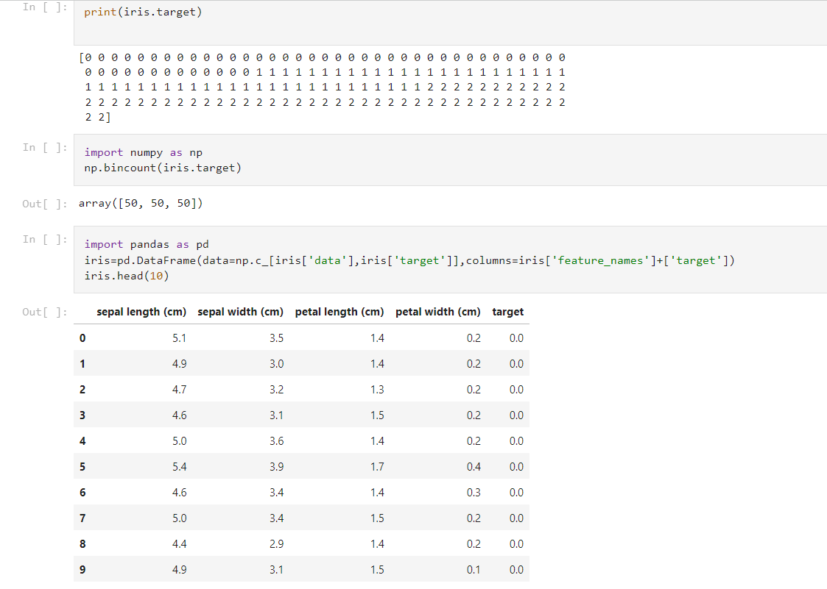

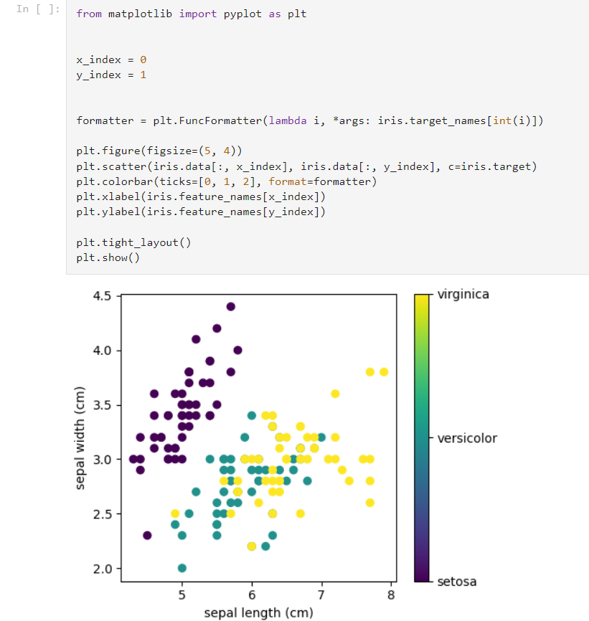

**b. Practice Exercise - Dataset Exploration – Wine data set**

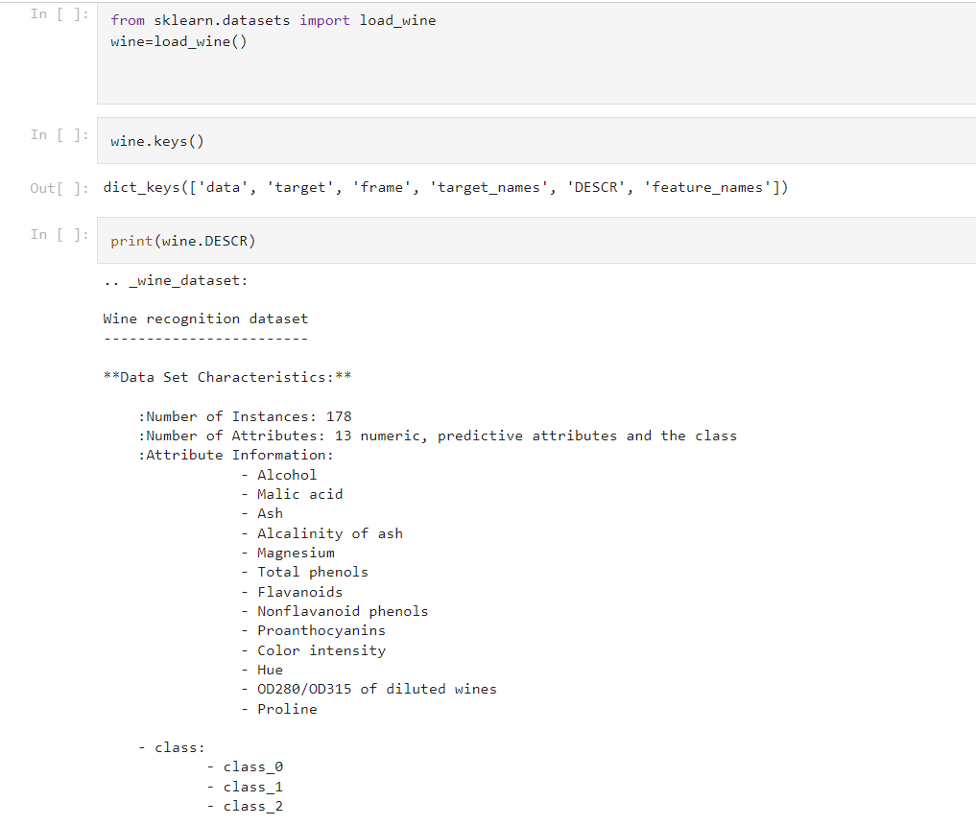

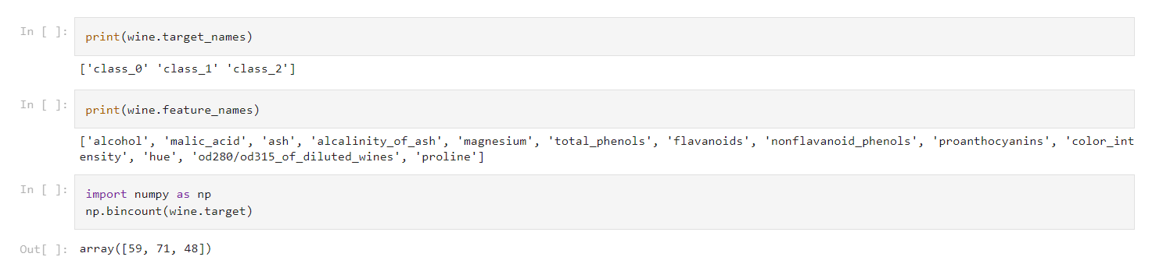

**Date:8/4/2023**

**Program 2 – Implement and demonstrate the FIND-S algorithm for finding the most specific hypothesis based on a given set of training data samples .Read the training data from a .CSV file**

**Data set:Enjoysport**

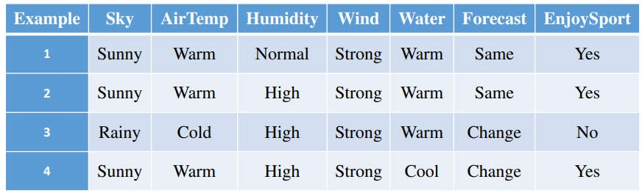

**Observation:**

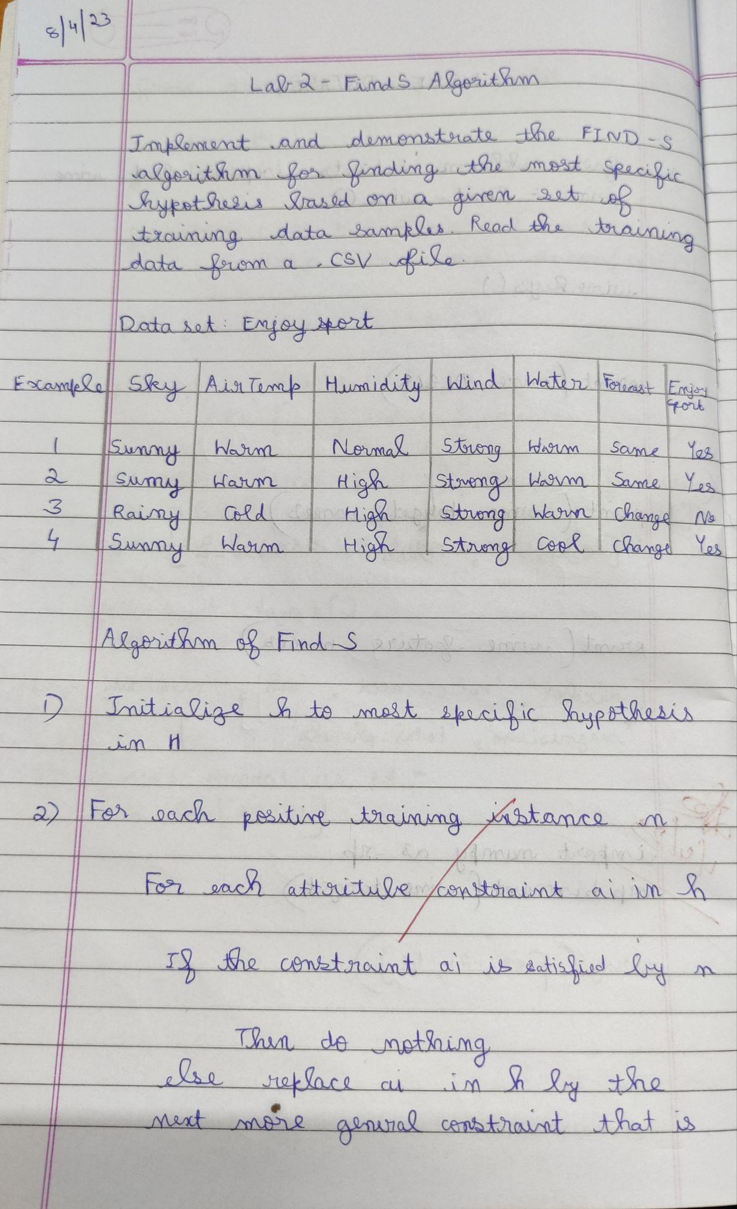

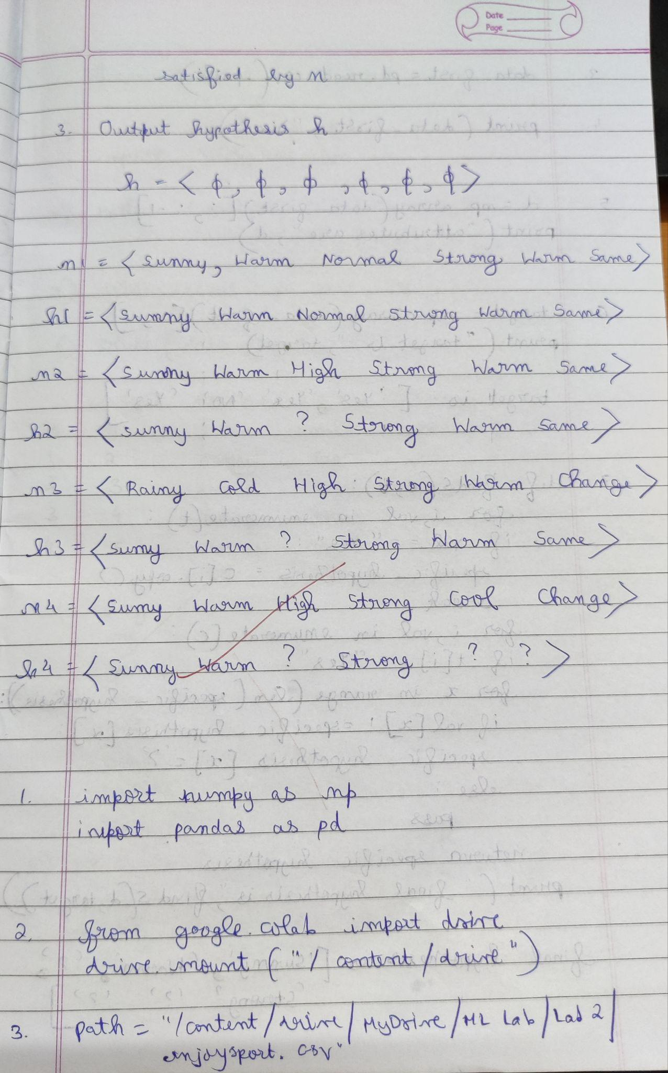

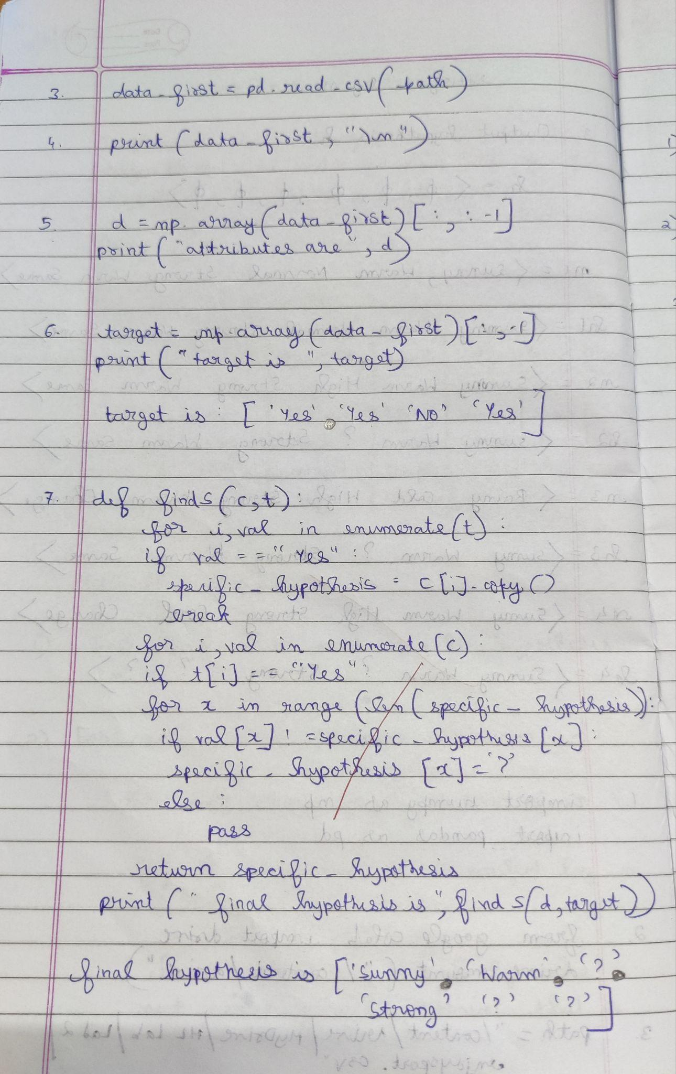

The first step of **FIND-S** is to initialize h to the most specific hypothesis in H h — (Ø, Ø, Ø, Ø, Ø, Ø)

1. First training example **x1 = < Sunny, Warm, Normal, Strong ,Warm ,Same>,**

EnjoySport = +ve. Observing the first training example, it is clear that hypothesis h

is too specific. None of the “Ø” constraints in h are satisfied by this example, so

each is replaced by the next more general constraint that fits the example **h1 = <**

**Sunny, Warm, Normal, Strong ,Warm, Same>.**

2. Consider the second training example **x2 = < Sunny, Warm, High, Strong, Warm,**

**Same>**, EnjoySport = +ve. The second training example forces the algorithm to

further generalize h, this time substituting a “?” in place of any attribute value in h

that is not satisfied by the new example. Now **h2 =< Sunny, Warm, ?, Strong,**

**Warm, Same>**

3. Consider the third training example **x3 =< Rainy, Cold, High, Strong, Warm,**

**Change>,**EnjoySport = — ve. The FIND-S algorithm simply ignores every negative

example. So the hypothesis remain as before, so **h3 =< Sunny, Warm, ?, Strong,**

**Warm, Same>**

4. Consider the fourth training example **x4 =<Sunny,Warm ,High, Strong, Cool, Change>**, EnjoySport =+ve. The fourth example leads to a further

generalization of h as **h4 =< Sunny, Warm, ?, Strong, ?, ?>**

5. So the final hypothesis is **< Sunny, Warm, ?, Strong, ?, ?>**

CSV file creation :

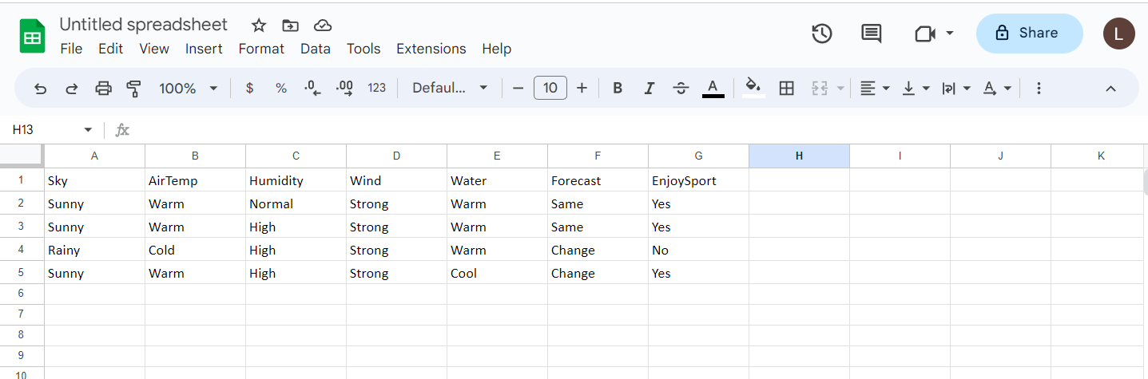



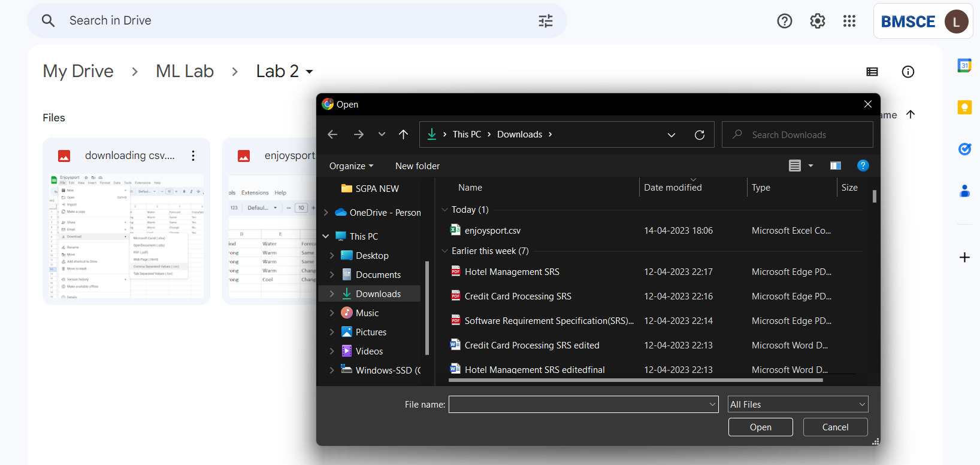

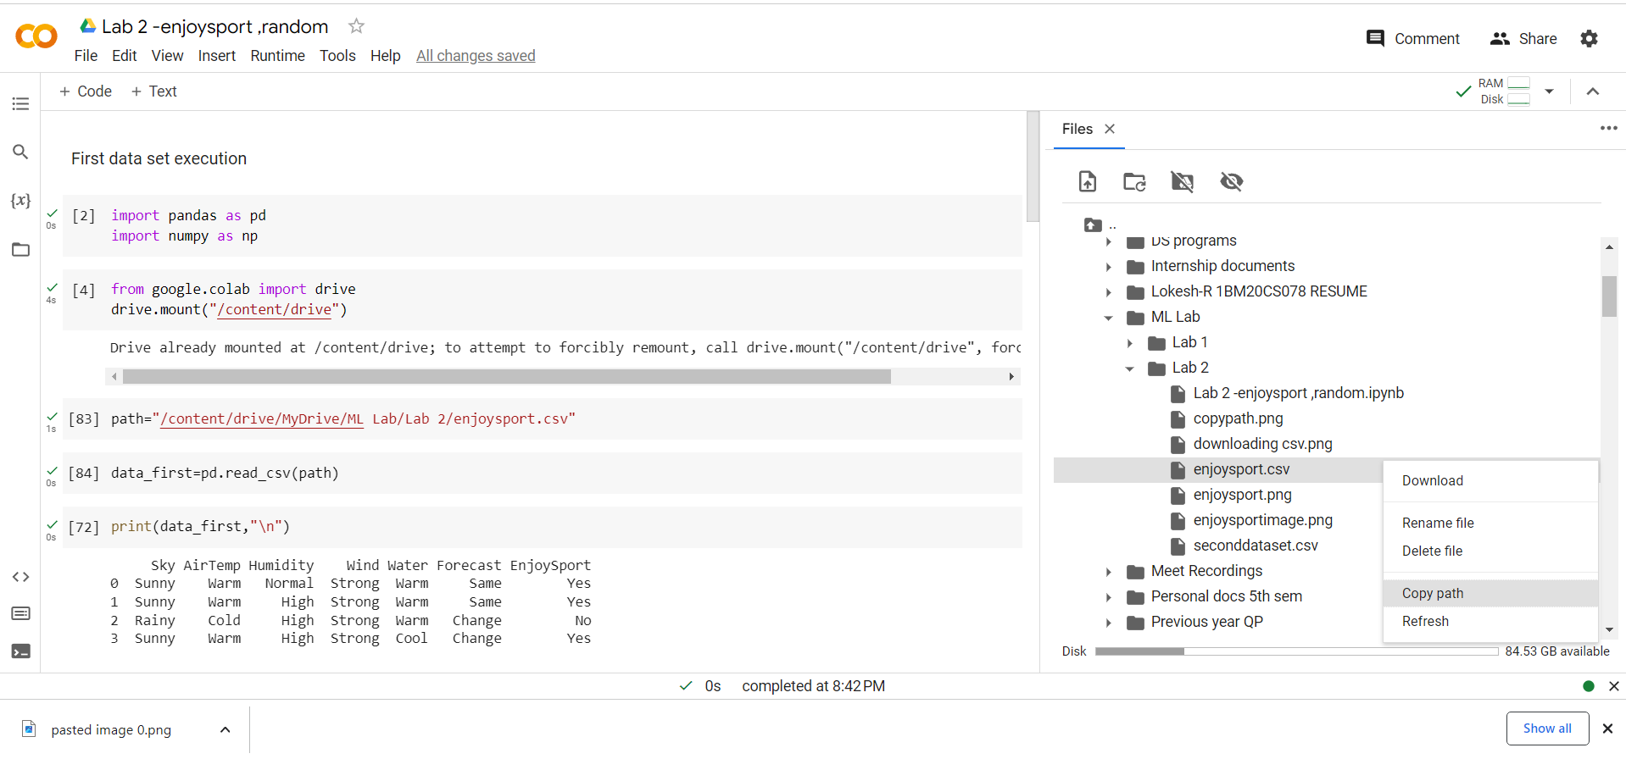

**Program 1:**

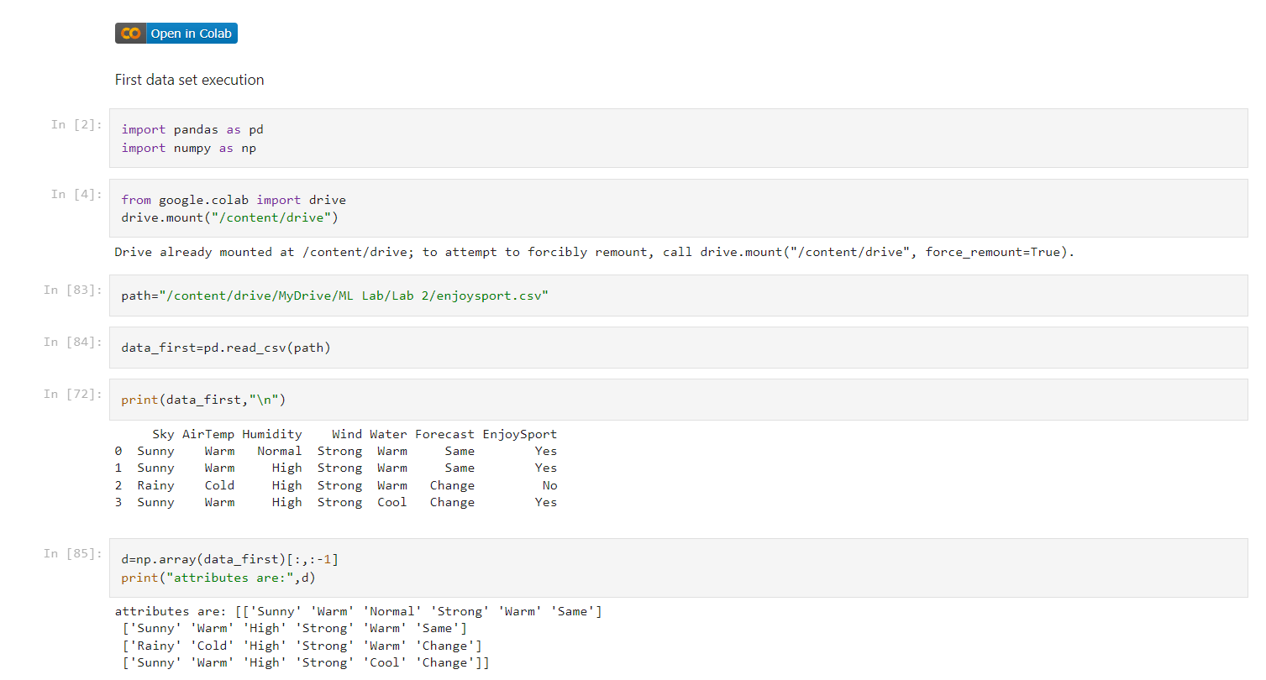

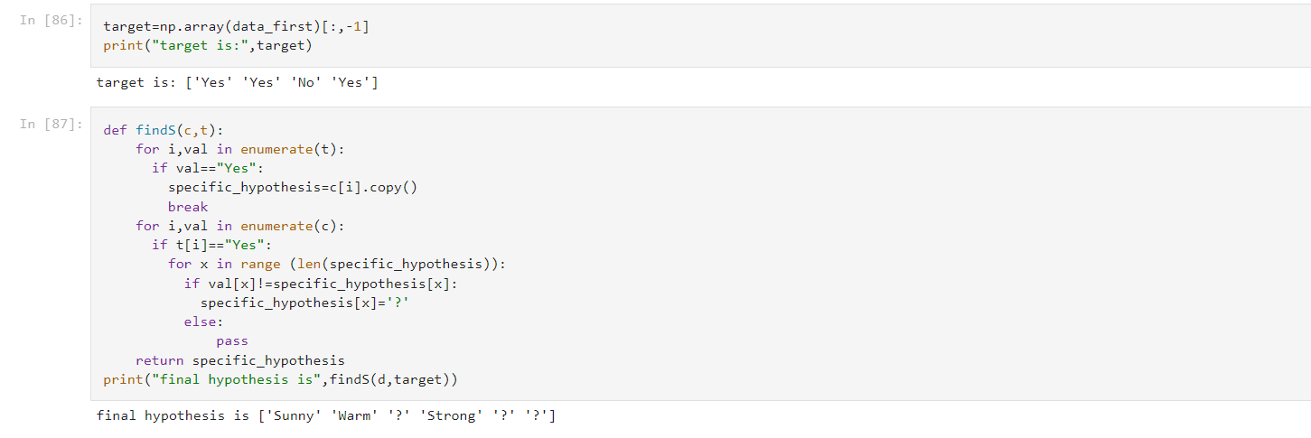

**Second dataset-**

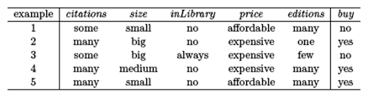

**CSV file contents:**

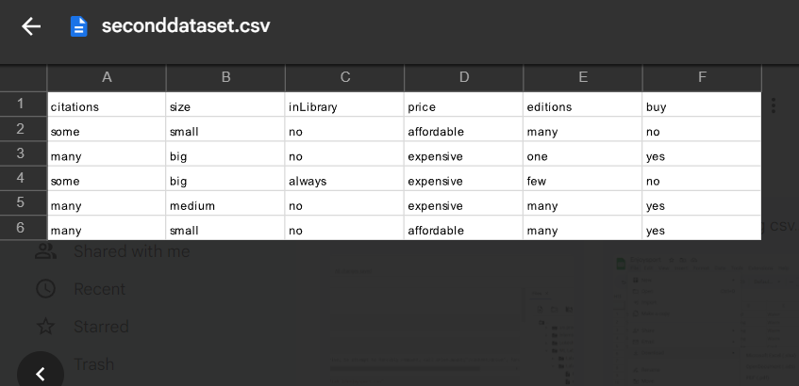

**Observation :**

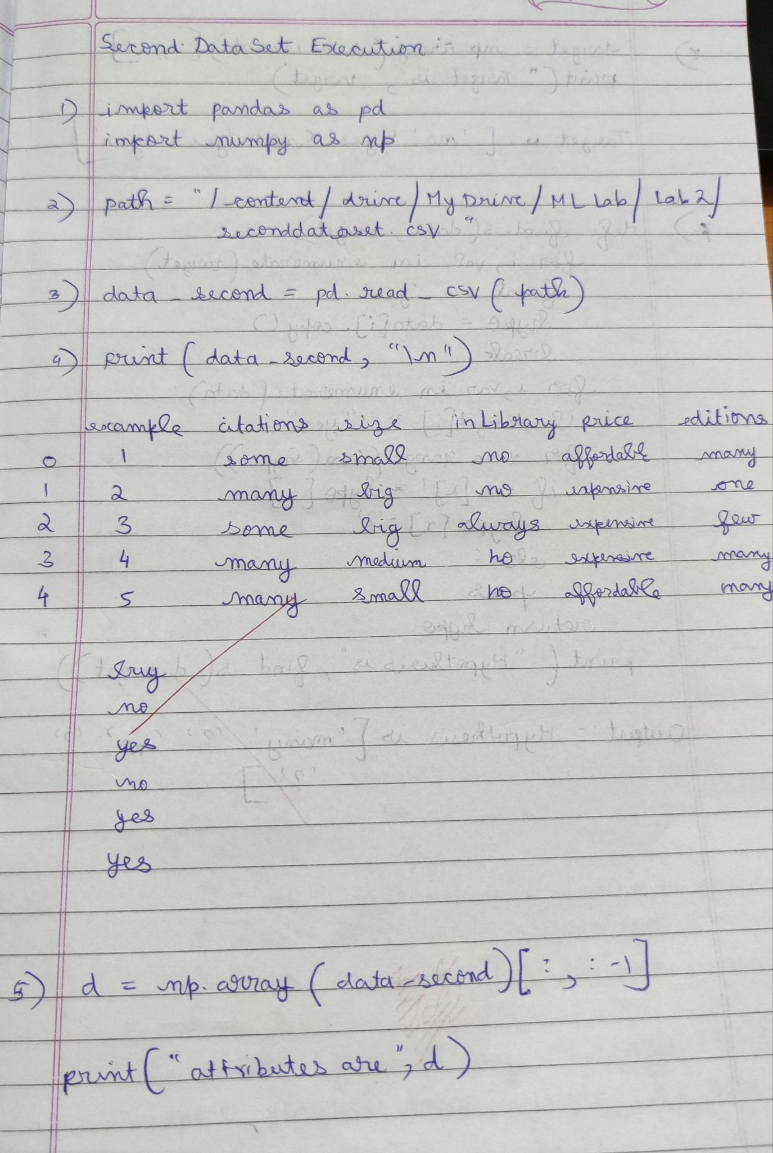

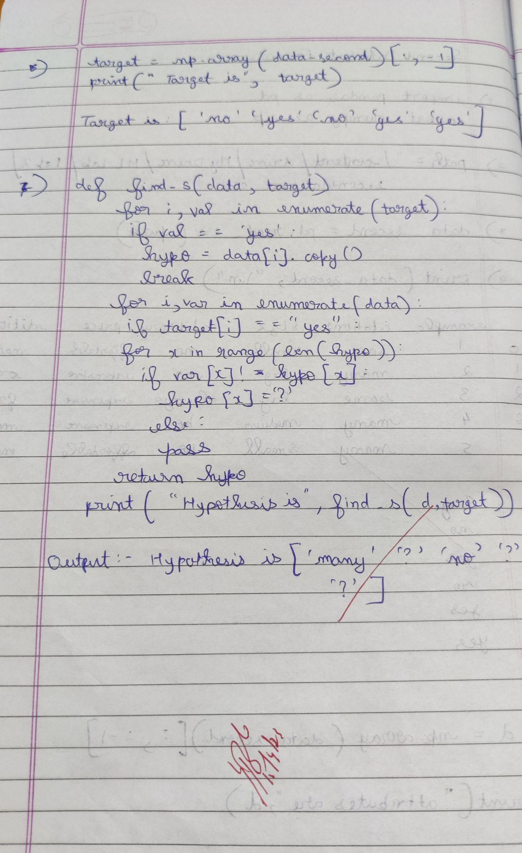

**Program 2 execution:**

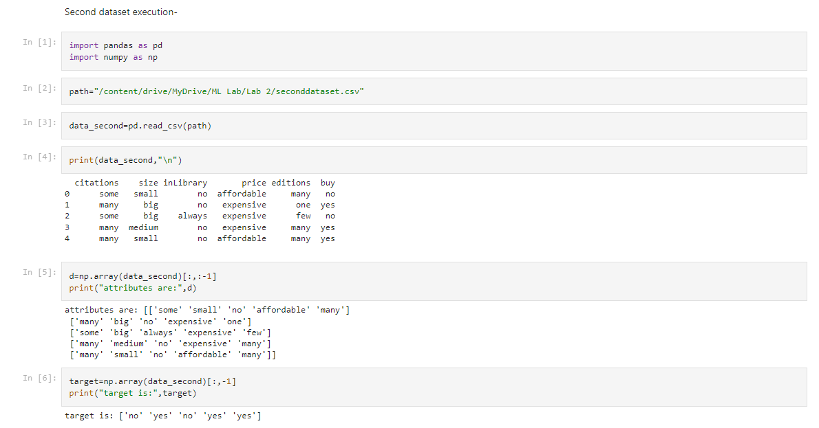

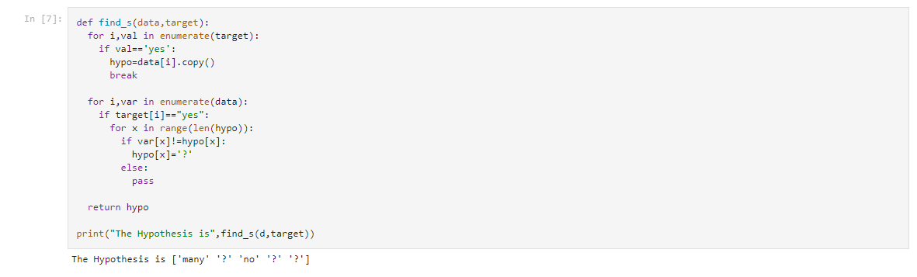

**Date:15/4/23**

**Program 3- For a given set of training data examples stored in a .csv file ,implement and demonstrate the Candidate-Elimination algorithm to output a description of the set of all hypothesis consistent with training examples.**

**Data set-EnjoySport**



**Observation :**

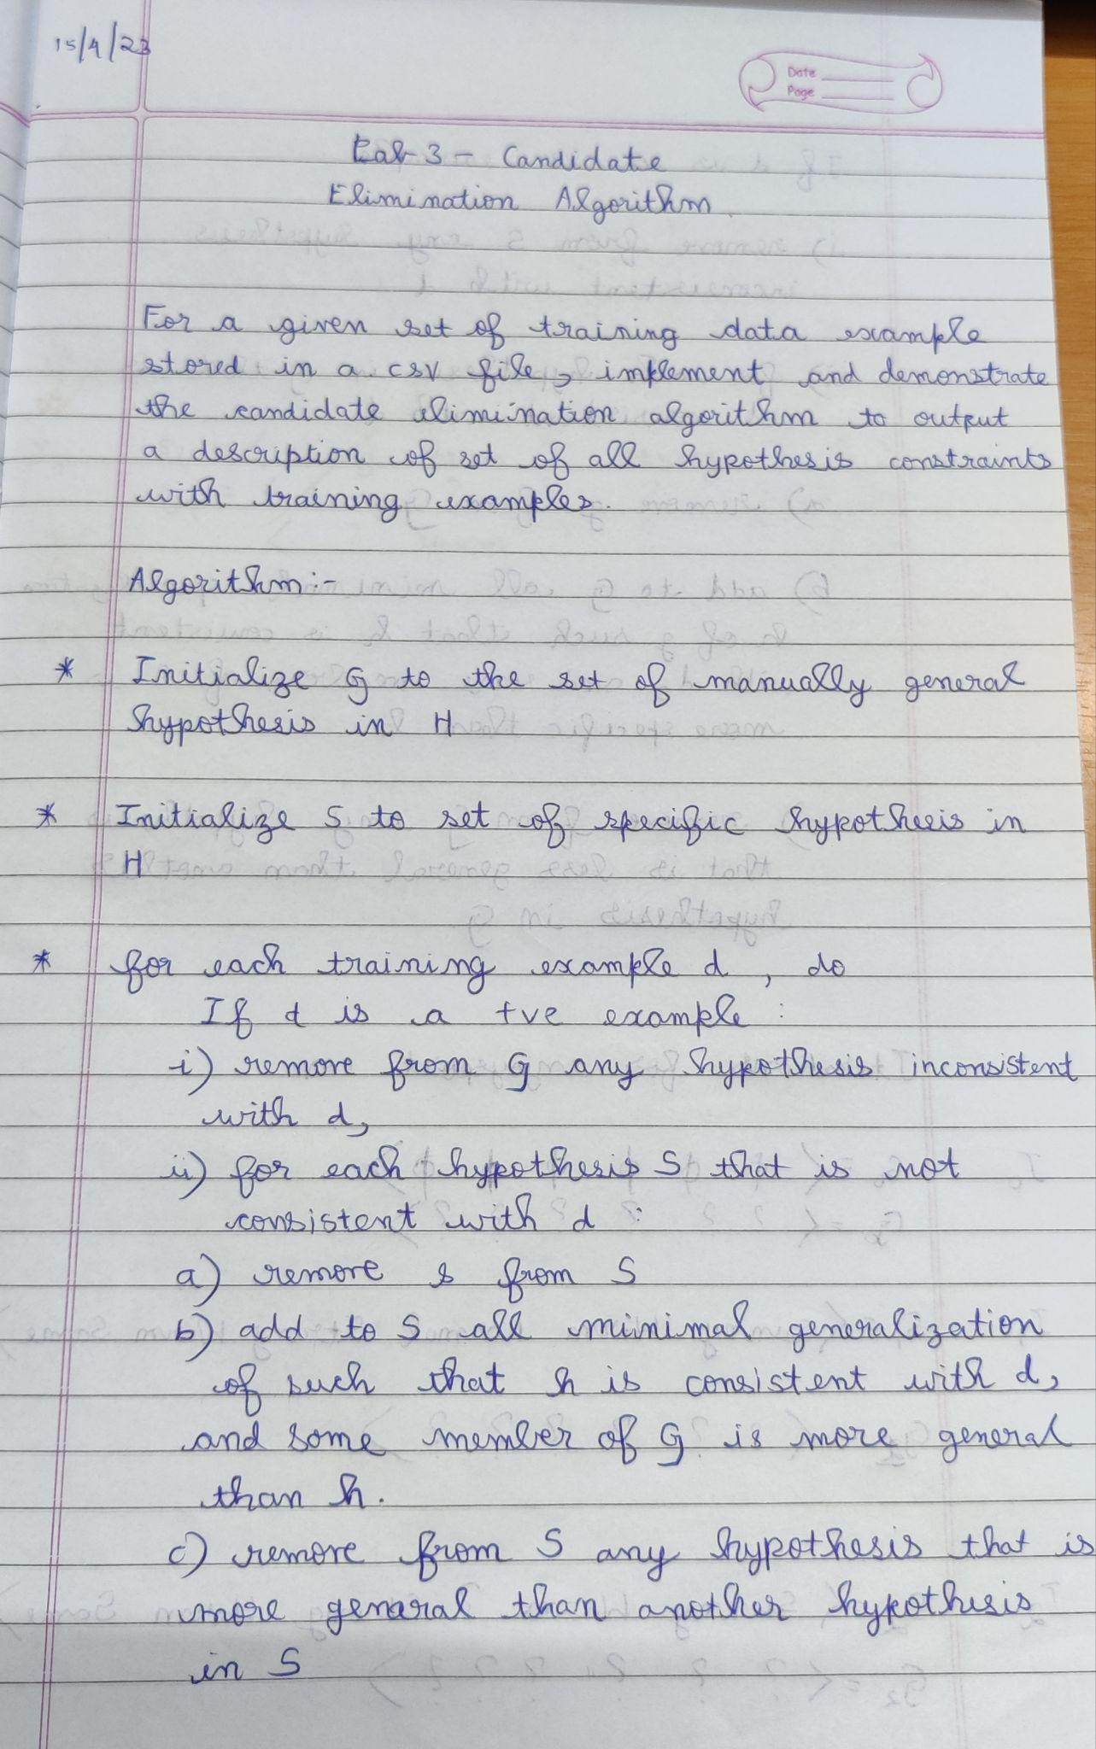

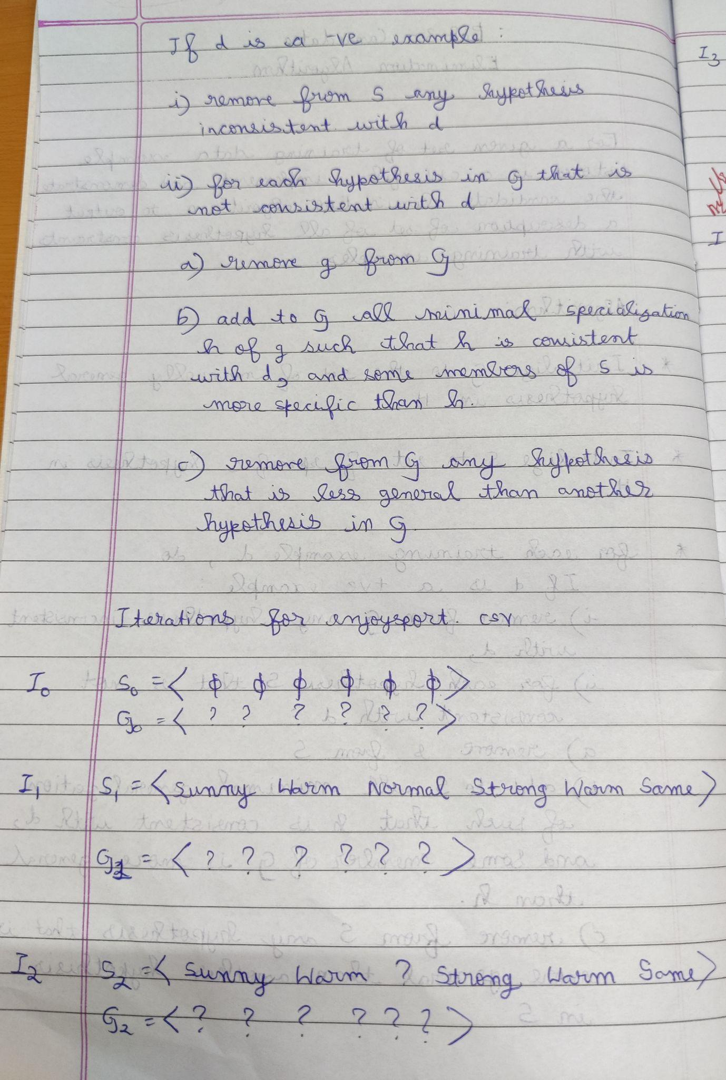

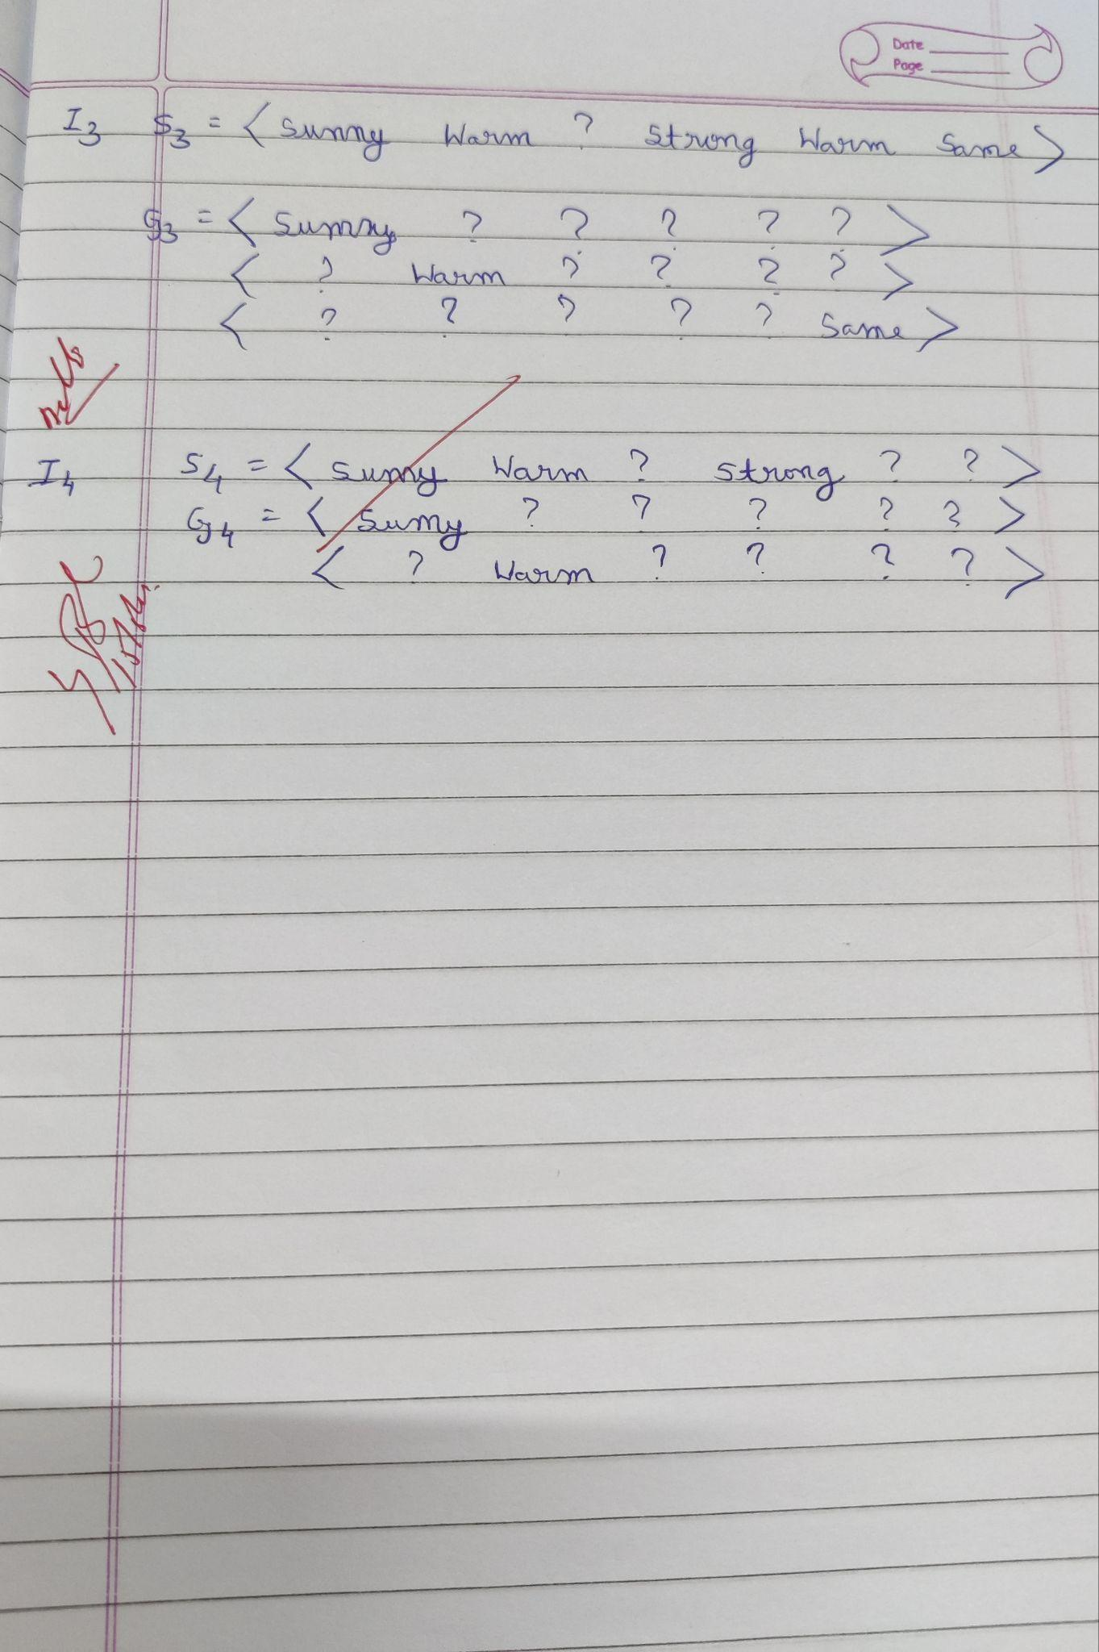

**Uploading csv :**

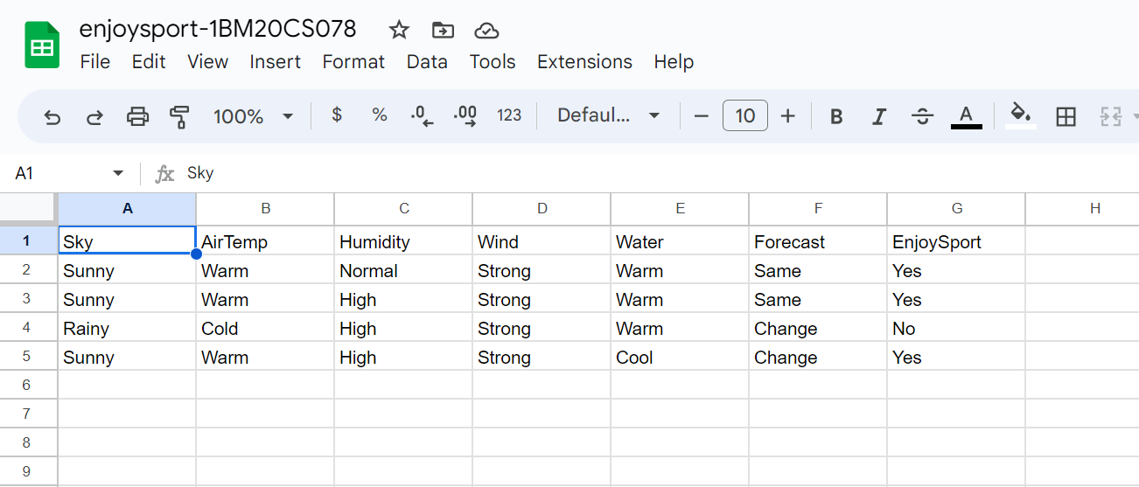

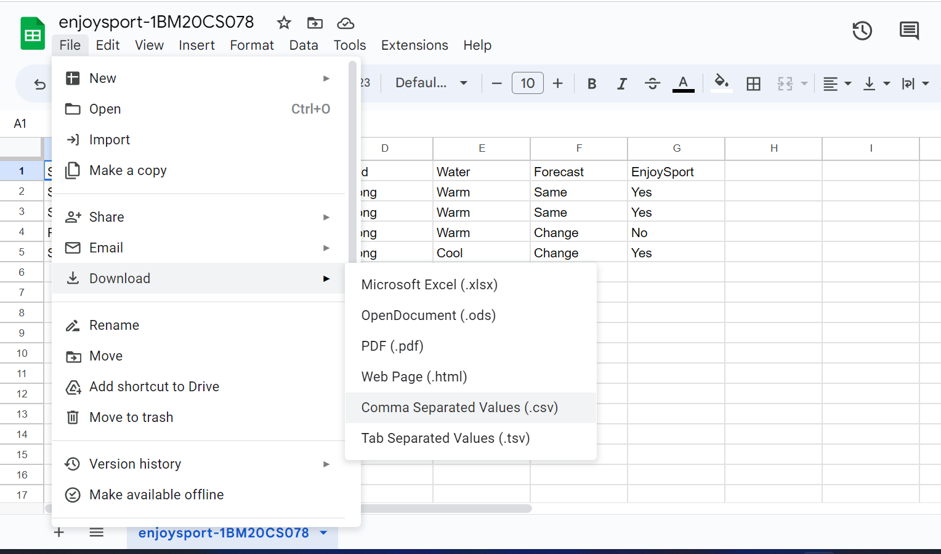

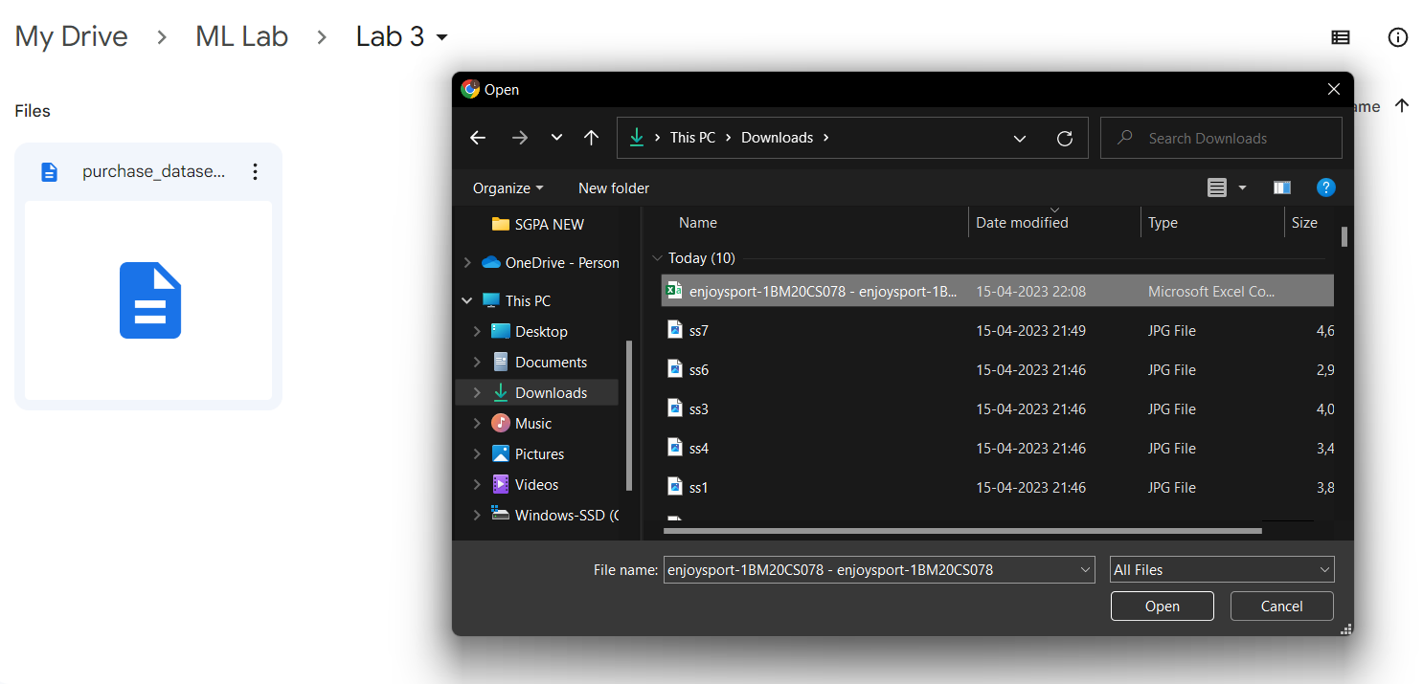

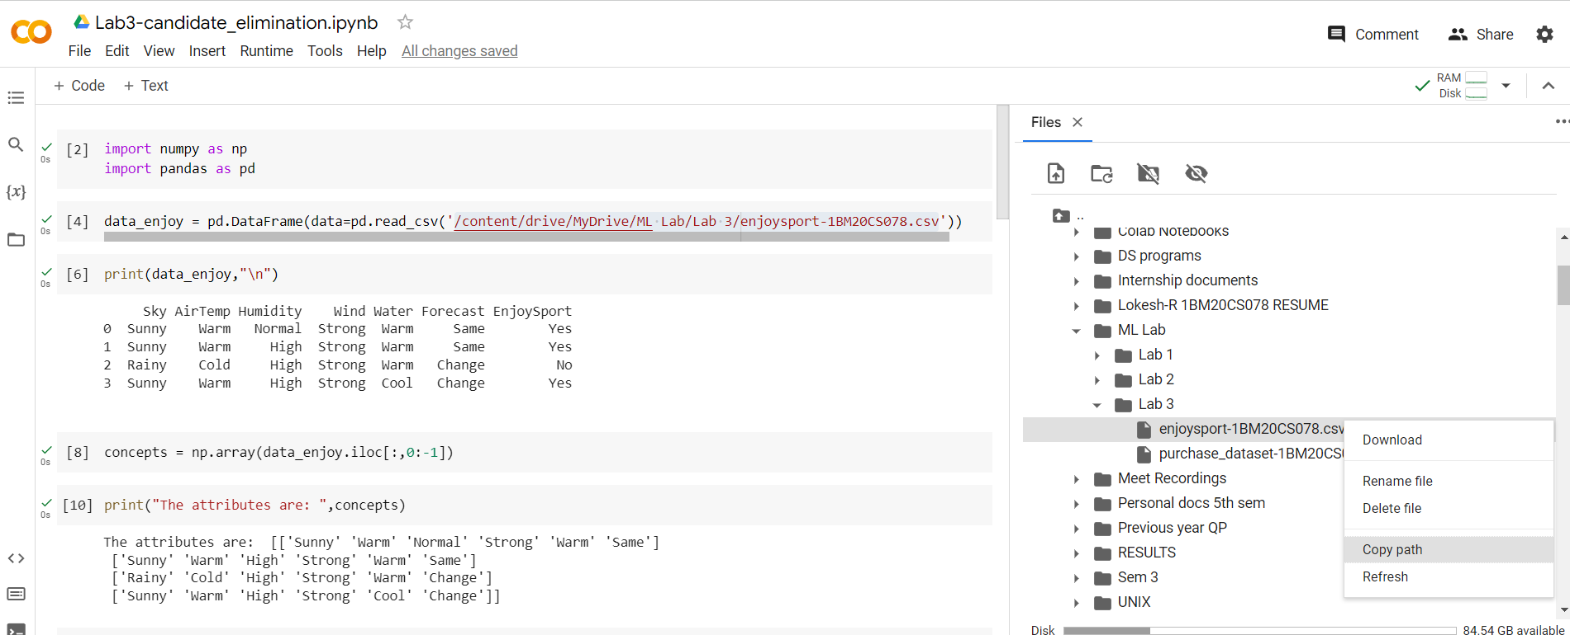

**Program execution -**

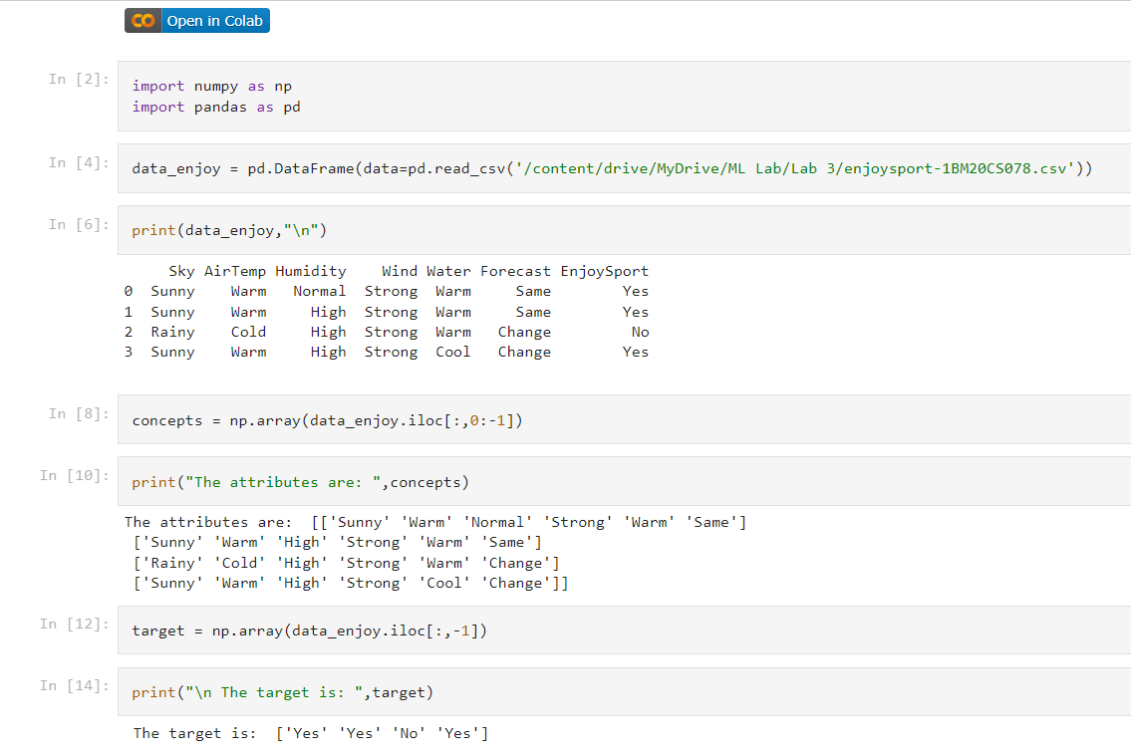

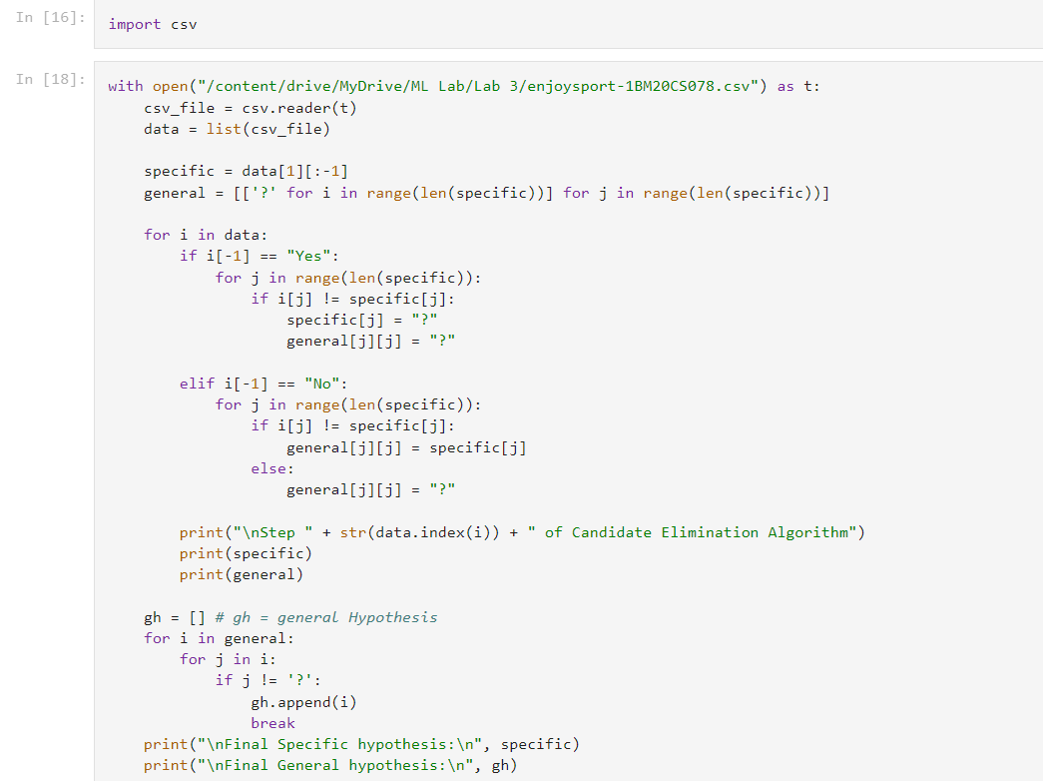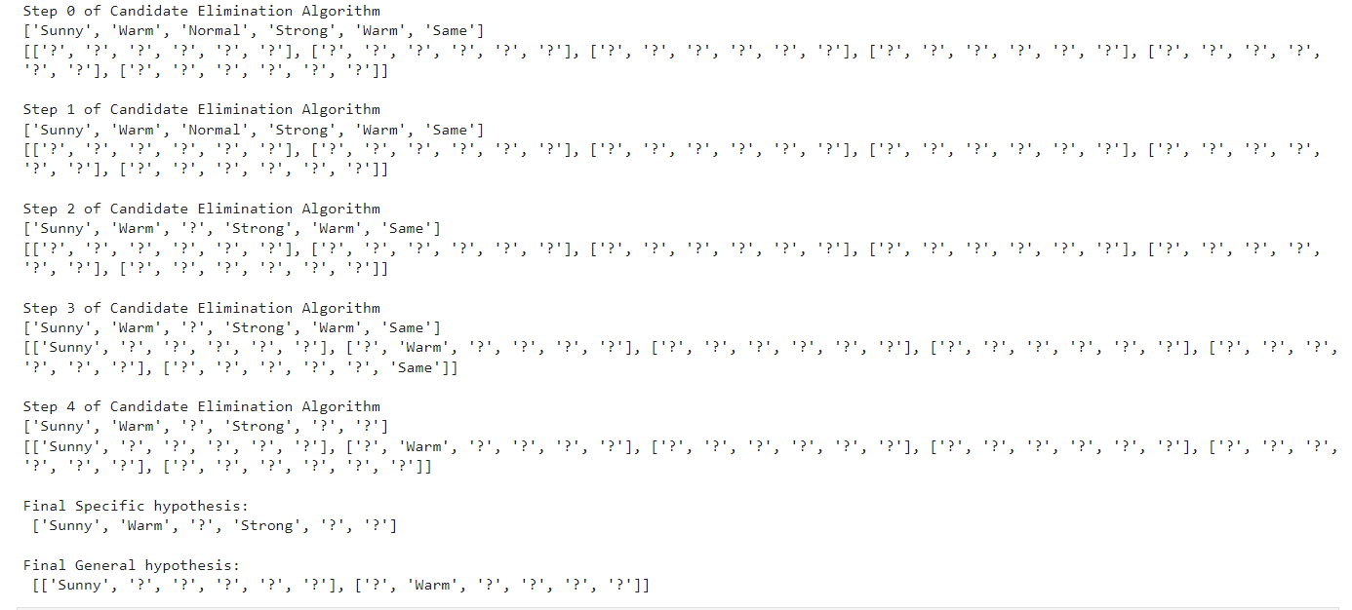

**Second dataset -**

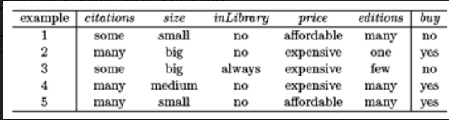

**CSV file**

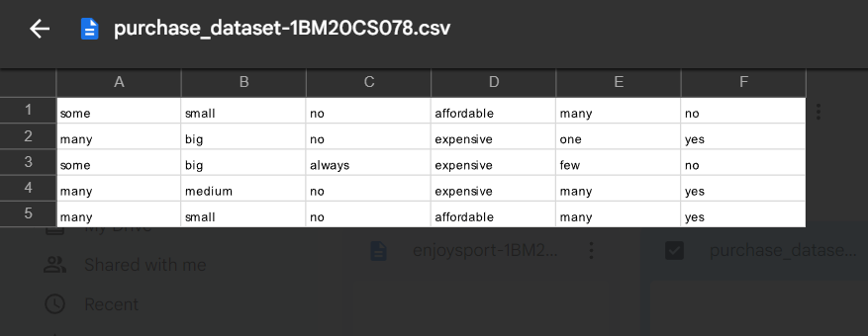

**Program execution -**

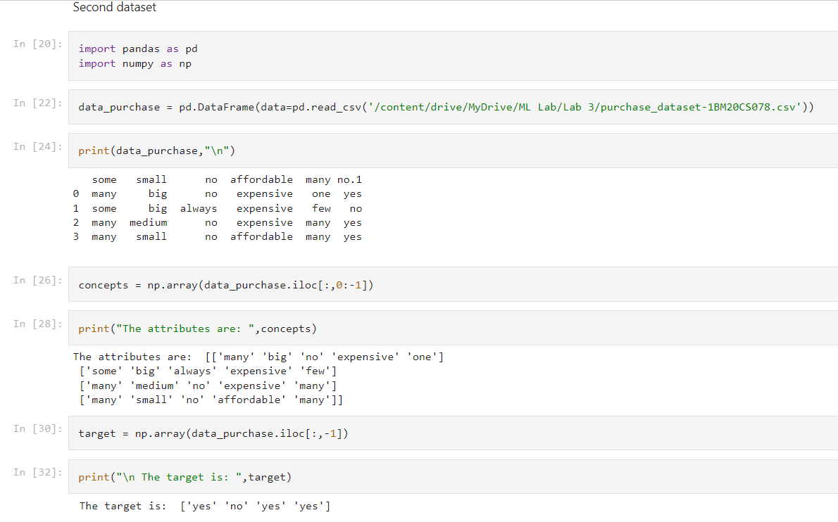



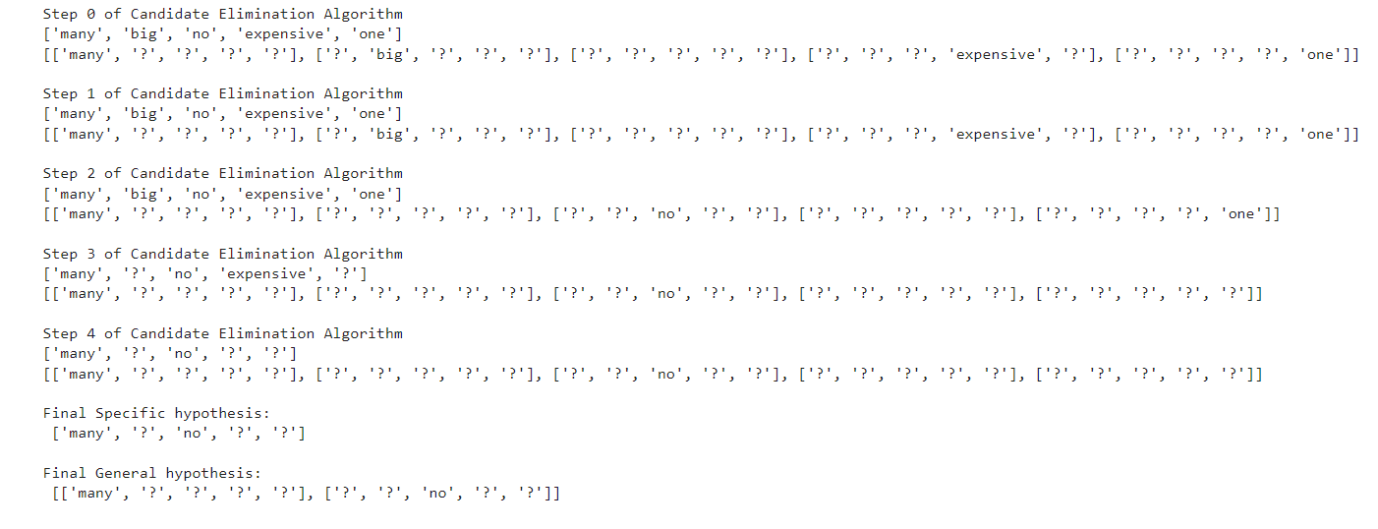

**Date:29-04-2023**

**Program-4:**

**Write a program to demonstrate the working of the decision tree based ID3 algorithm. Use an appropriate data set for building the decision tree and apply this knowledge to classify a new sample.**

**Dataset: Playtennis**

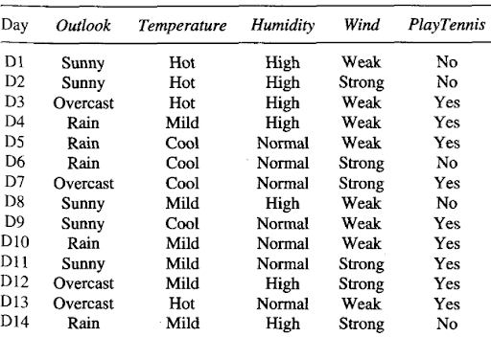

**Observation -**

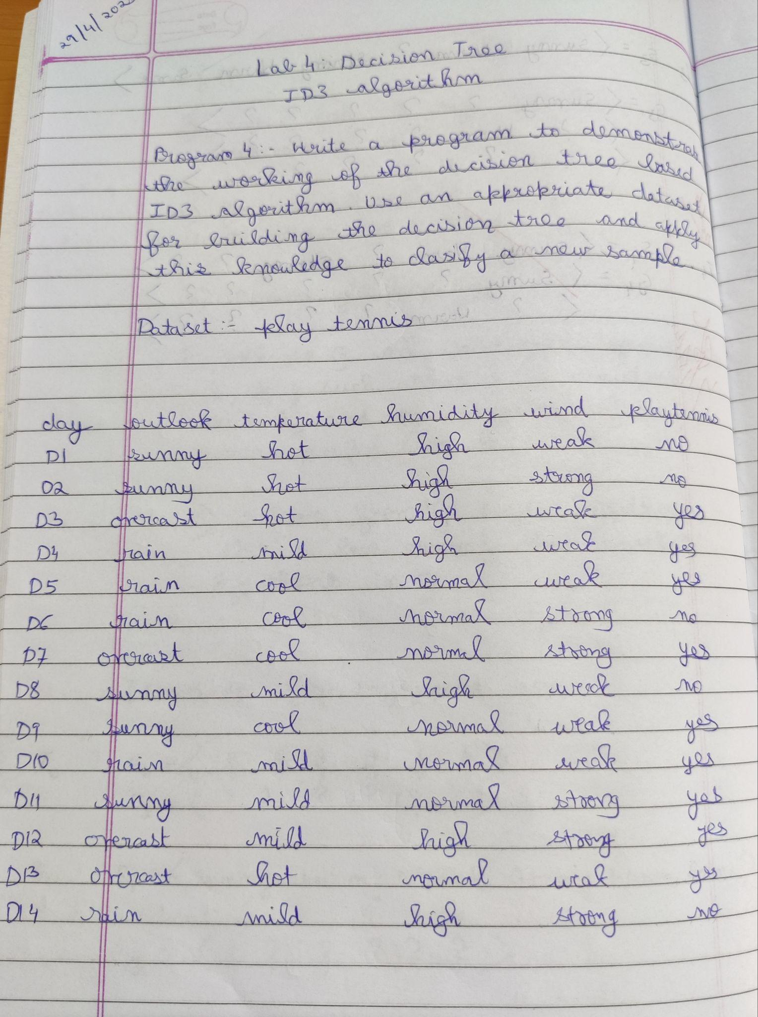

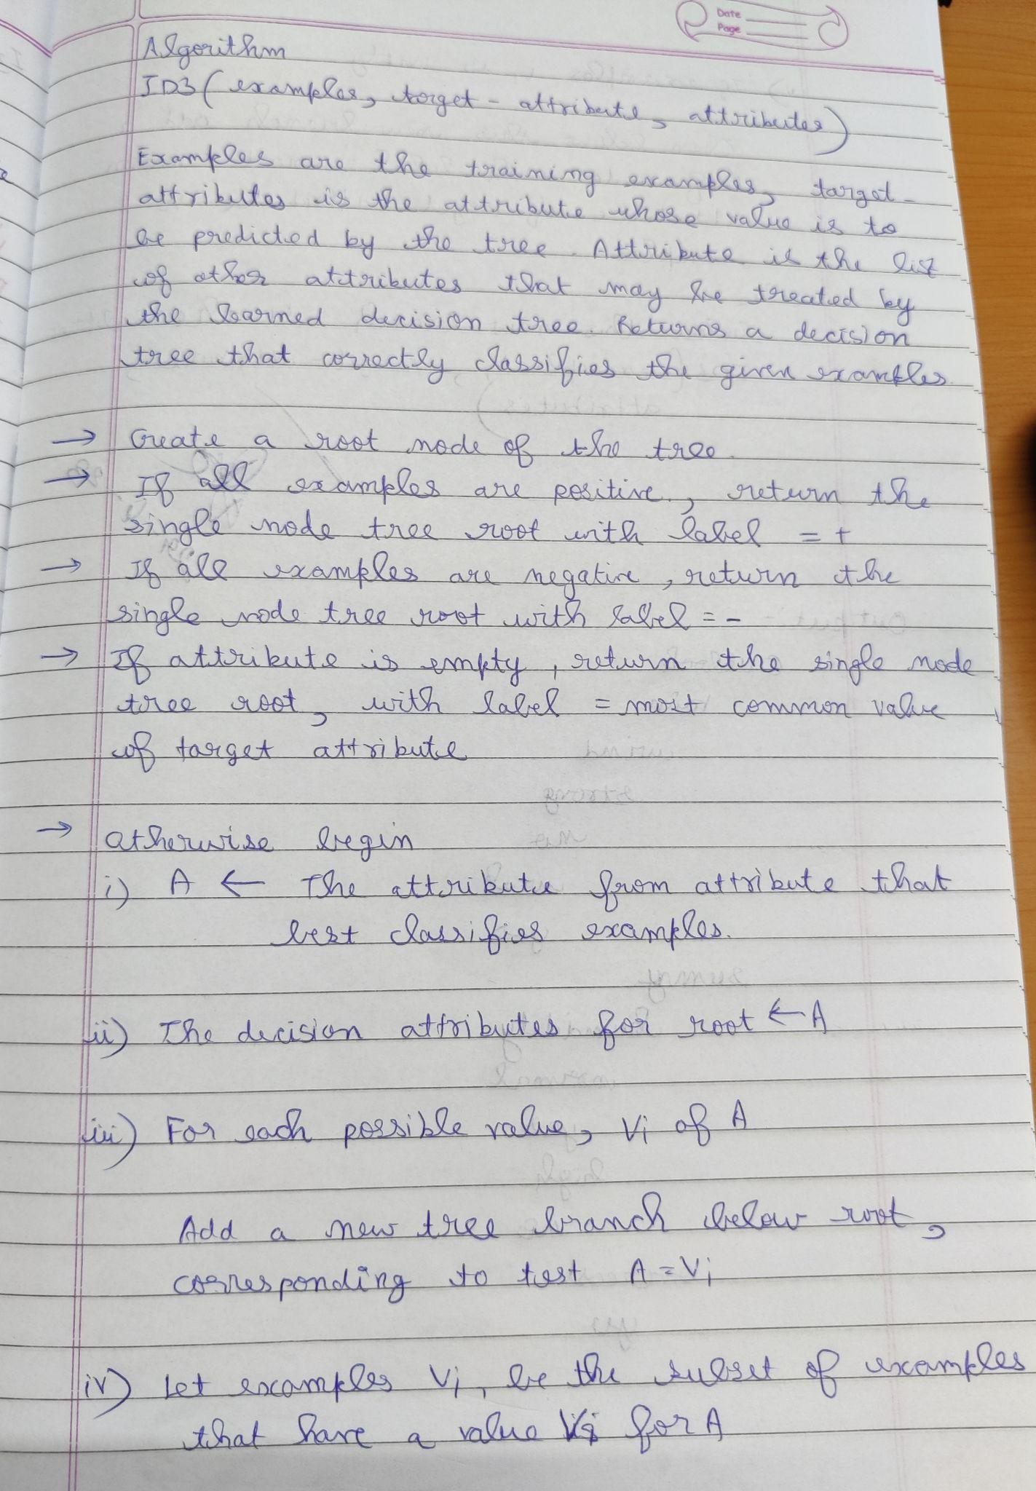

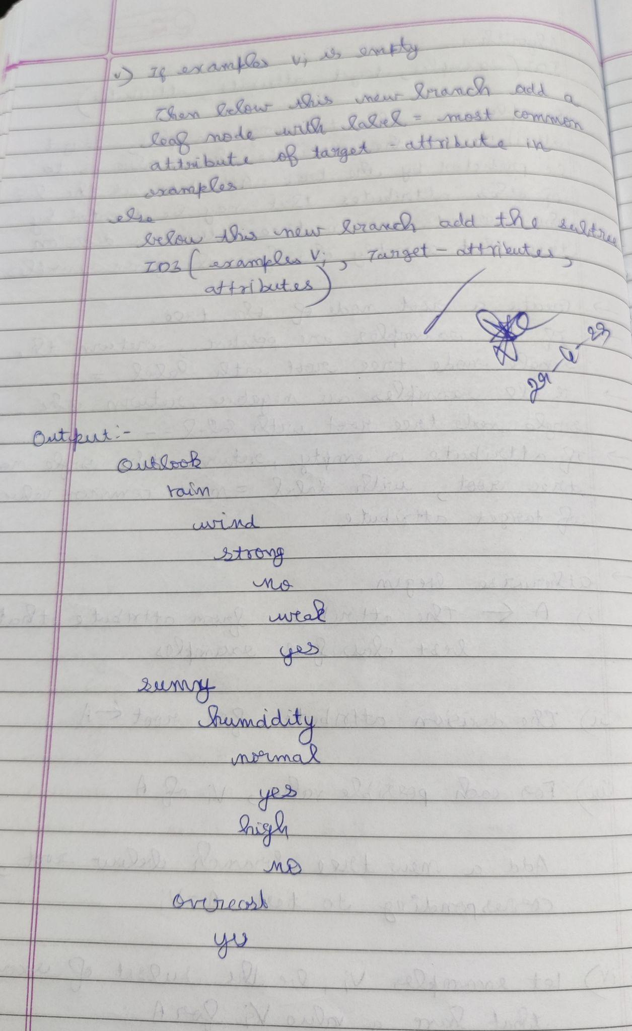

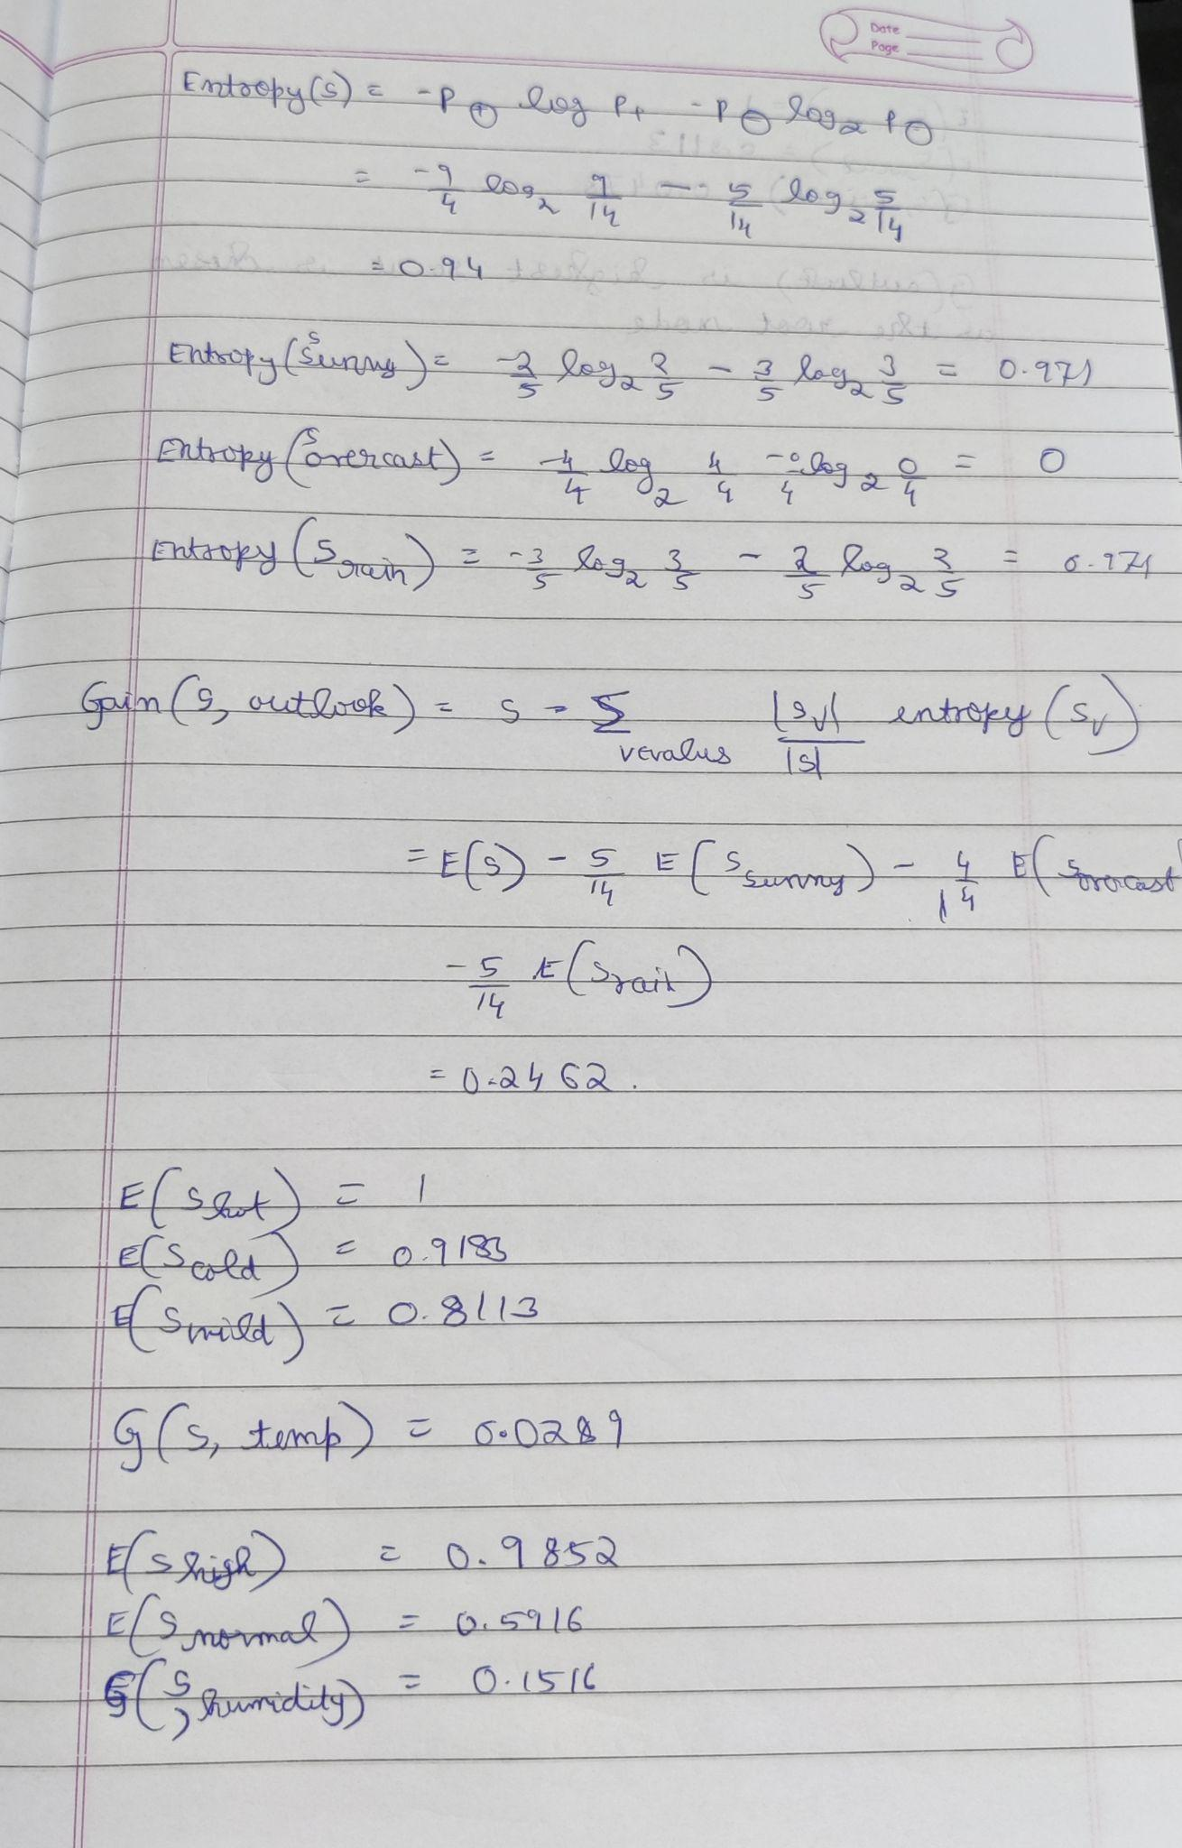

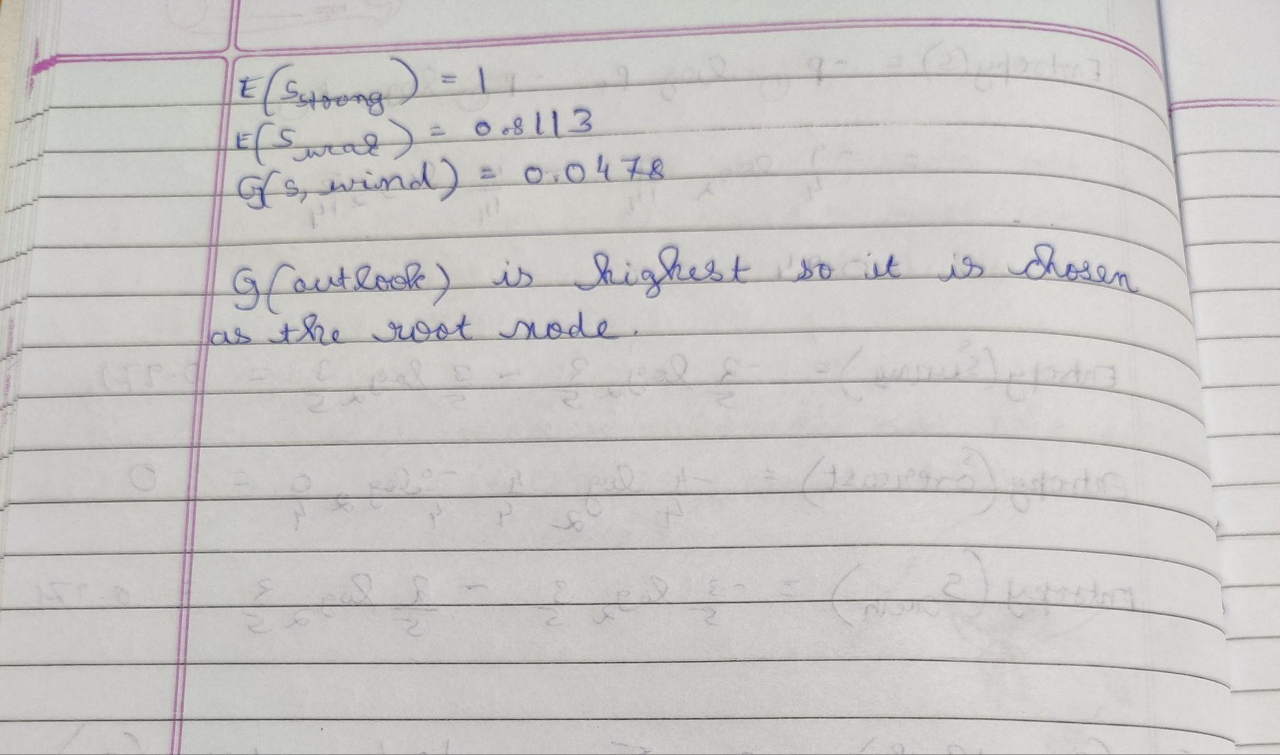

**Uploading CSV :**

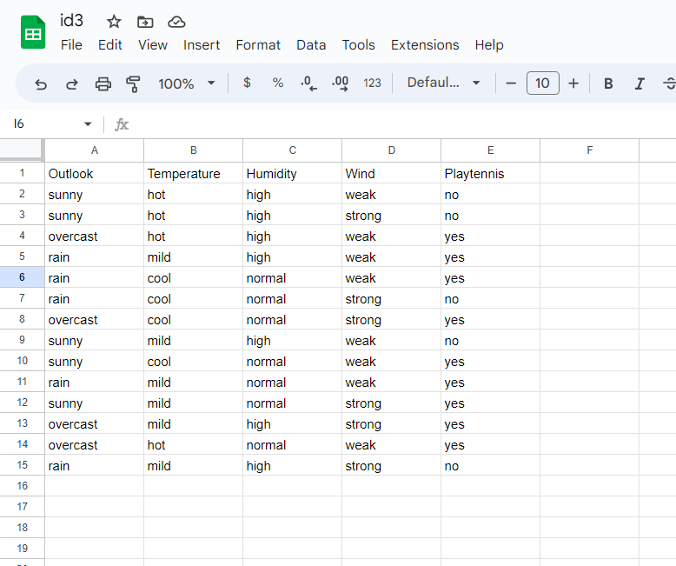

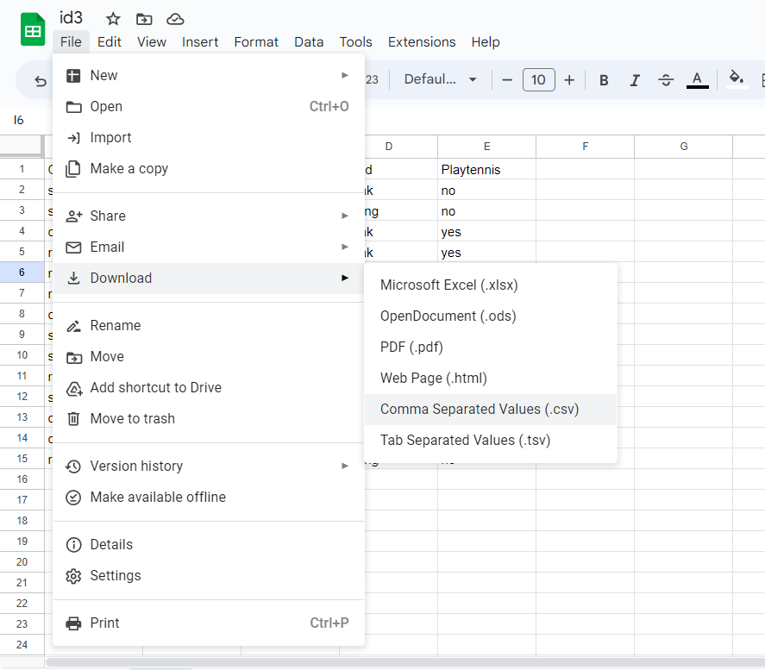

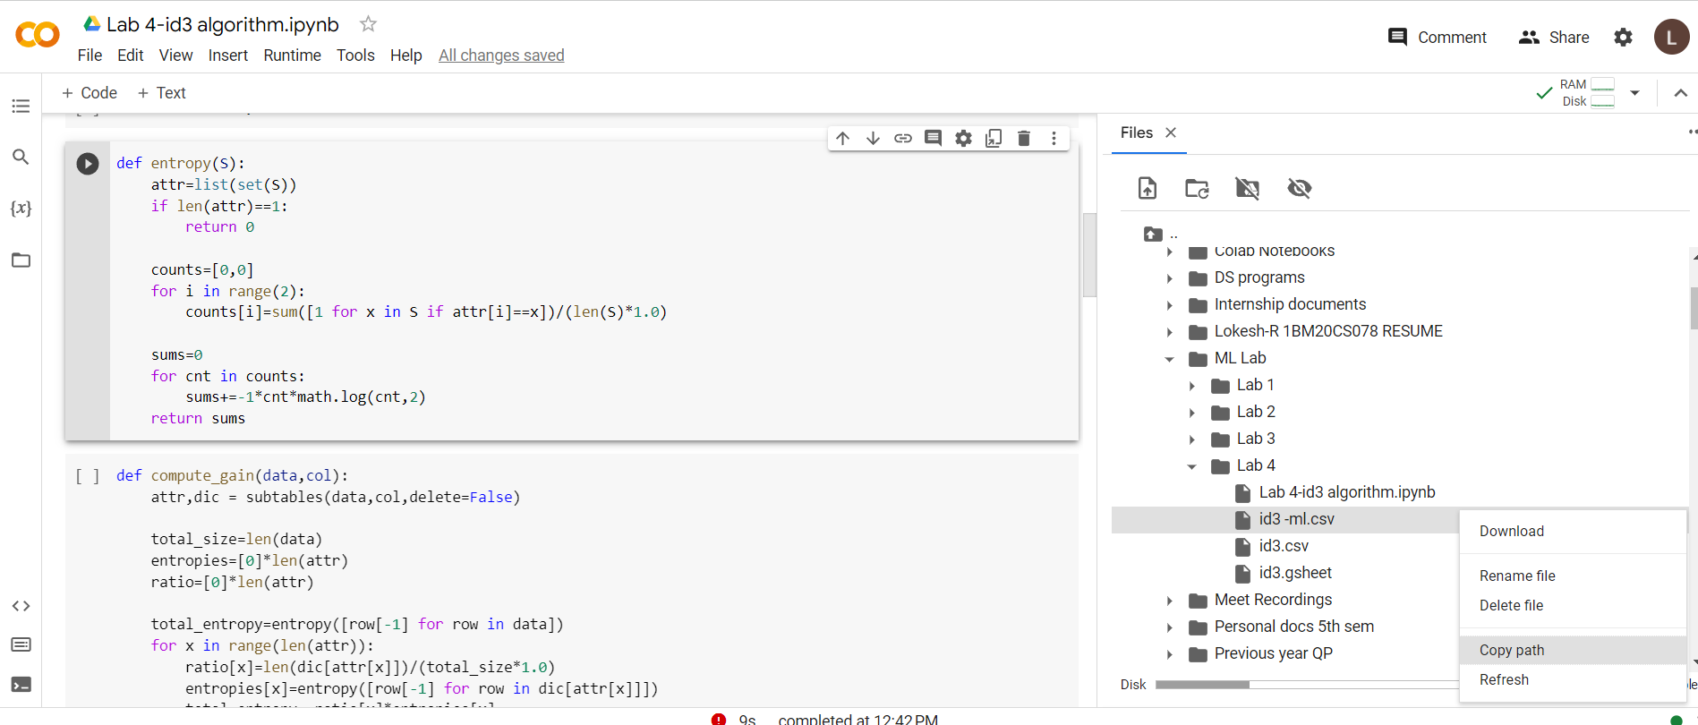

**Program execution -**

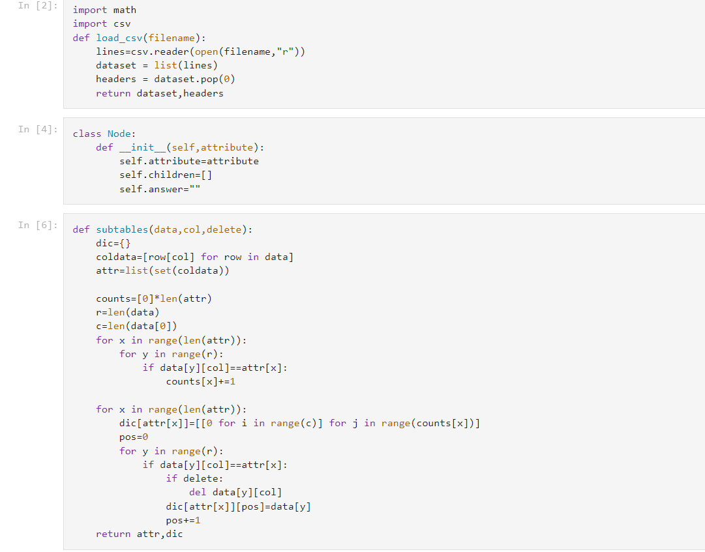

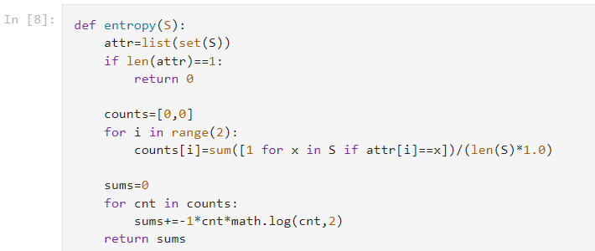

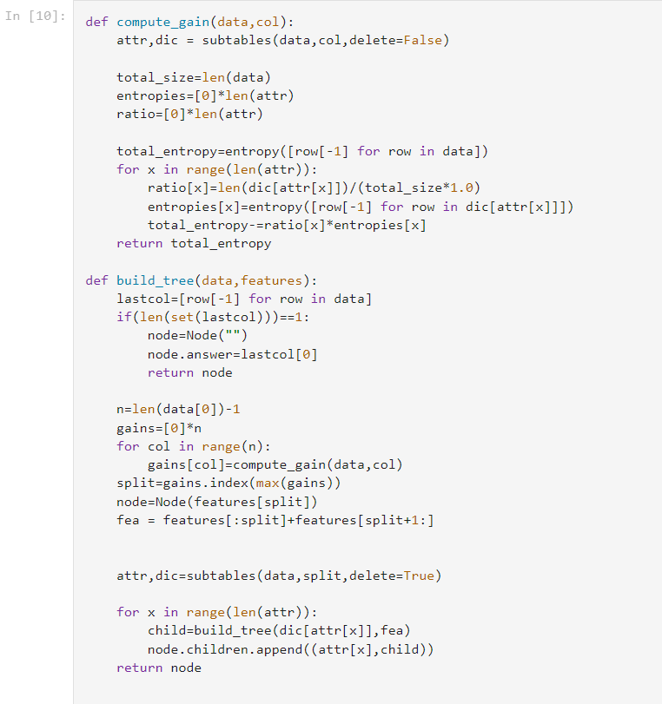

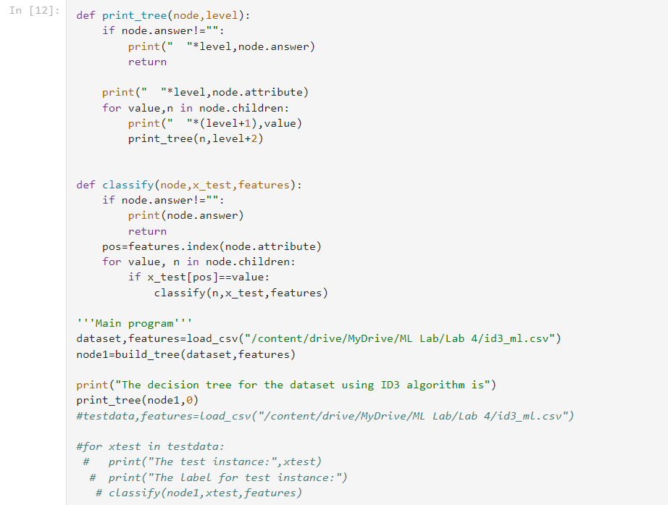

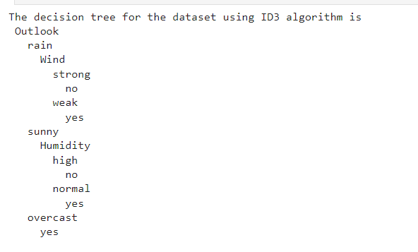

**Date:12-05-2023**

**Program-5: Linear regression**

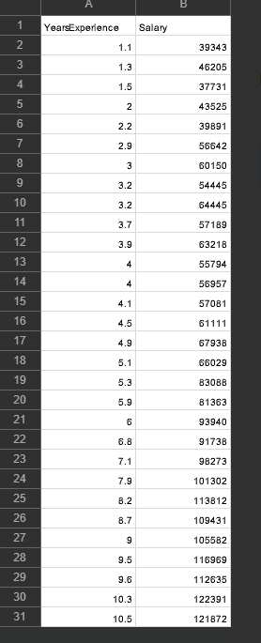

**Observation :**

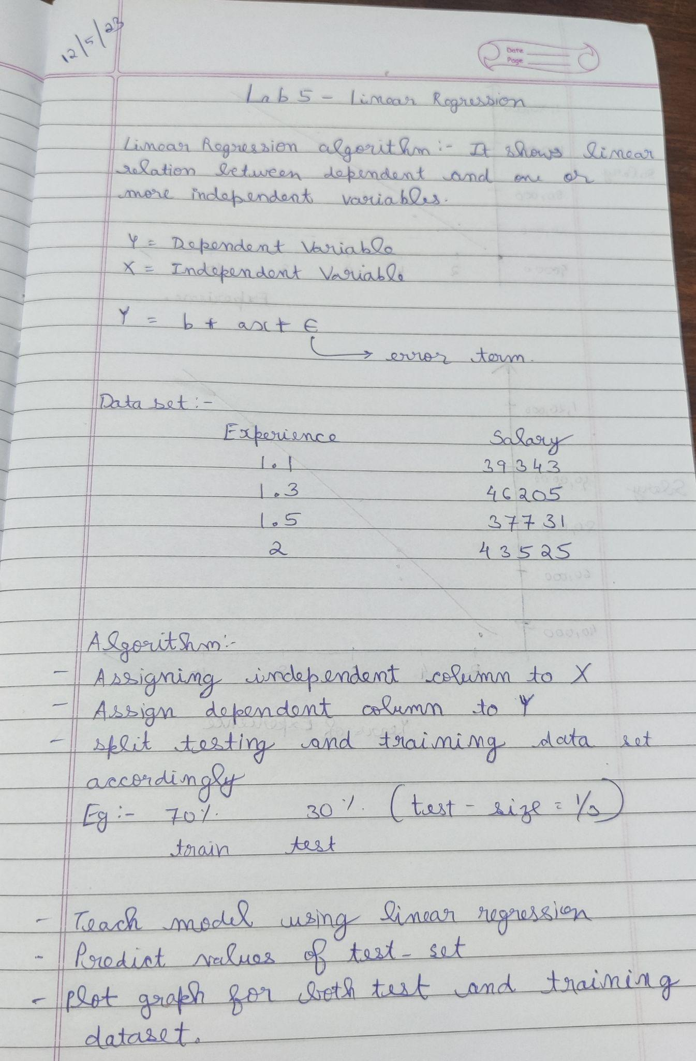

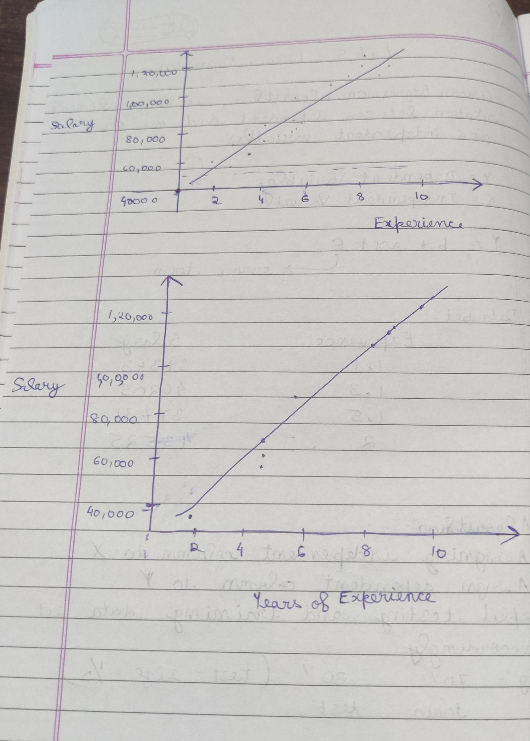

**Uploading CSV :**

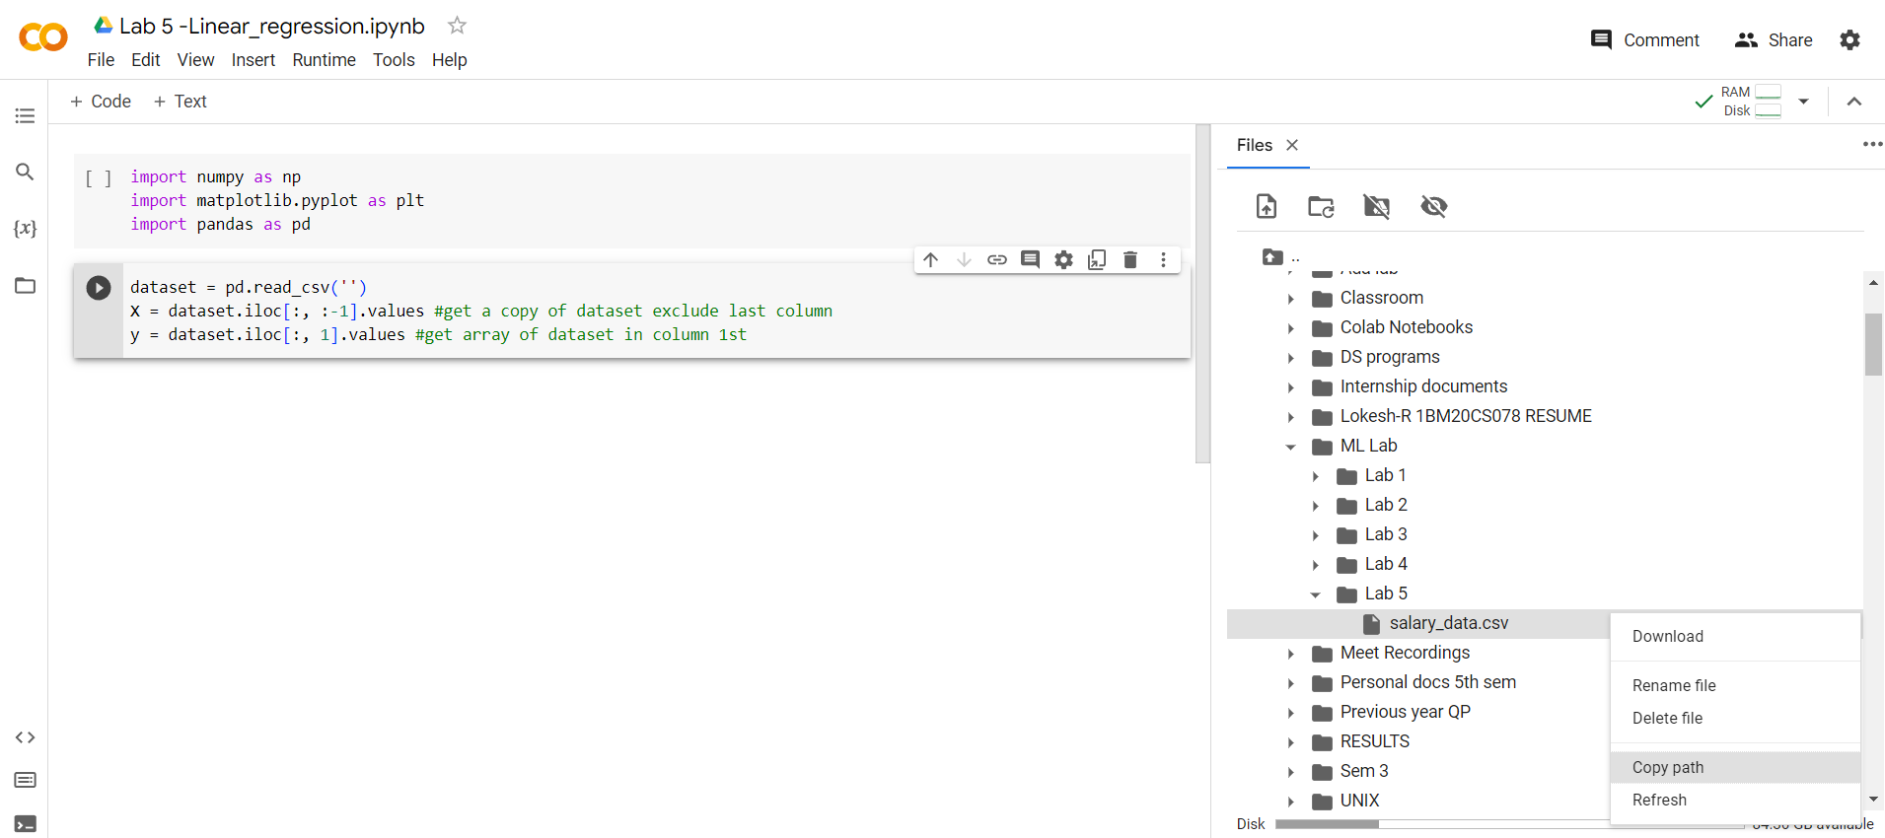

**Program execution-**

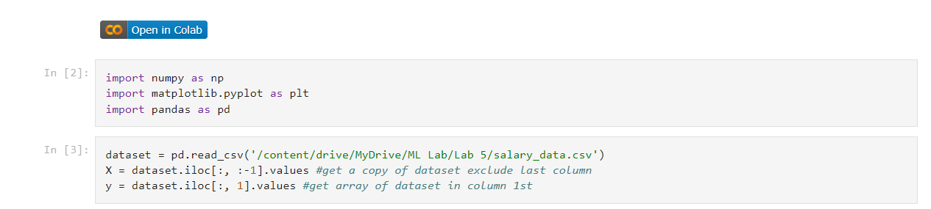

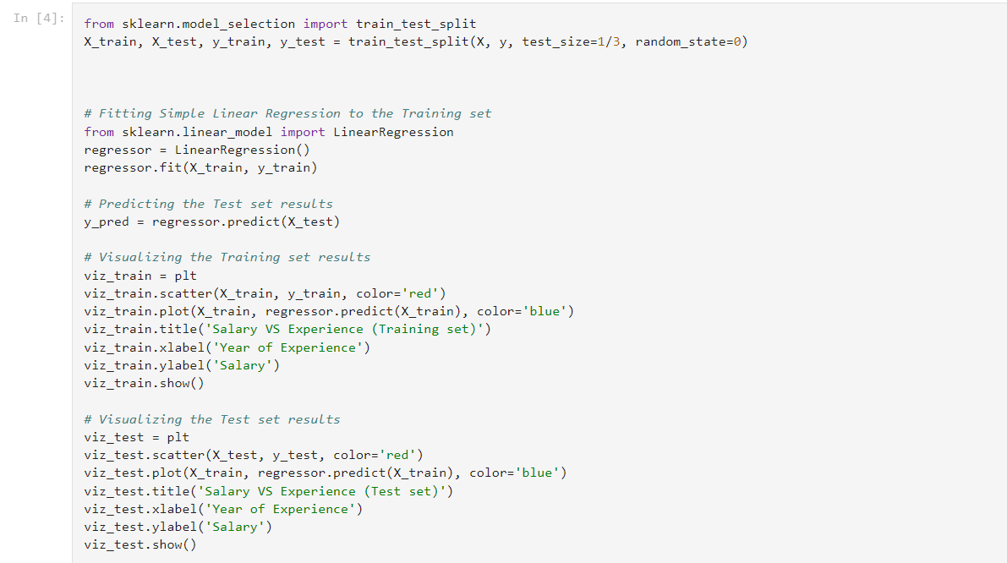

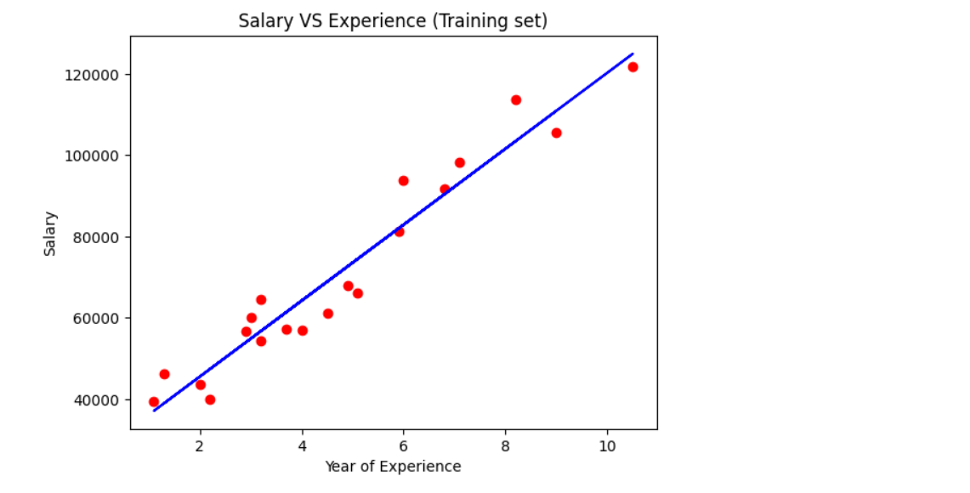

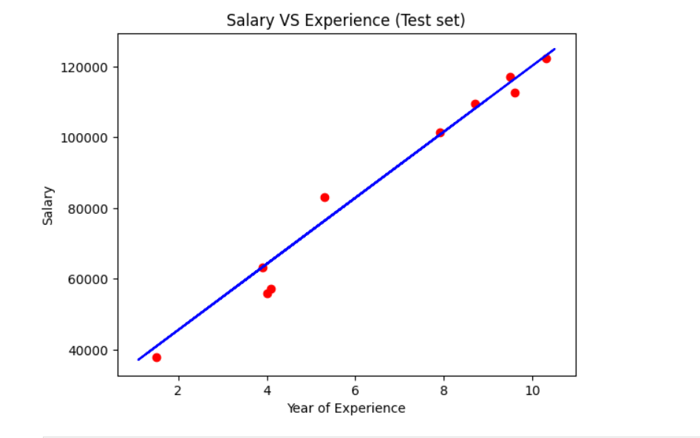

Date: 19.05.2023

**Program 6** – Write a program to construct a Bayesian network considering training data. Use this model to make predictions.

.

**Data set:** Climate Dataset

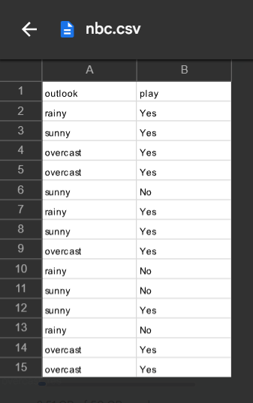

**Observation :**

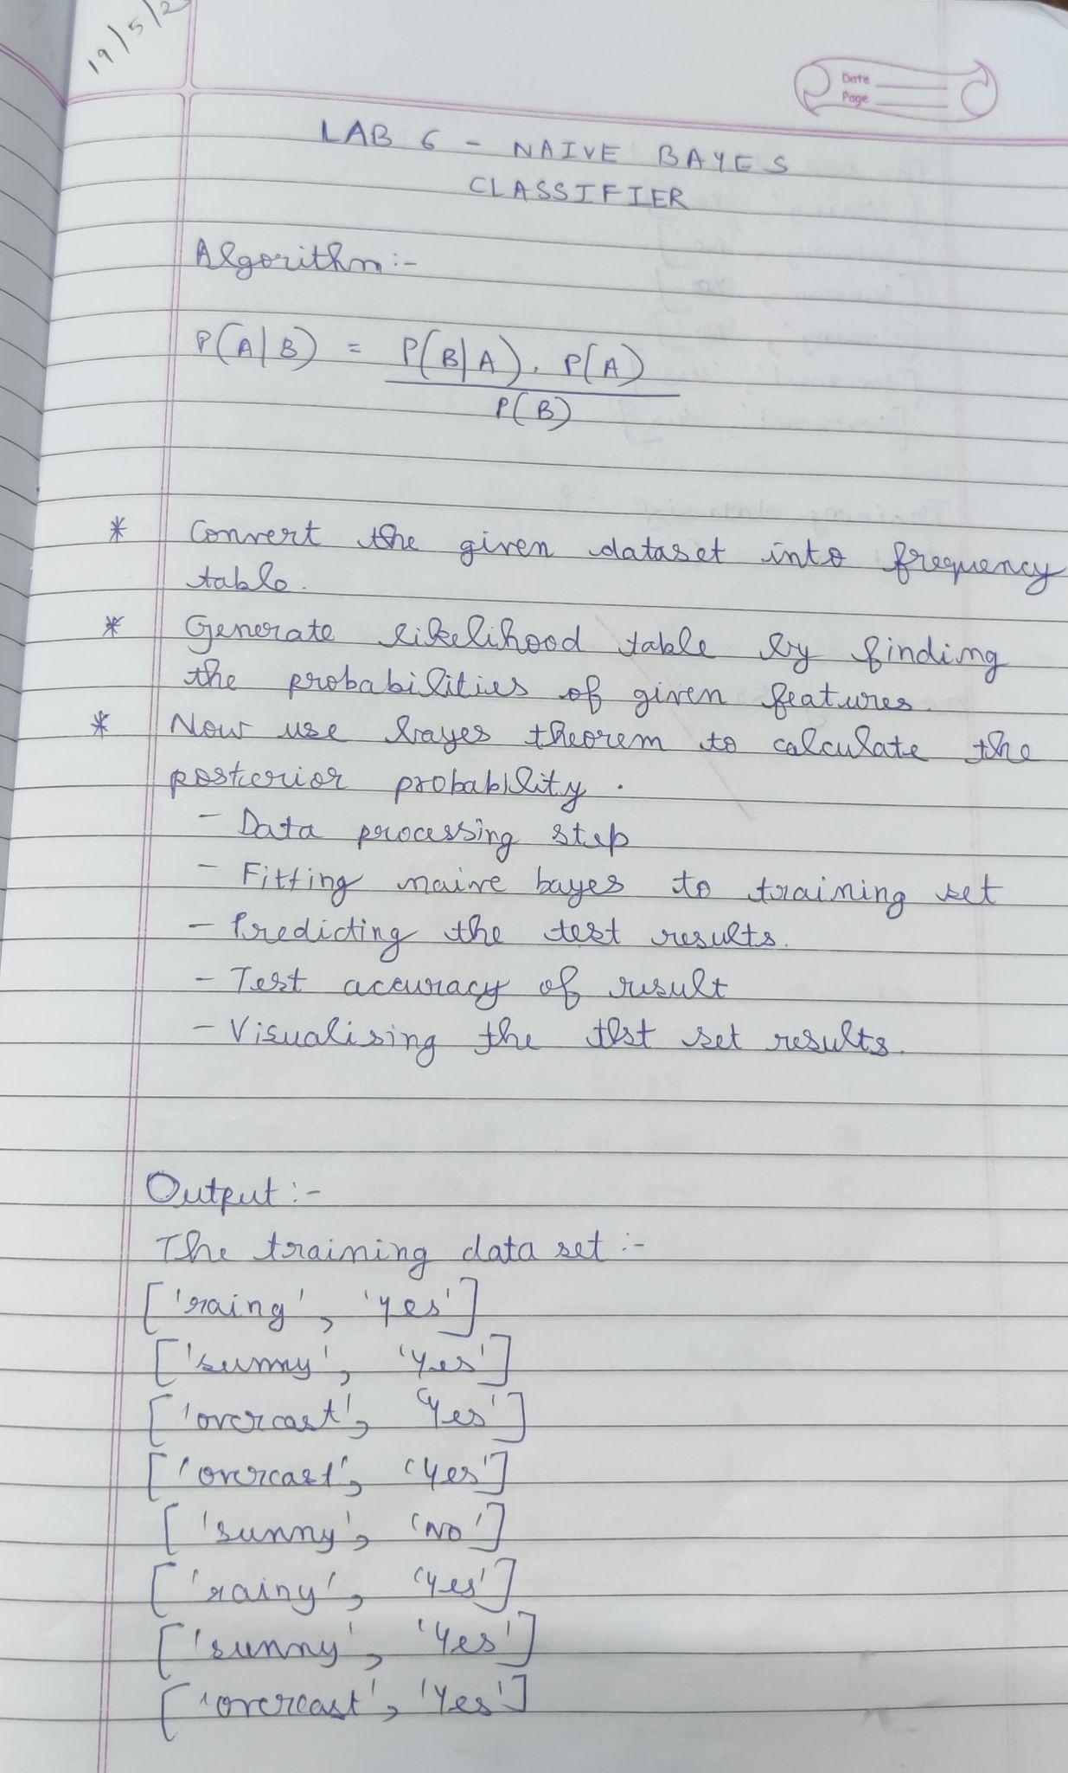

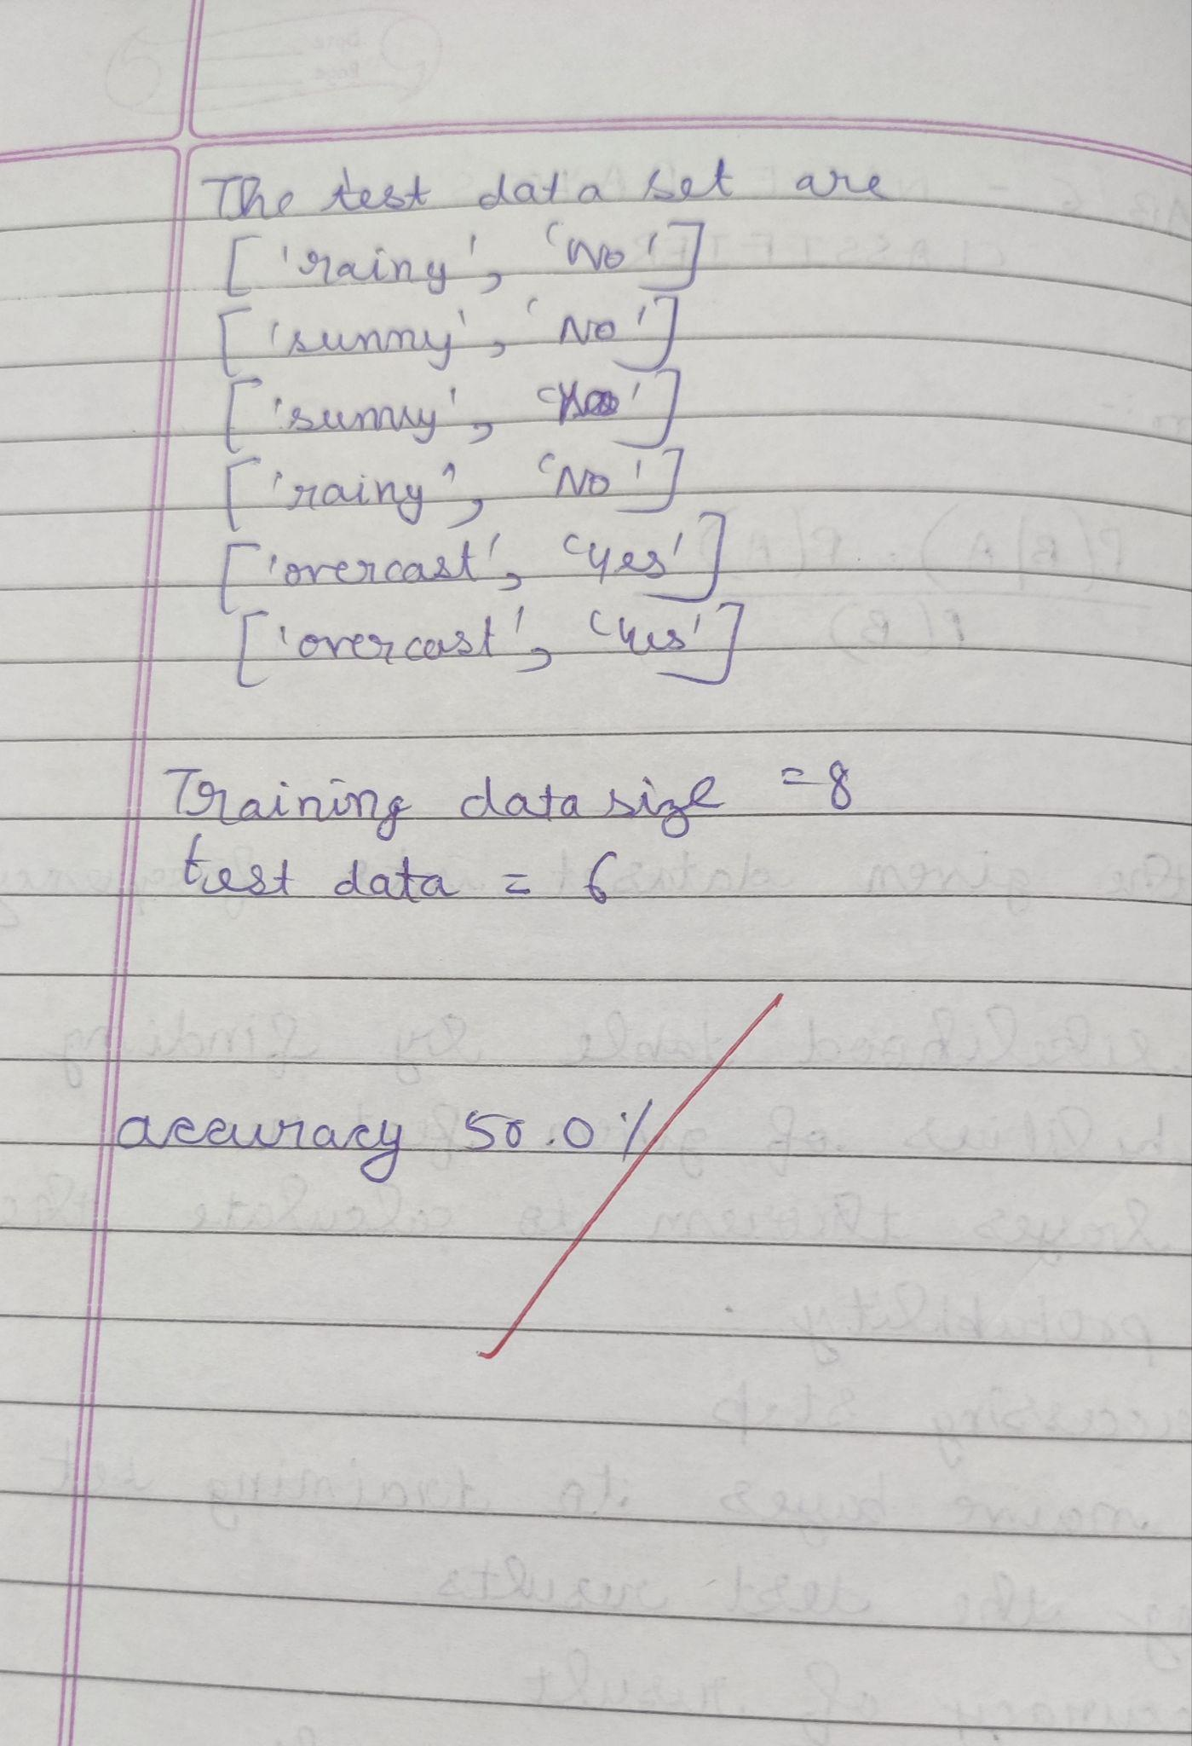

**Uploading csv file:**

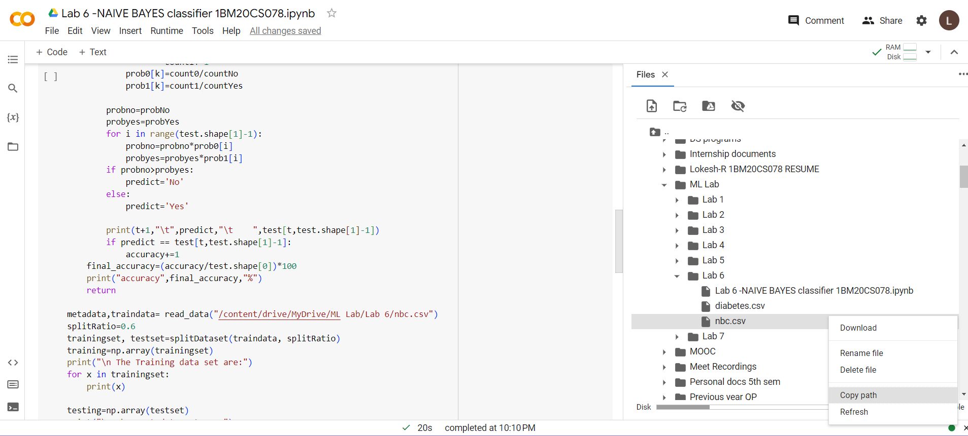

**Program execution-**

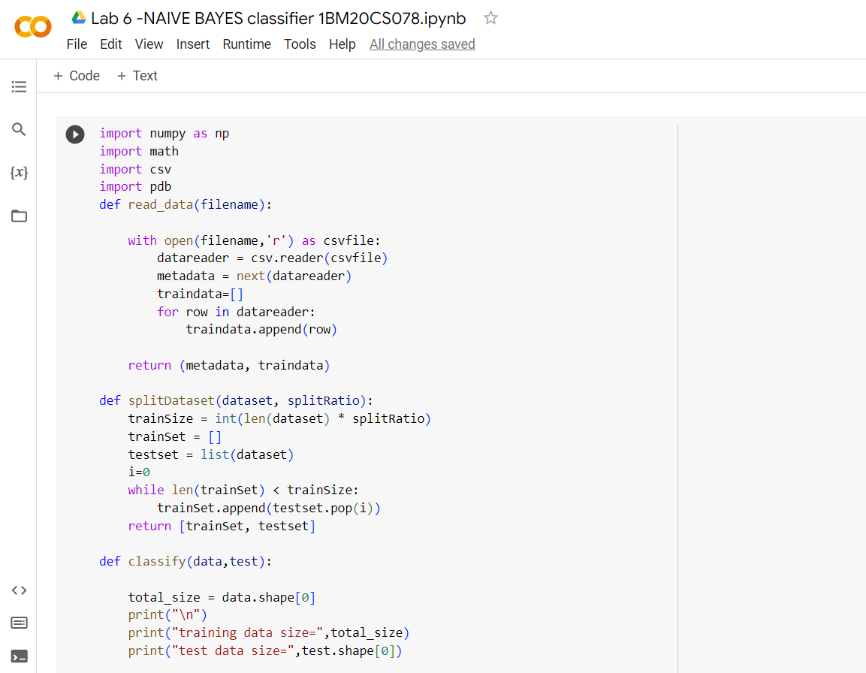

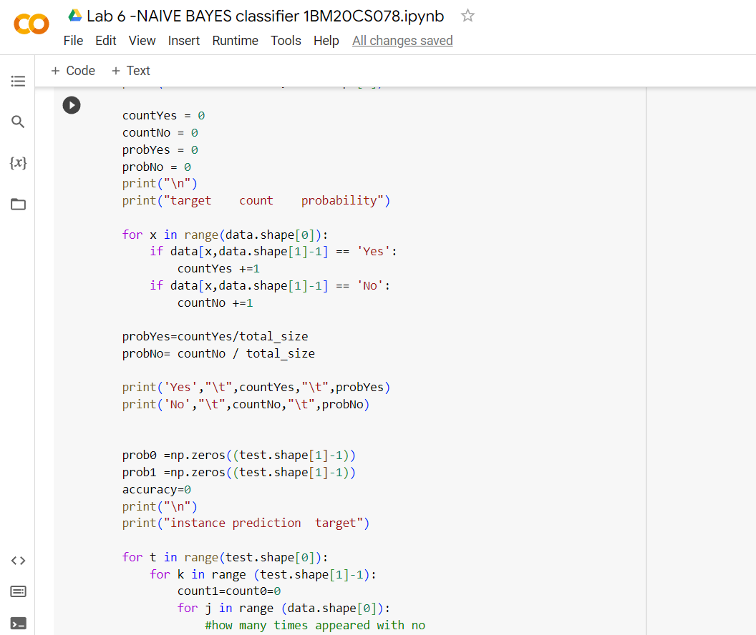

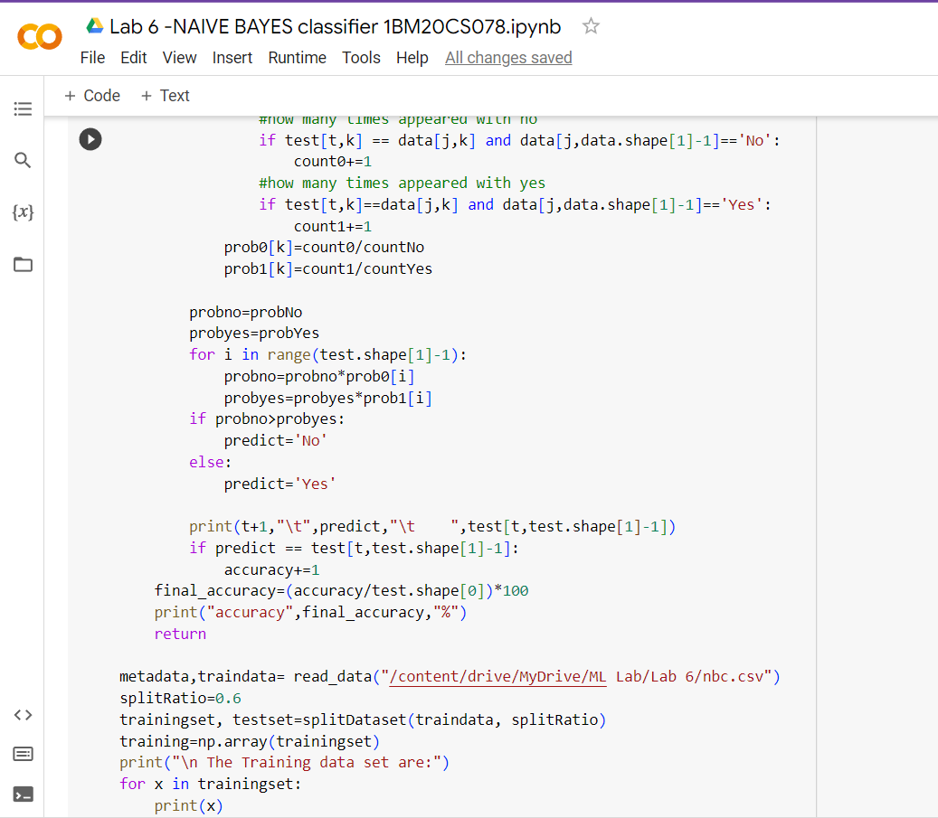

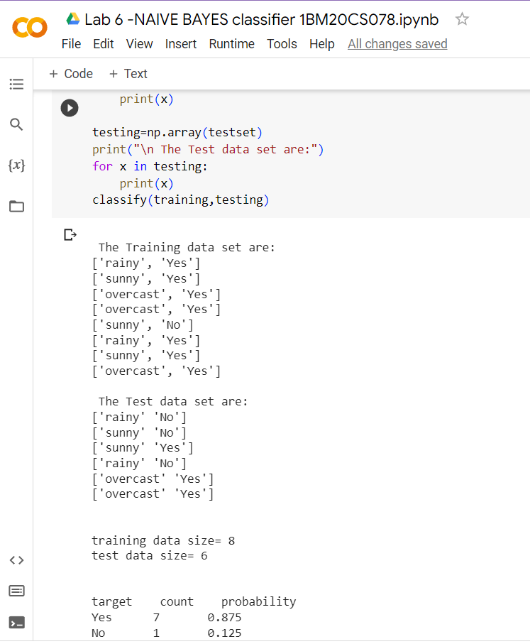

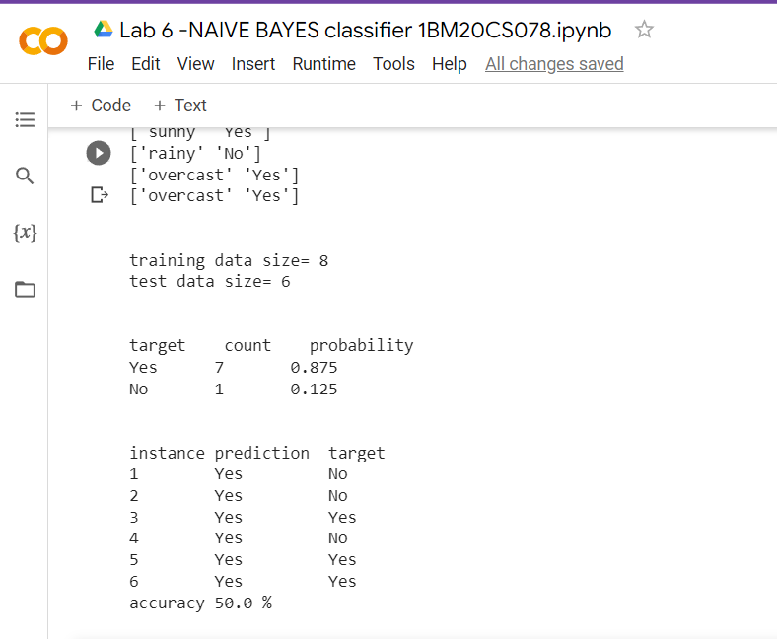

Date: 19.05.2023

**Program 7** – Apply k-Means algorithm to cluster a set of data stored in a .CSV file.

.

**Data set:**

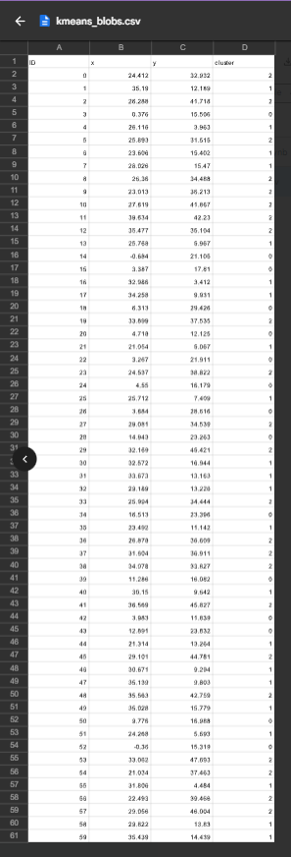

**Observation :**

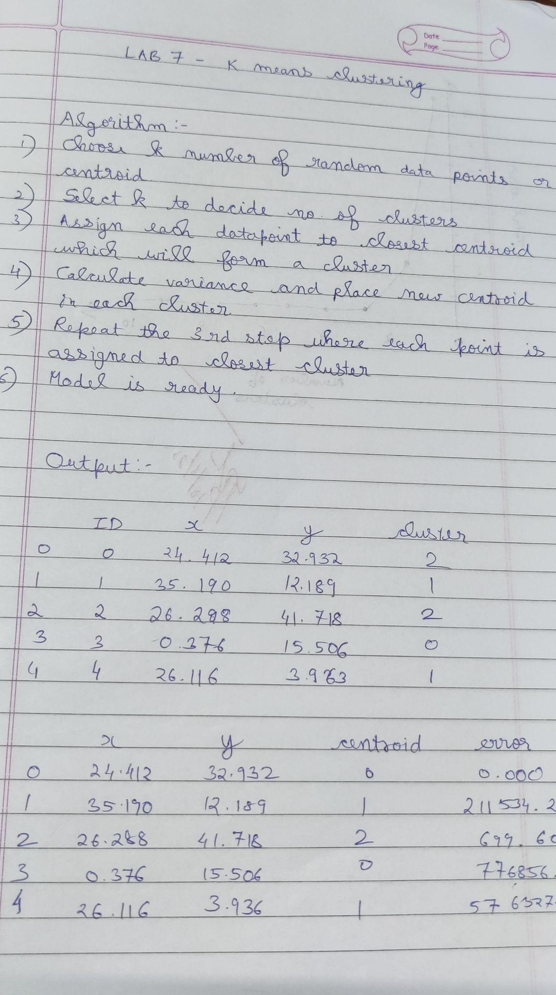

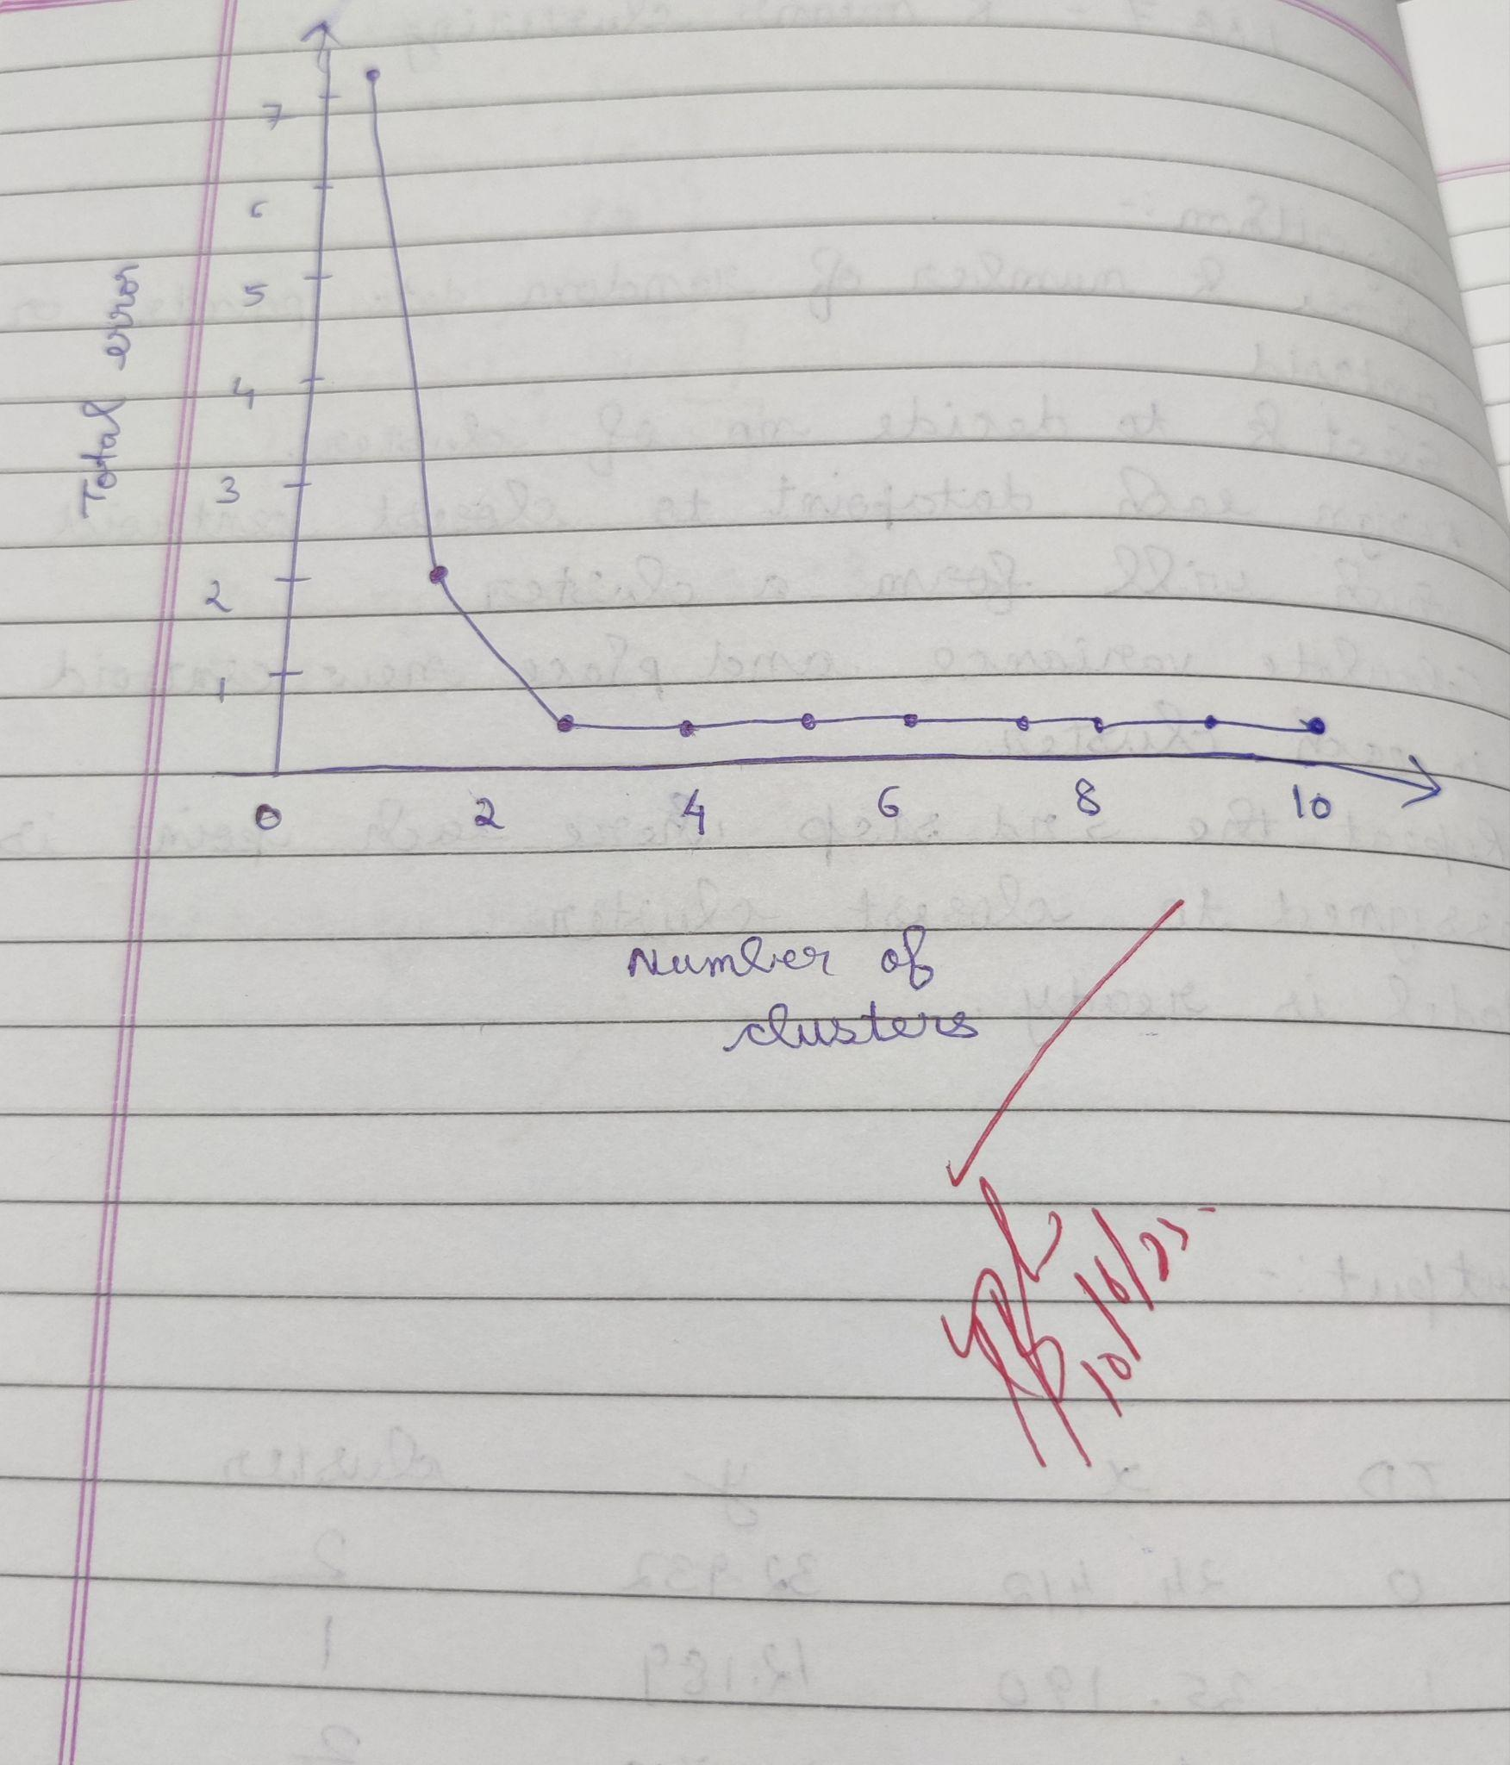

**Program execution:**

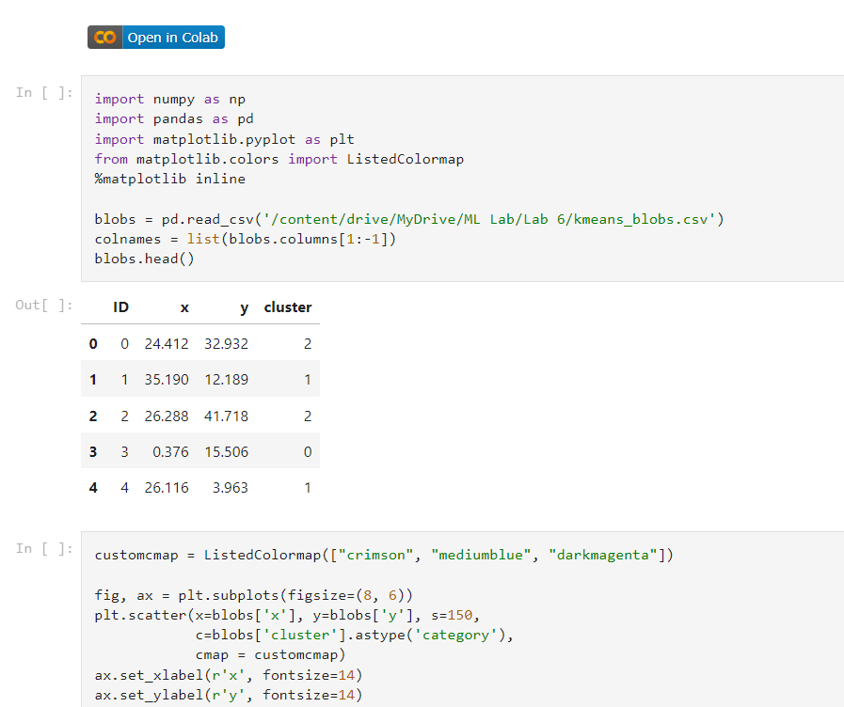

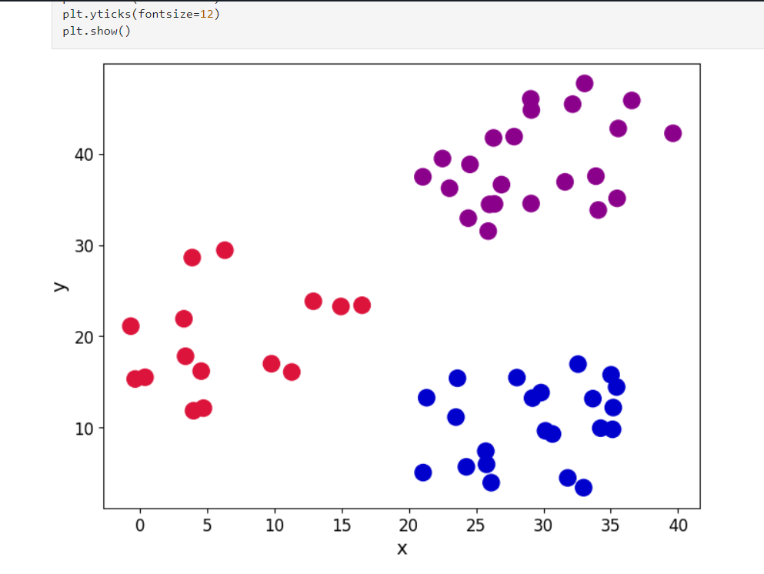

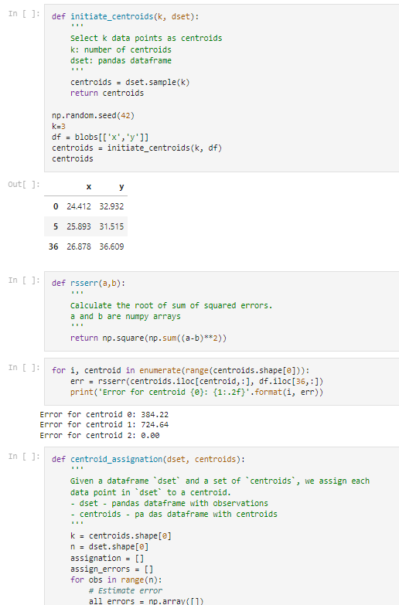

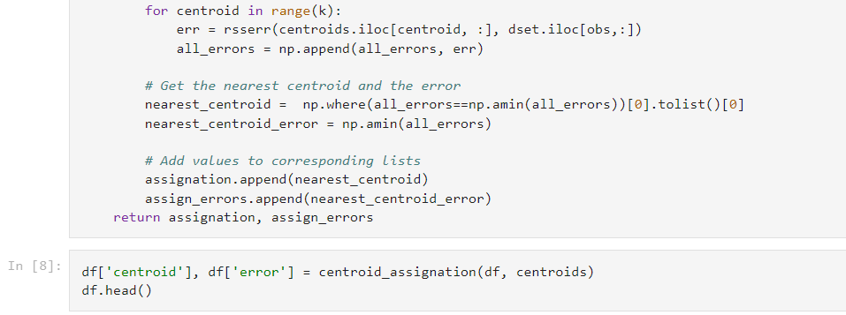

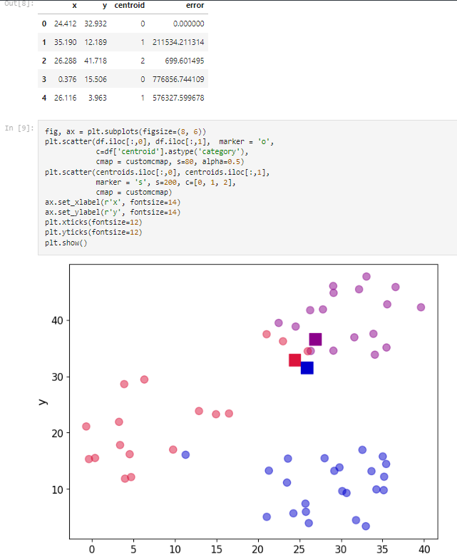

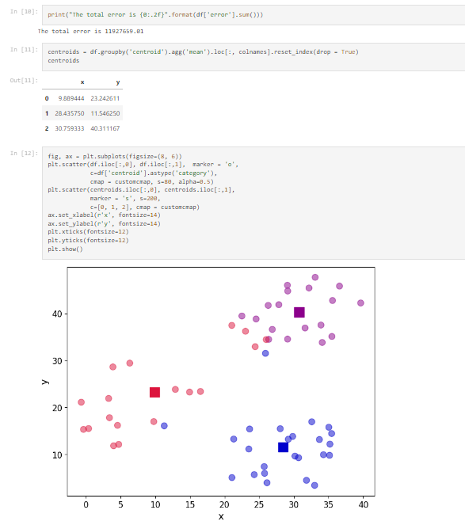

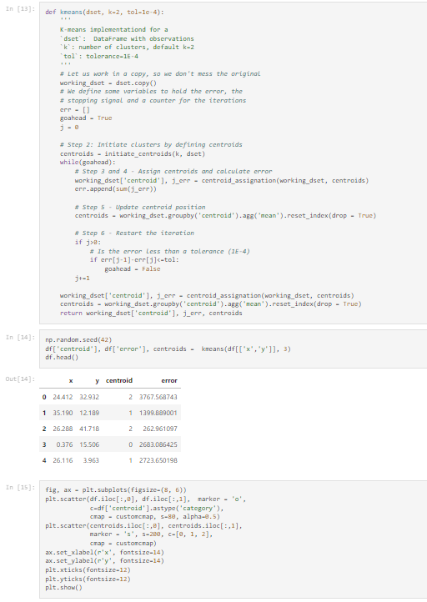

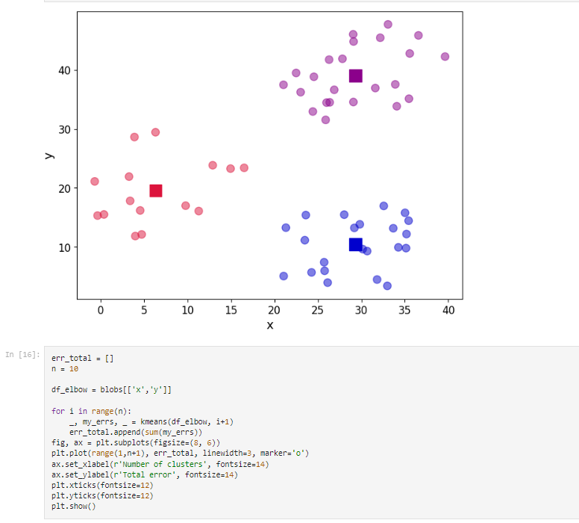

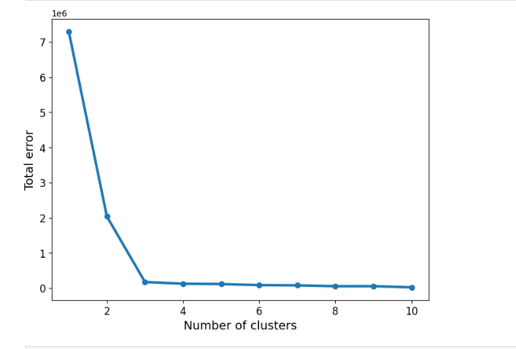

Date: 10.06.2023

**Program 8** – Apply EM algorithm to cluster a set of data stored in a .CSV file. Compare the results of k-Means algorithm and EM algorithm.

.

**Data set:** Iris Dataset

**Observation:**

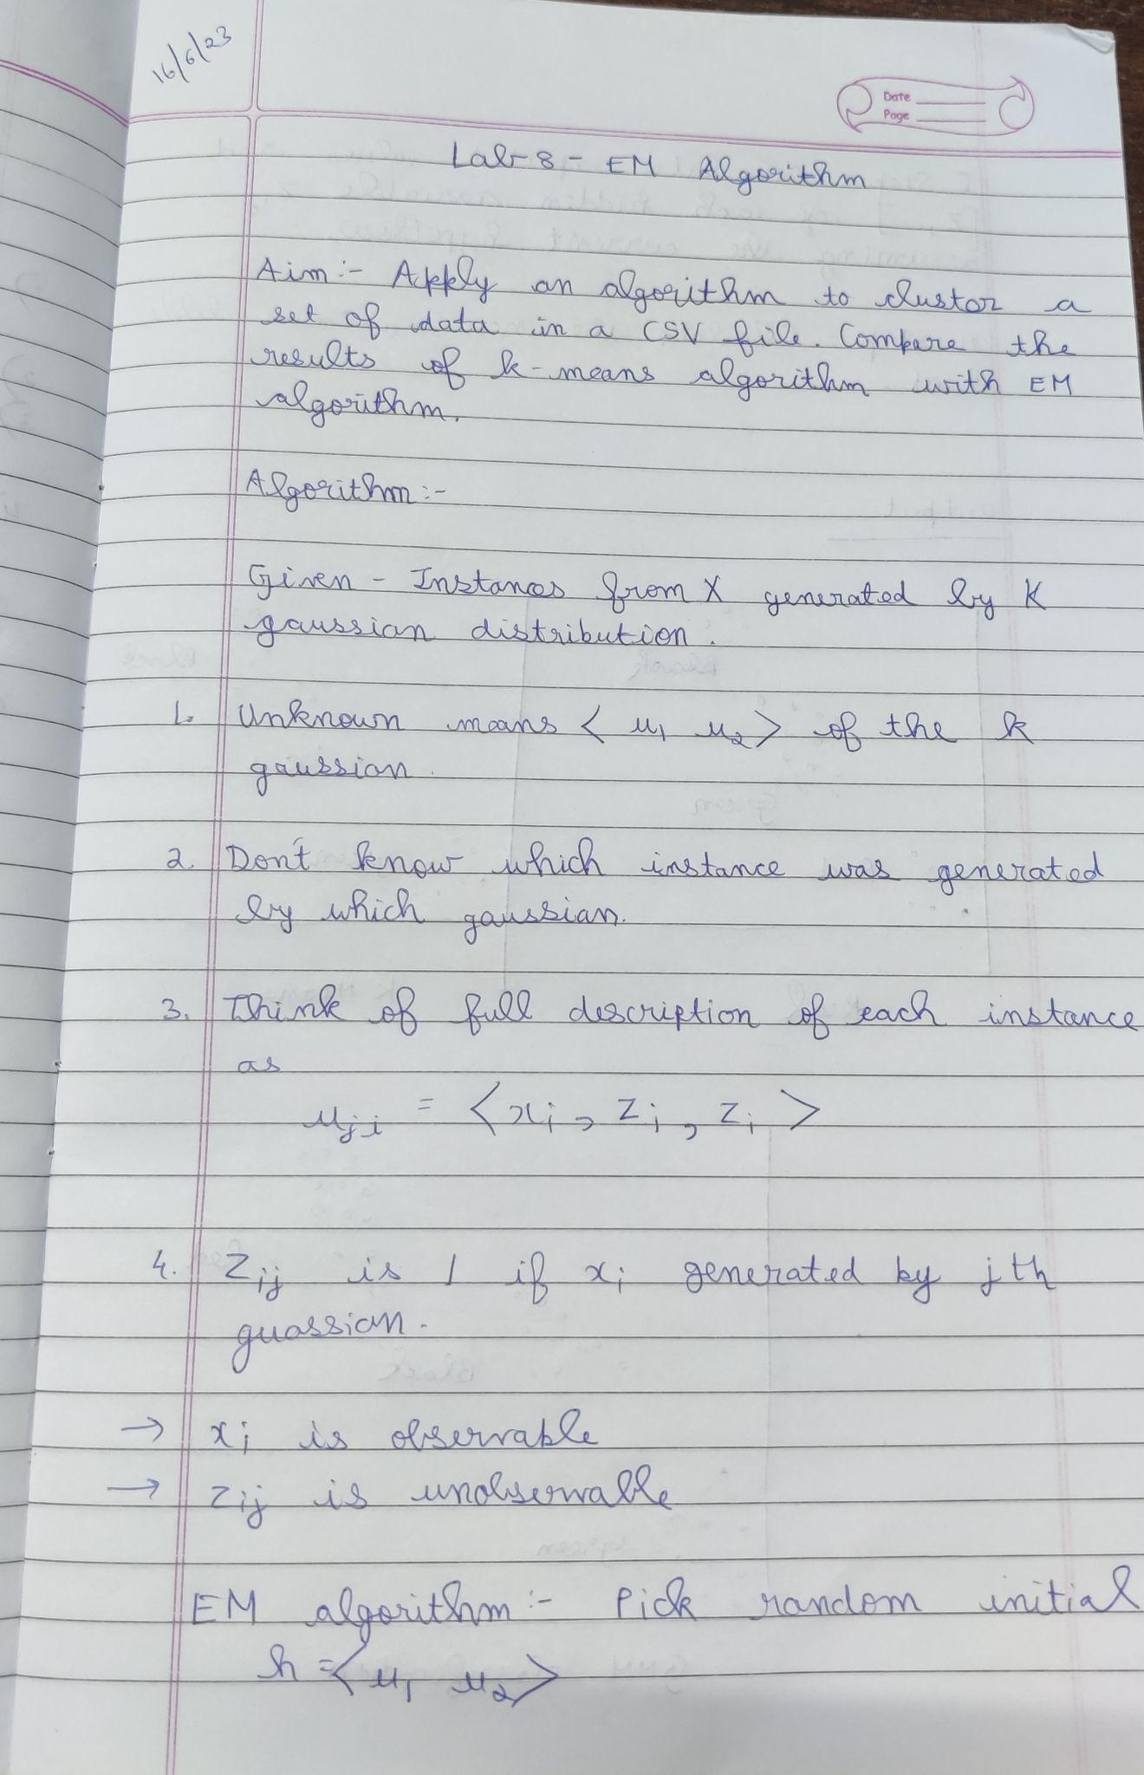

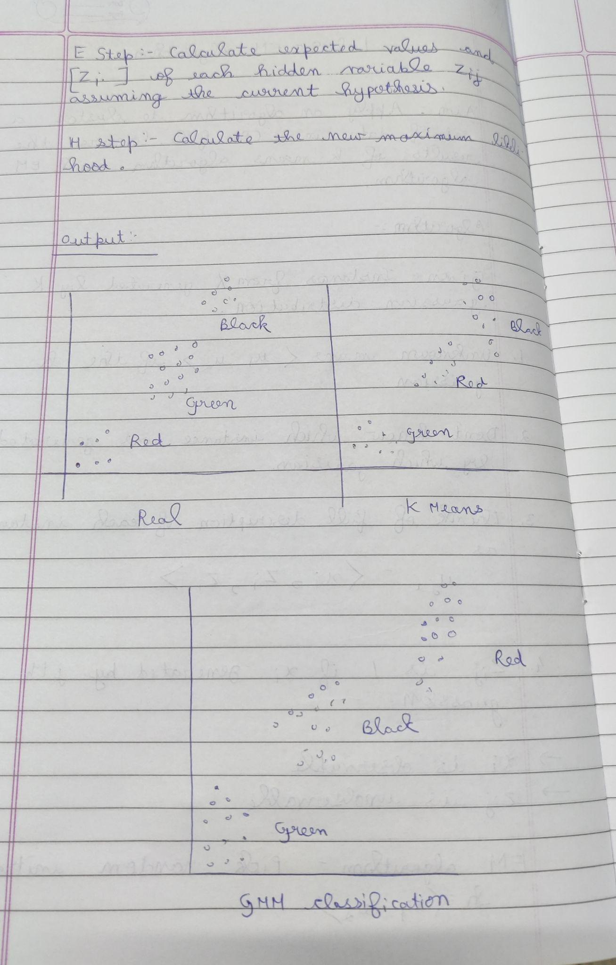

Program execution :

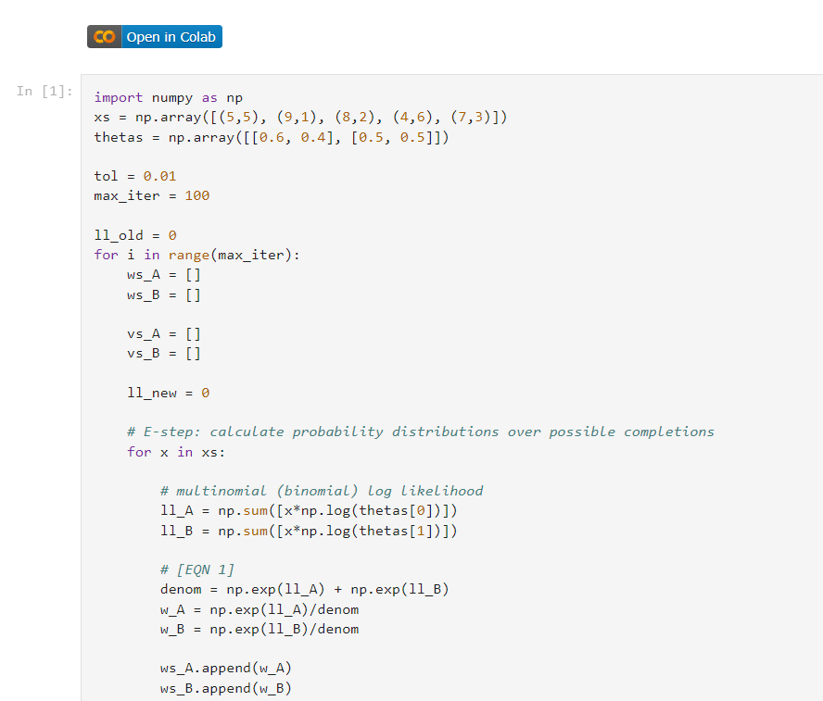

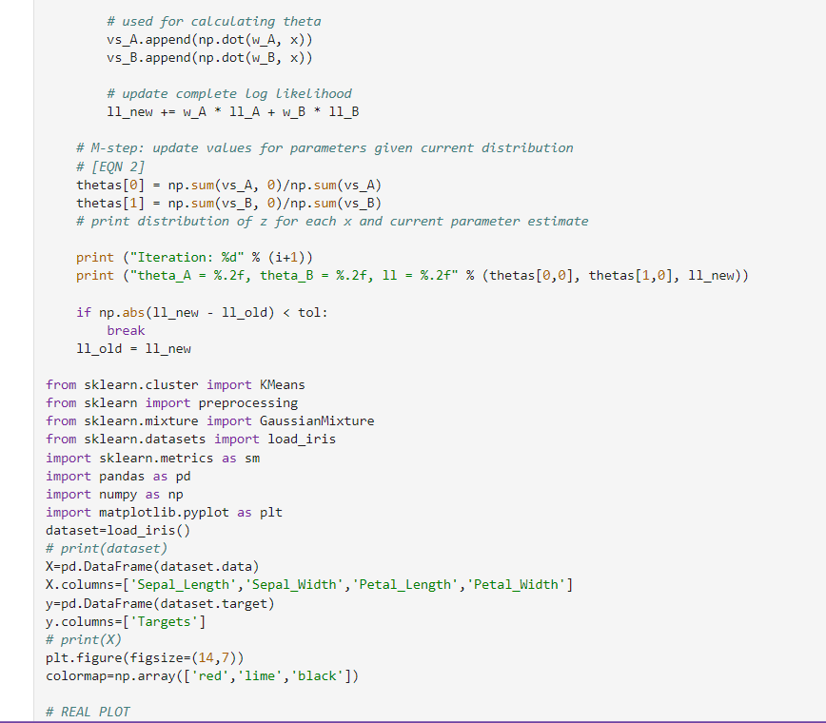

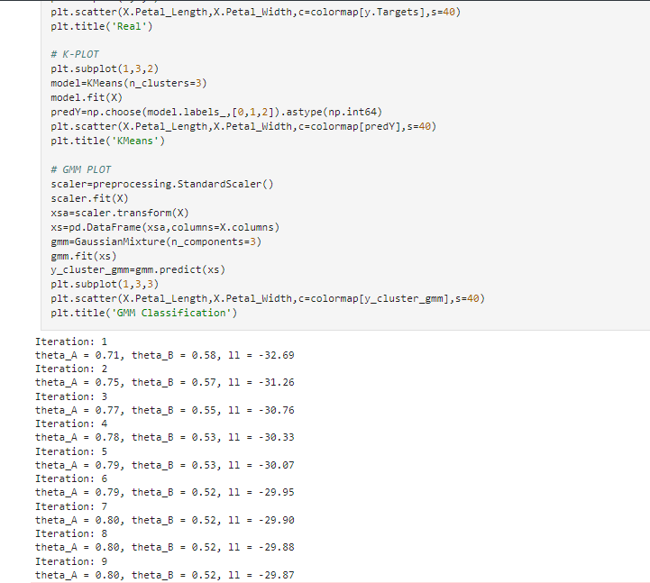

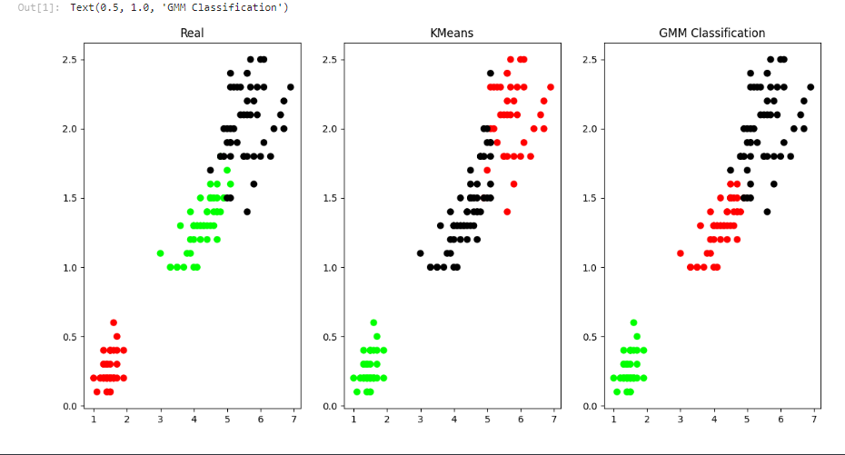

**17.06.2023**

**Program 9: Write a program to construct a Bayesian Network considering training data.**

**Use this model to make predictions.**

**Dataset-heart**

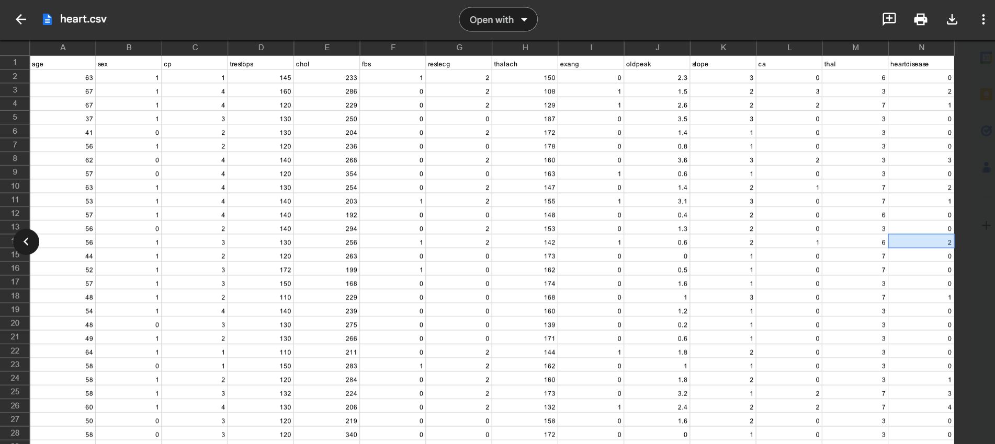

**Algorithm :**

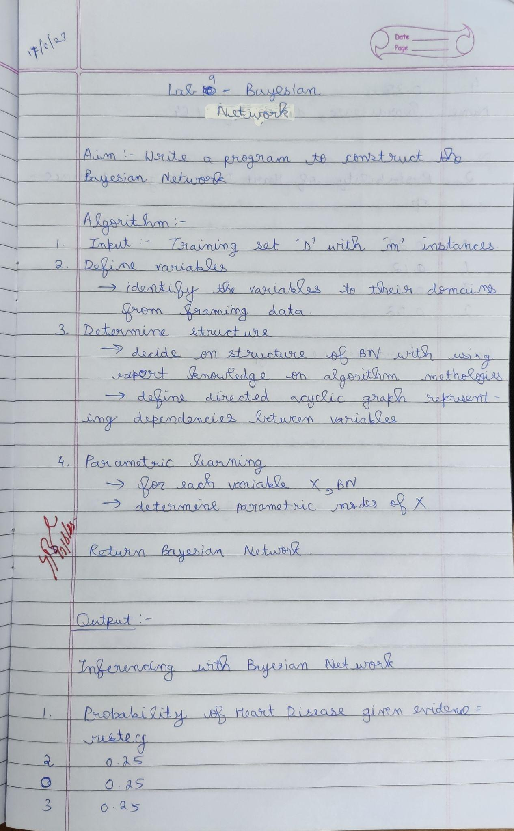

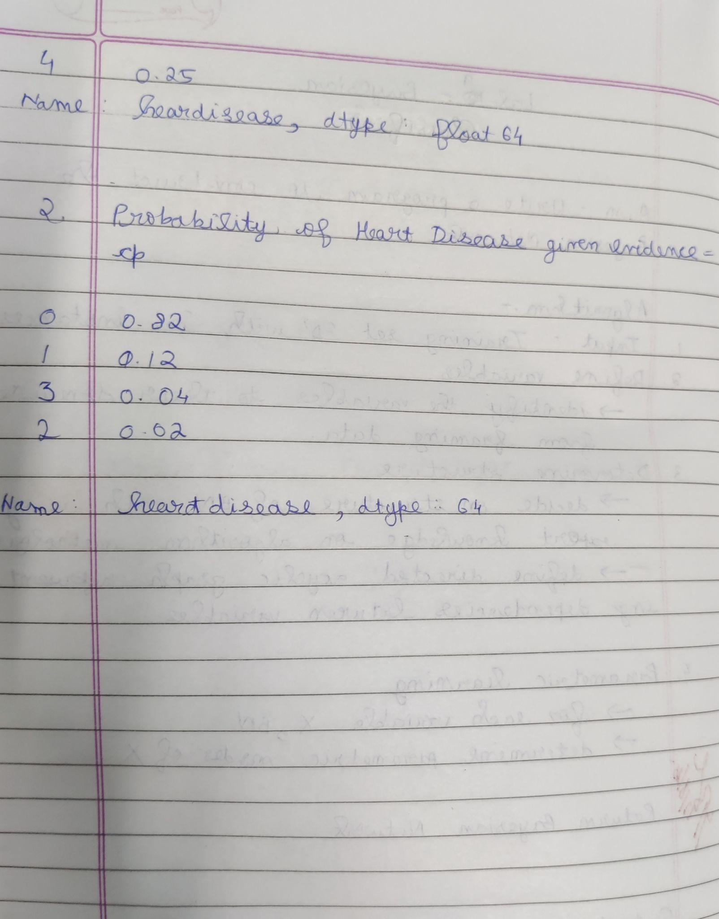

**Uploading csv :**

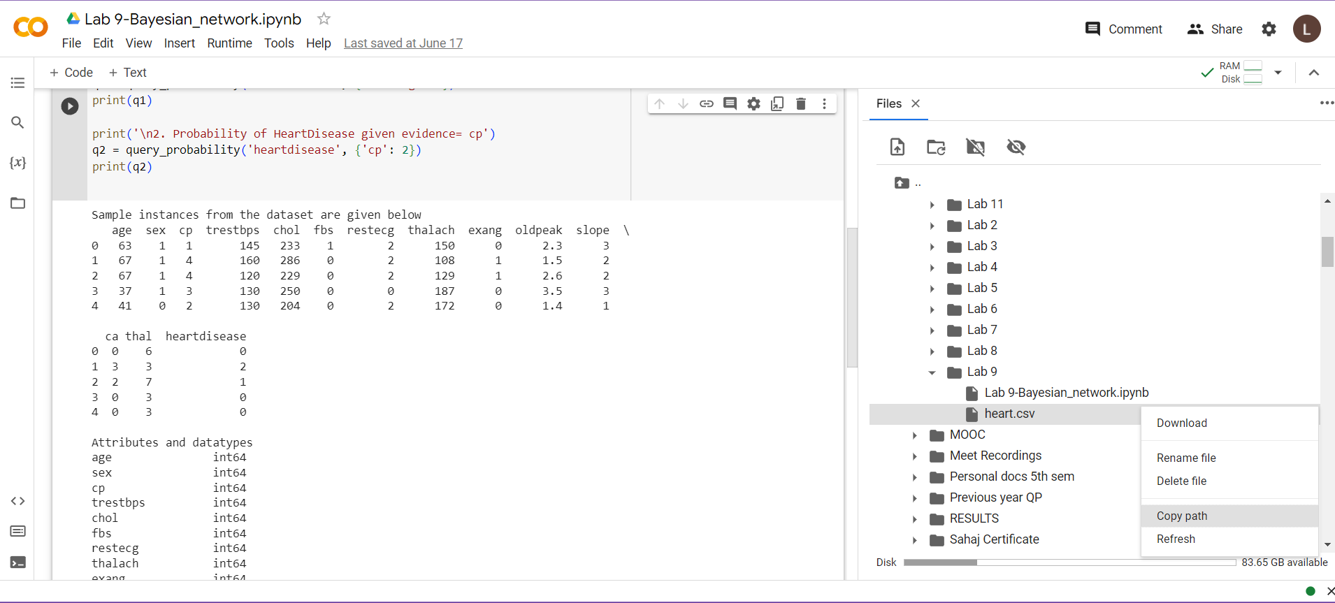

**Program execution :**

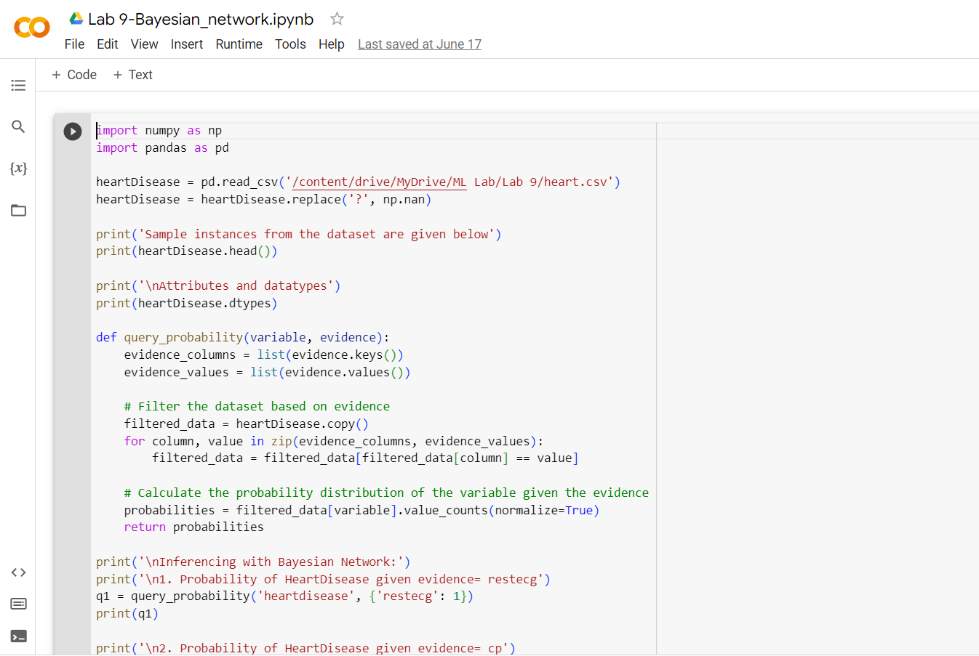

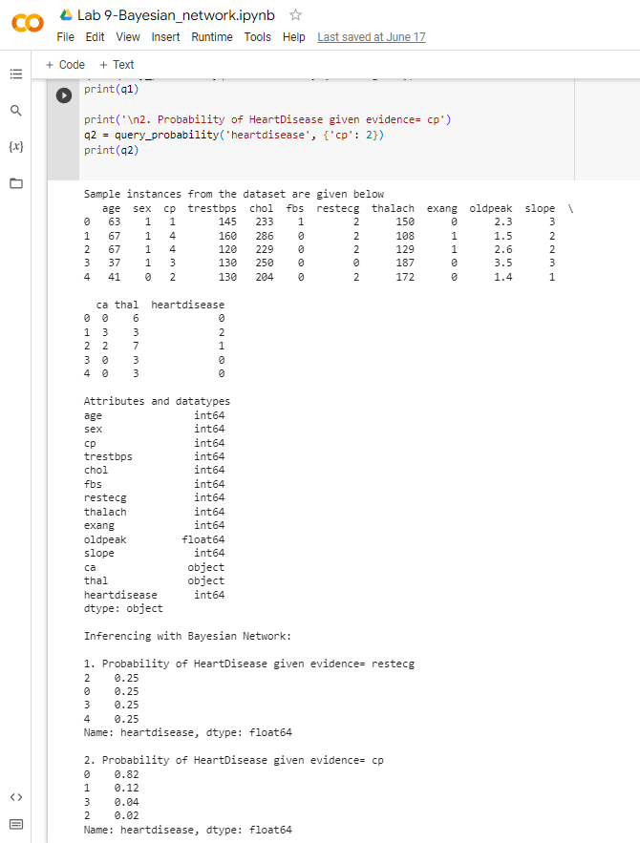

Date: 17.06.2023

**Program 10**– Write a program to implement k-Nearest Neighbour algorithm to classify the iris data set. Print both correct and wrong predictions.

**Data set:** Iris Dataset

Algorithm :

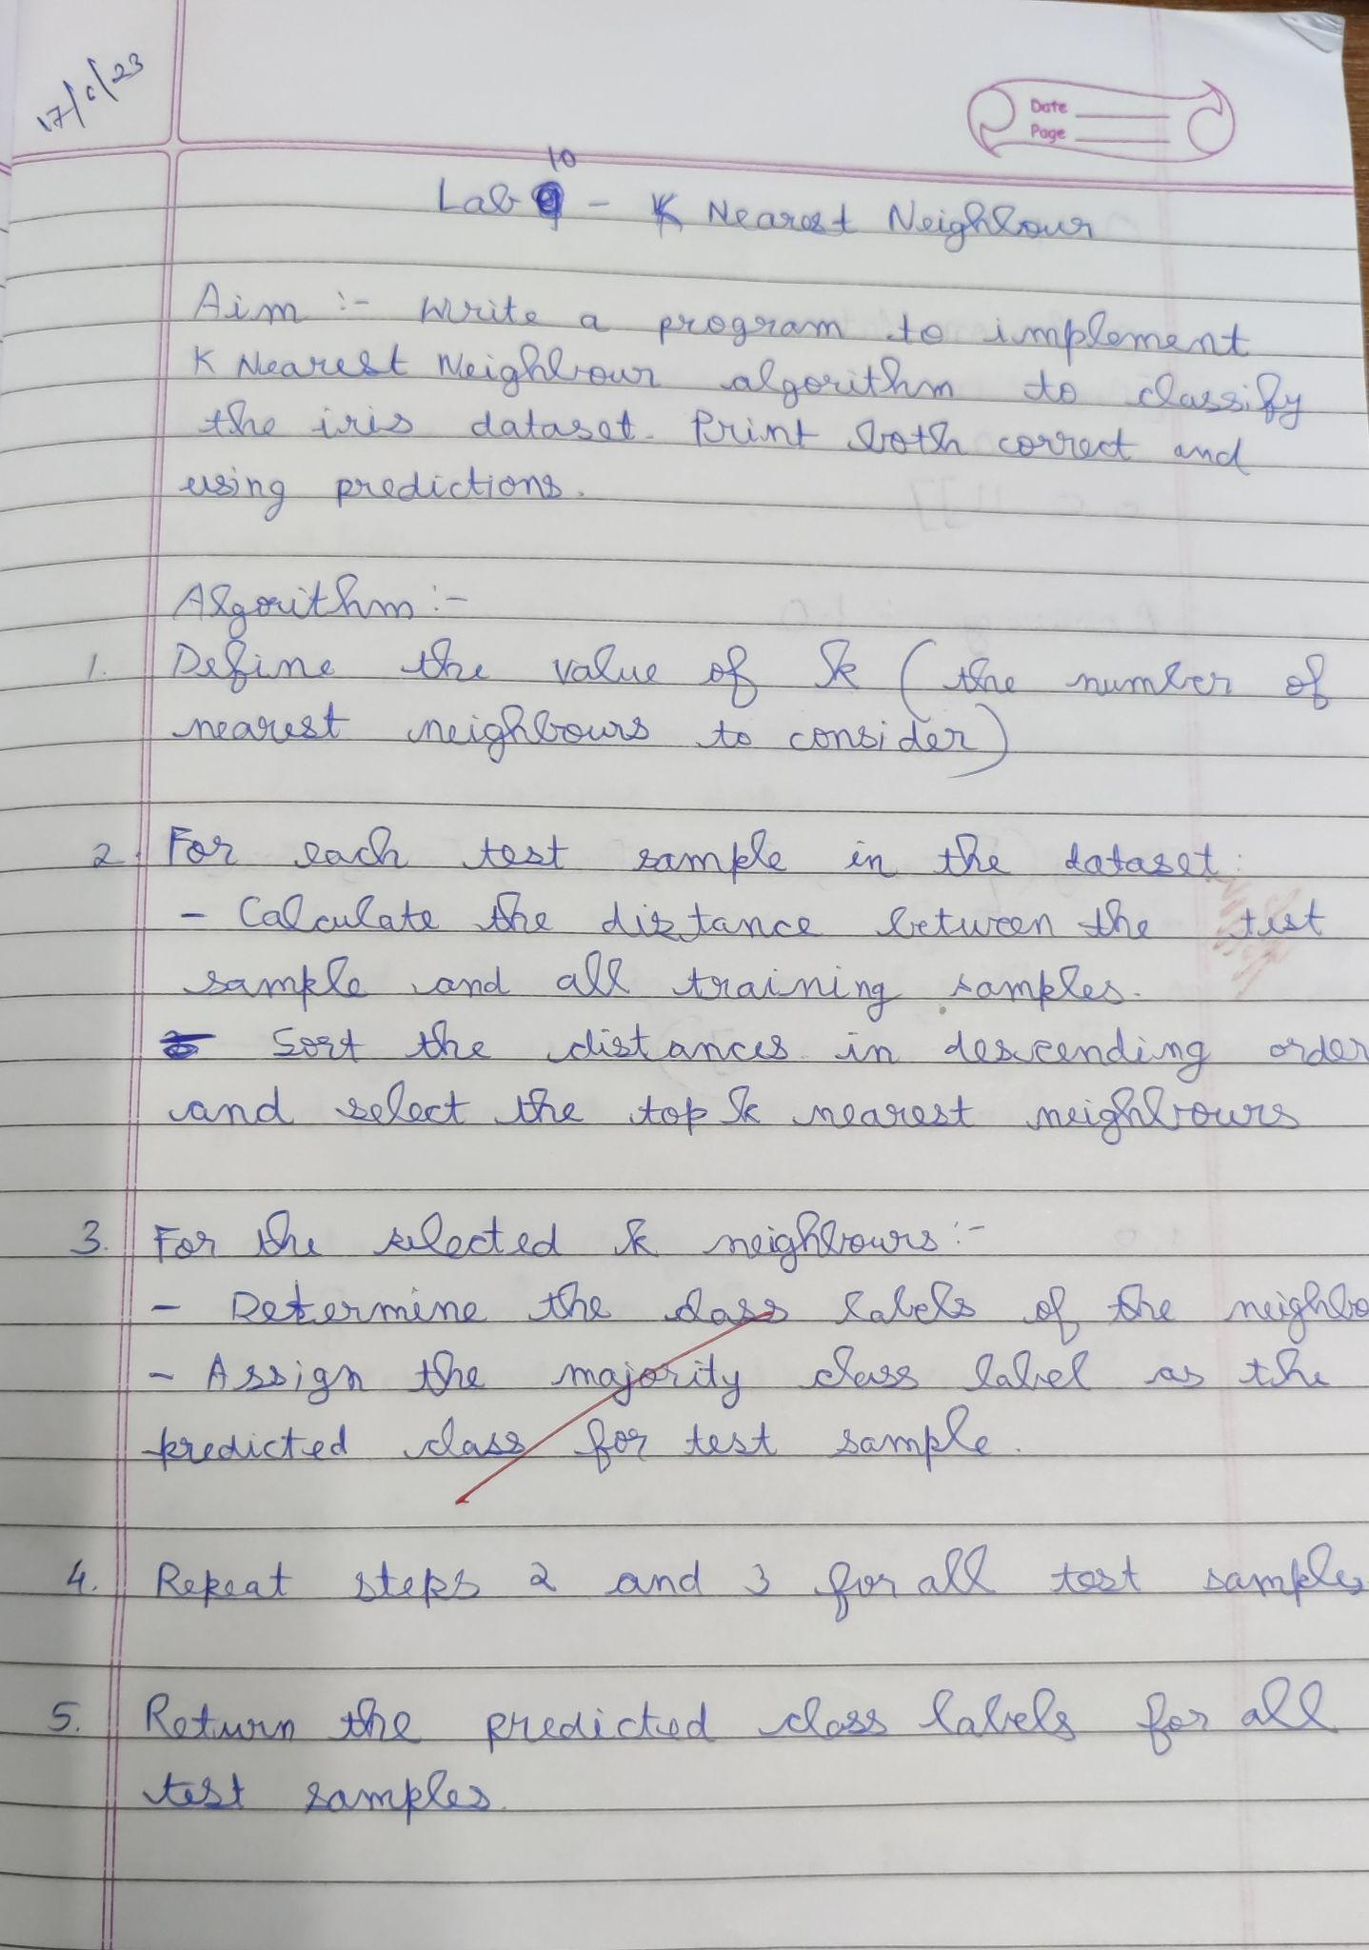

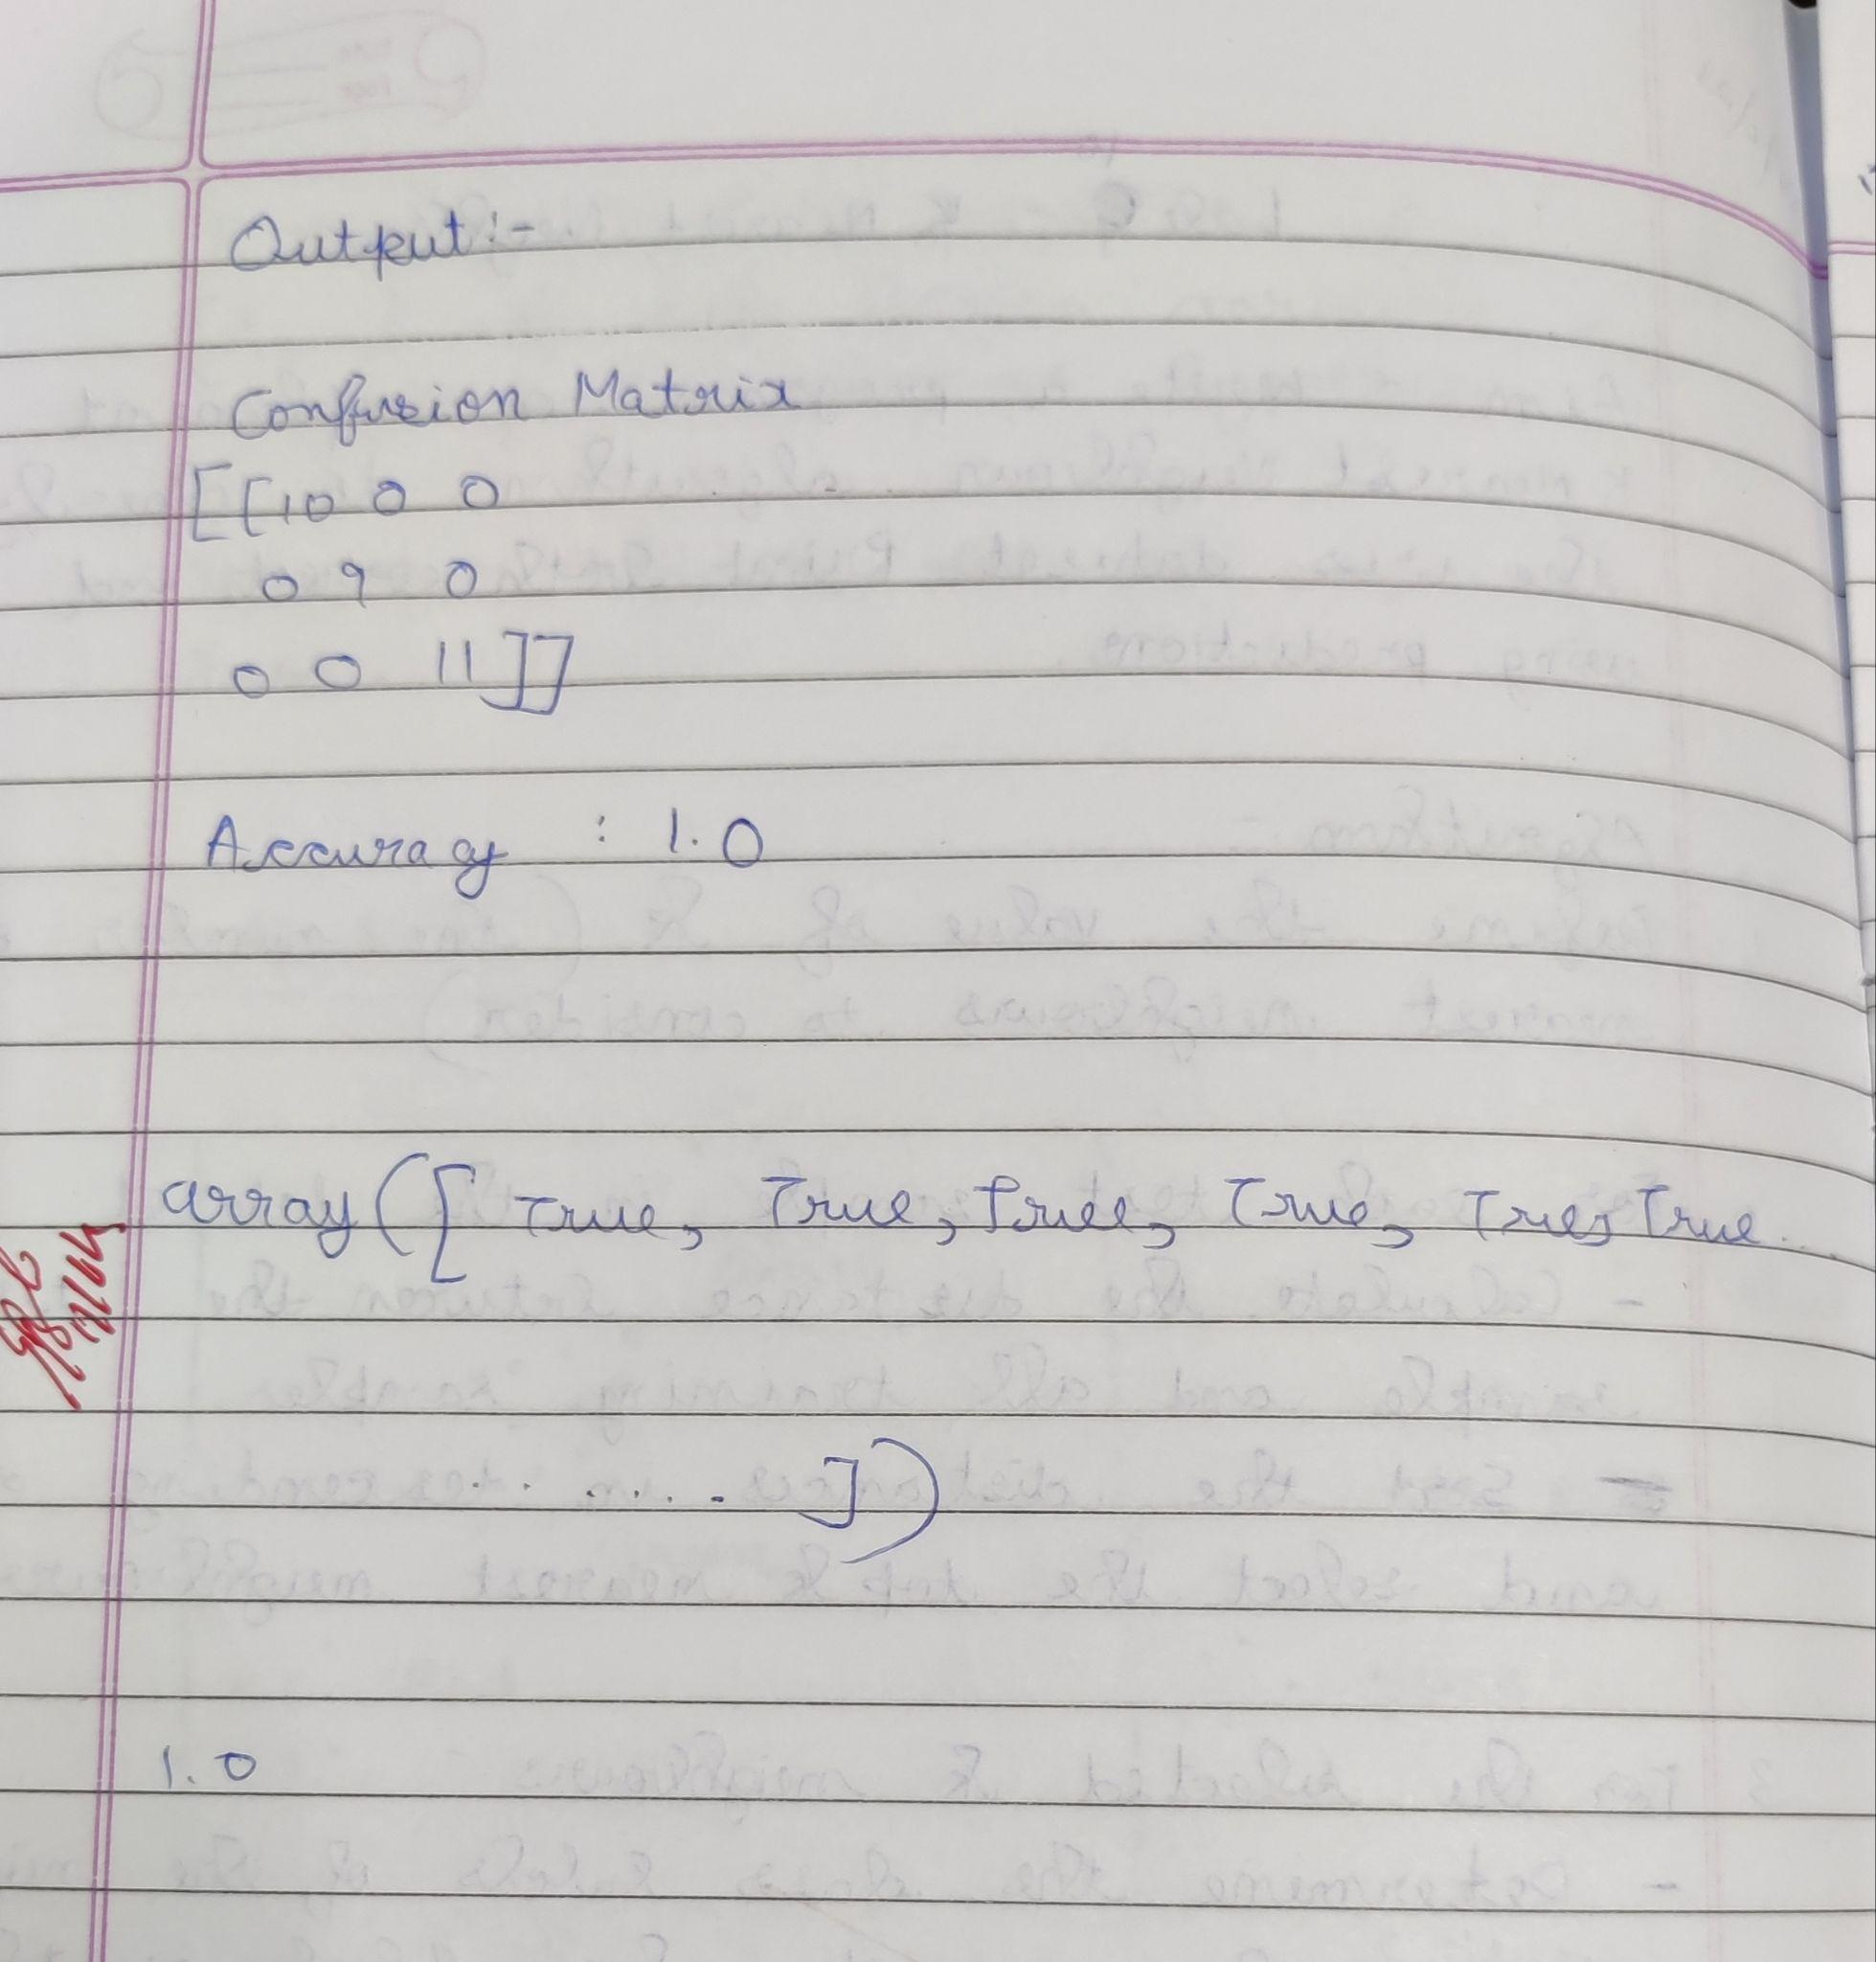

Uploading csv :

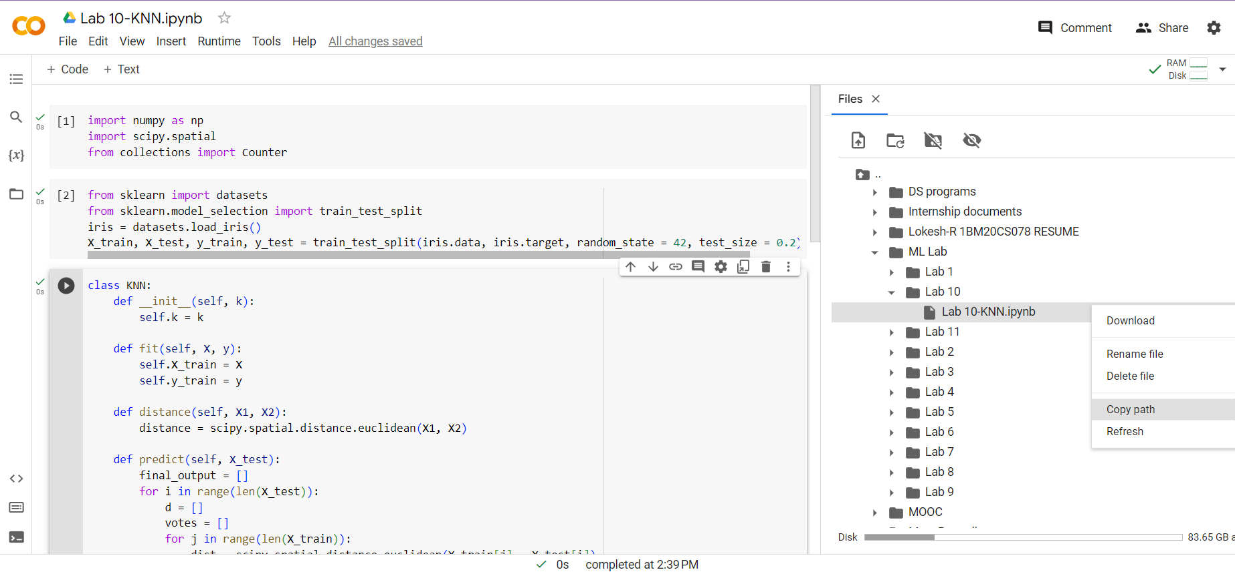

Program execution :

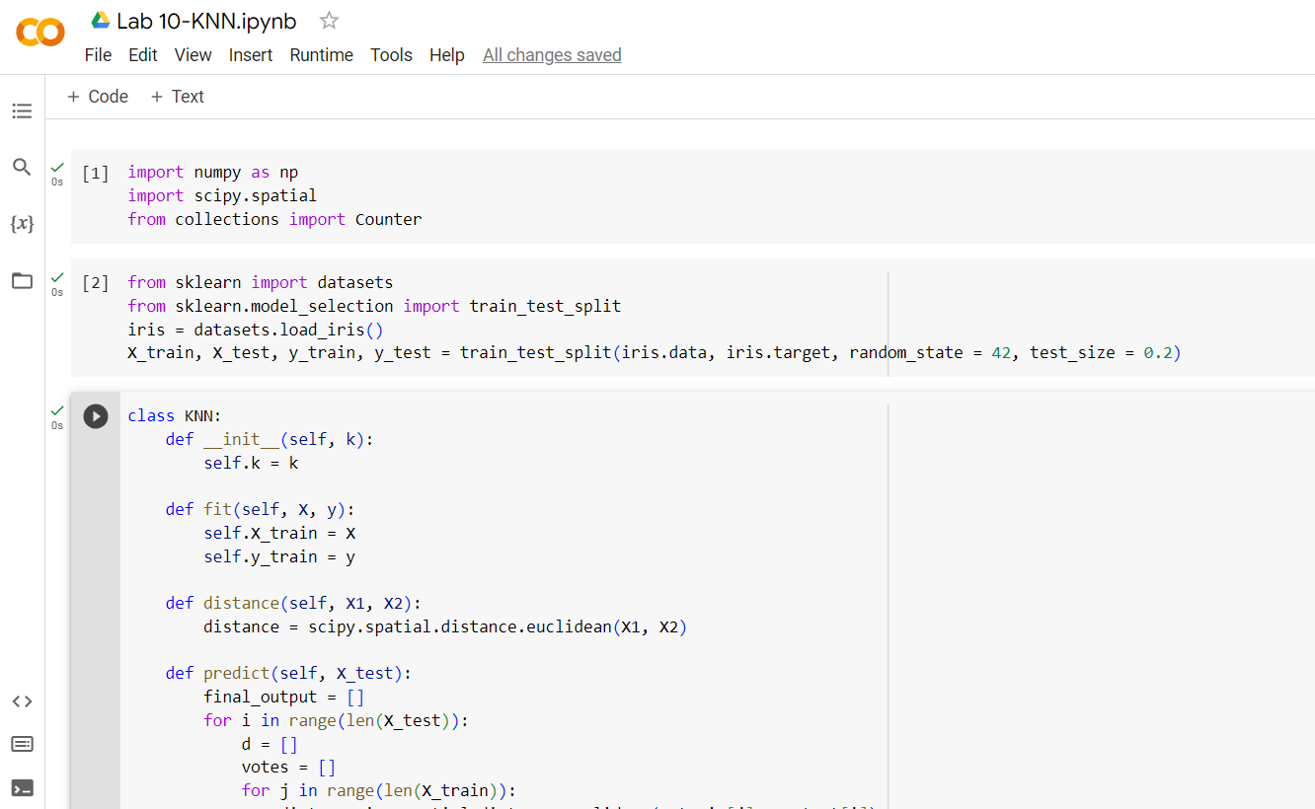

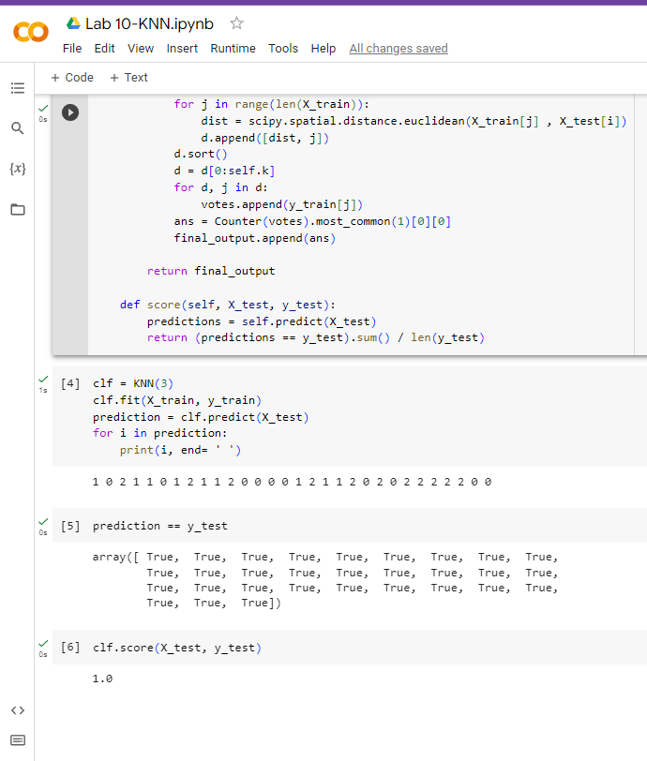

**Date: 17.05.2023**

**Program 11:**

Implement the non-parametric Locally Weighted Regression algorithm in order to fit data points. Select appropriate data set for your experiment and draw graphs.

Dataset :tips.csv

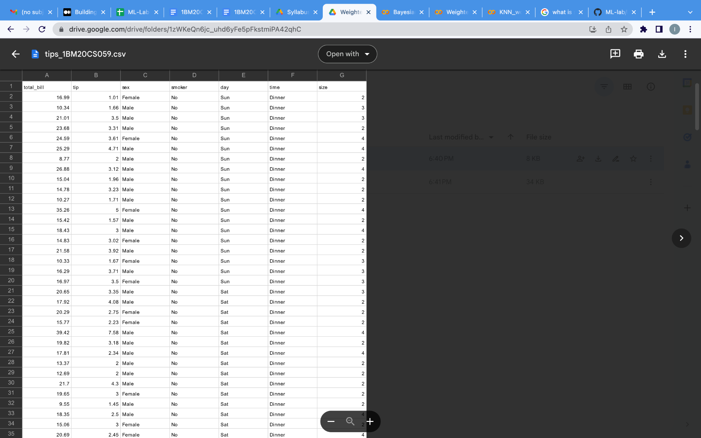

Algorithm :

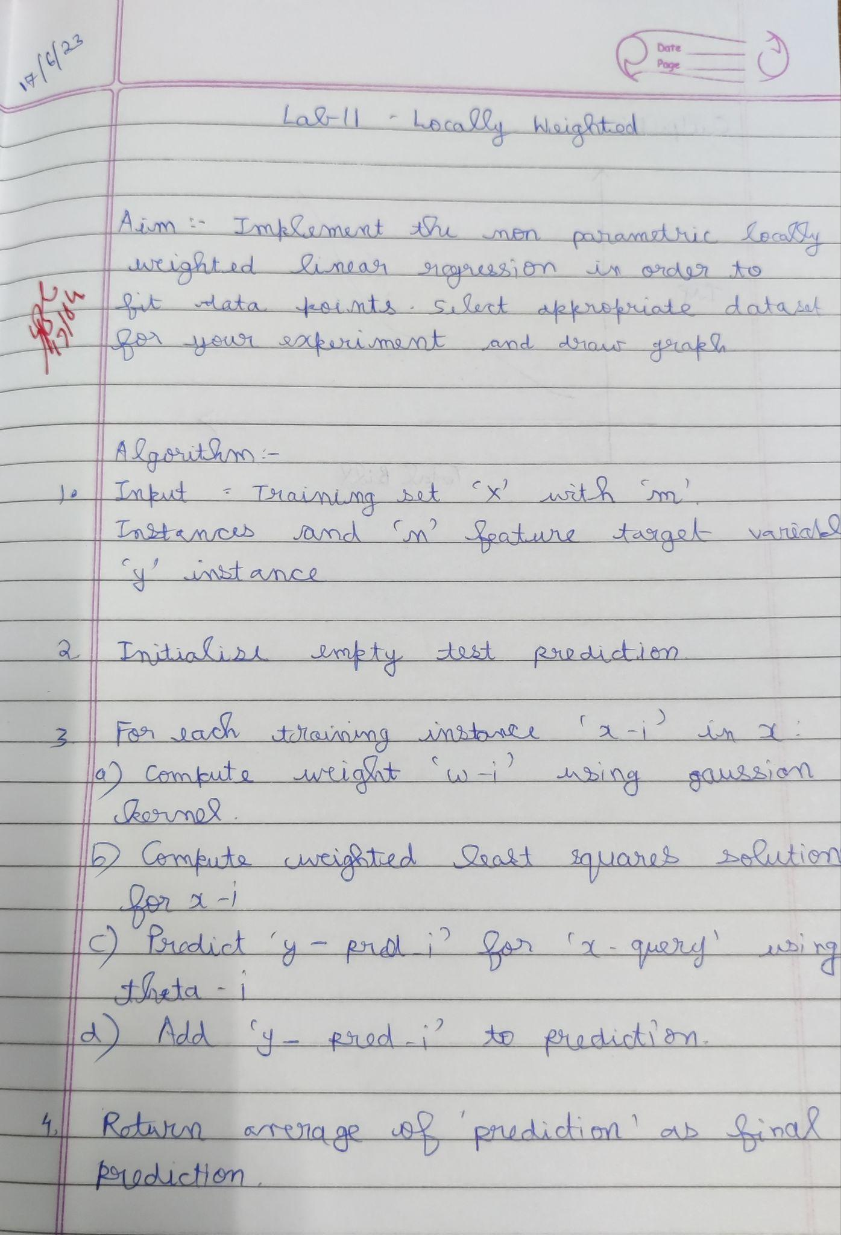

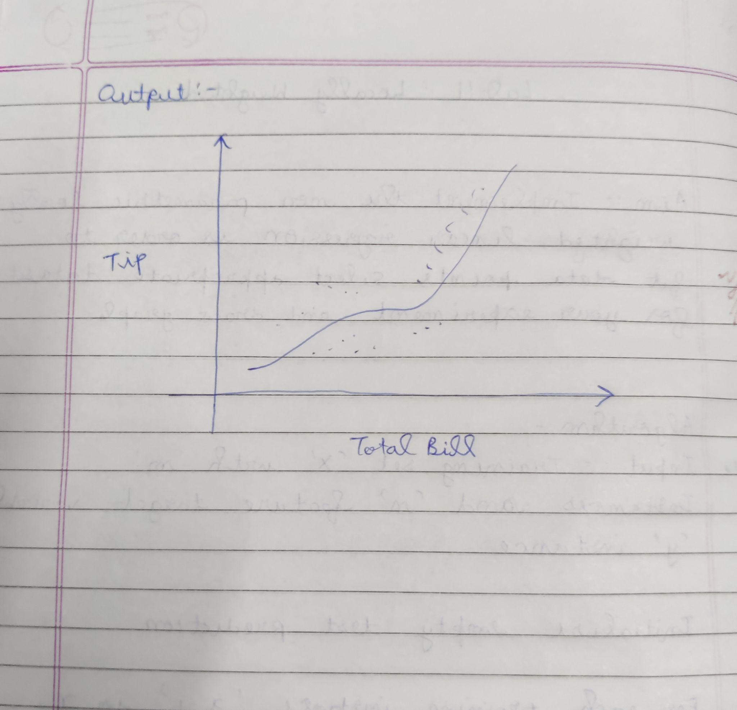

Uploading csv :

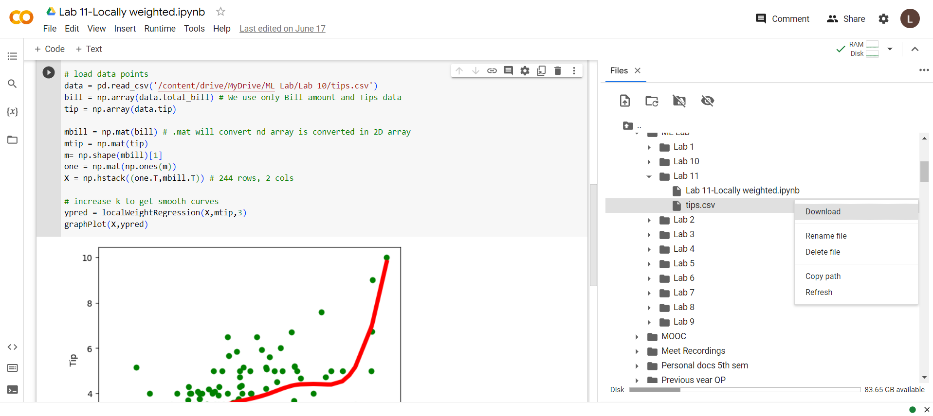

Program execution

